How to Become a
Muslim

by
Abd Ar-Rahman bin Abd Al-Karim Ash-Sheha



بسم الله الرحمن الرحيم

All praises are due to Allah, and may Allah exalt the praises and send Peace upon our Prophet Muhammad, and upon his Family and Companions.
To begin with, I would like to sincerely congratulate you from the bottom of my heart, which loves you for the sake of Allah, for the guidance Allah has granted and favored upon you to accept the correct religion and to act according to it. I ask Allah that he keeps us both, as well as all the Muslims, firm upon this great religion until we meet Him, and not becoming apostate nor being put through a trial.
Indeed a true Muslim feels great joy when someone accepts Islam, for he wishes well for others and wants them to live as he does himself: a life of comfort and delight with spiritual joy and mental stability. This can only result from implementing the teachings of Islam. Allah () says:
“Whoever works righteousness - whether male or female – while he [or she] is a true believer, verily, to him we shall give a good life, and we shall pay them certainly a good reward according to the best of what they used to do.” [Surah an-Nahl (16):97]
Allah () clarified the condition of those who do not believe in Him and what He revealed. Allah () says:
“And whoever turns away from My Reminder, verily, for him is a life of hardship, and We shall raise him up blind on the Day of Resurrection. * He will say, ‘O my Lord! Why have I you raised me up blind, while [before] I had sight.’ * He [Allah] will say, ‘Like this Our Aayaat [proofs, evidences, verses, lessons, signs, revelations, etc.] came to you, but you disregarded them, and so this Day, you will be neglected.’ ” [Surah Taa-Haa (20):124-126]
A true Muslim also wishes that they live happily forever in the Hereafter, whose delights are never-ending. Allah () says:
“Verily those who believe and do righteous deeds shall have the Gardens of Firdaws (the highest level of Heaven) for their entertainment. * Therein they shall dwell [forever]. No desire will they have for removal therefrom.” [Surah al-Kahf (18):107-108]
The end is inevitable; it is either eternal happiness or eternal remorse. Whoever dies upon disbelief - and refuge is sought in Allah - he will reside in Hellfire for eternity. Allah () says:
“Verily those who disbelieve from the people of the Book and the polytheists will abide in the Fire of Hell. They are the worst of creatures.” [Surah al-Bayyinah (98):6]
My noble brothers and sisters, indeed it is a great blessing and favor of Allah that He has guided you to Islam and has saved you from disbelief. There are many who have not been granted the guidance to realize that Islam is the correct religion; and there are others who have, but have not been granted the guidance to follow it. You must thank Allah, my brothers and sisters, for this favor from Allah and this sacred gift which He has chosen for you over others. Ask Allah that He keeps you firm upon this religion until you meet Him. Allah () says:
“They regard as a favor to you [O Muhammad ()] that they have embraced Islam Say, ‘Count not your Islam as a favor to me. Nay but Allah has conferred a favor upon you that He has guided you to the Faith, if you indeed are true.’ ” [Surah al-Hujuraat (49):17]
We are all humans, and all humans are in dire need of Allah. Allah () says:
“O Mankind! It is you who stand in need of Allah. But Allah is Rich (Free of all needs), Worthy of all praise.” [Surah al-Faatir (35):15]
Allah () is in no need of us: He neither benefits from our obedience and worship, nor is He harmed by our disbelief and disobedience. Allah () says:
“If you disbelieve, then verily Allah is not need of you, He likes not disbelief for His slaves. And if you are grateful [by being believers] He is pleased with that for you.” [Surah az-Zumar (39):7]
The Messenger of Allah () said in a Hadeeth Qudsi,
“Allah said: ‘O My servants! I have forbidden dhulm (oppression and injustice) for Myself, and I have made it forbidden amongst you, so do not oppress one another. O My servants, all of you are astray except those whom I have guided, so seek guidance from Me and I shall guide you. O My servants, all of you are hungry except those whom I have fed, so seek food from Me and I shall feed you. O My servants, all of you are naked except those whom I have clothed, so seek clothing from Me and I shall clothe you. O My servants, you commit sins by day and by night, and I forgive all sins, so seek forgiveness from Me and I shall forgive you. O My servants, you will not attain harming Me so as to harm me, and you will not attain benefiting Me so as to benefit Me. O My servants, if the first of you and the last of you, and the humans of you and the Jinn of you, were all as pious as the most pious heart of any individual amongst you, then this would not increase My Kingdom an iota. O My servants, if the first of you and the last of you, and the humans of you and the Jinn of you, were all as wicked as the most wicked heart of any individual amongst you, then this would not decrease My Kingdom an iota. O My servants, if the first of you and the last of you, and the humans of you and the Jinn of you, were all to stand together in one place and ask of Me, and I were to give everyone what he requested, then that would not decrease what I Possess, except what is decreased of the Ocean when a needle is dipped into it. O My servants, it is but your deeds that I account for you, and then recompense you for. So he who finds good, let him praise Allah, and he who finds other than that, let him blame no one but himself.’ ” (Muslim)

How Does One Enter the Fold of Islam?

In order to enter the fold of Islam and become a Muslim, there are no specific religious rituals or customs that one need to perform, neither in specific areas nor in front of specific people. This is due to the fact that Islam is a direct relationship between the slave and His Lord without any intermediaries. Also one does not need to exert great efforts [to enter its fold], he merely needs to utter a few words which are easy on the tongue but very weighty in meaning. One who has decided to become Muslim says the following words in order to enter the fold of Islam, which is called the ‘Shahaadataan’:
“Ash-hadu an laa ilaaha ill-Allah, wa ashhadu anna Muhammadan ‘abd-ullahi wa rasooluh.
“I testify that there is no true deity except Allah, and I testify that Muhammad is His slave and Messenger.”
This statement is the key to the door of Islam. Whoever utters it shuns all other religions besides Islam and all beliefs which differ from it. Through this statement, he receives the rights which all other Muslims receive, and he must fulfill the rights which all other Muslims must fulfill. His wealth, honor and blood become consecrate and protected, except for those cases in which the Islamic law needs to intercede. It is true that one is regarded to be a Muslim by what is outward and apparent and that only Allah knows what is truly in his heart, but one must know the meanings found in the Shahaadataan.

The Shahaadataan

The Meaning of Laa Ilaaha Ill-Allah

This is the phrase of Tawheed. Due to this concept Allah brought the creation into being, and due to this concept He created Paradise and Hellfire. Allah () says:
“And I have neither created the Jinn nor humans except to worship Me.” [Surah adh-Dhaariyaat (51):56]
This is the belief which all the Prophets and Messengers called to, from Adam, the first Prophet, to Muhammad, the last messenger, may the Safety and Blessings of Allah be upon them all. Allah (I) says:
“And we have not sent before you any messenger except that We have revealed to him that there is no deity that is worshipped in truth except Me, so worship and obey Me.” [Surah al-Anbiyaa (10):25]

The Meanings of the Shahaadah:
- There is no Creator of this existence except Allah. Allah (I) says:
“Such is Allah, your Lord! Laa ilaaha illa Huwa (none has the right to be worshipped but He), the Creator of all things. So worship and obey Him (Alone), and He is the Wakeel (Trustee, Disposer of affairs, Guardian, etc.) over all things.” [Surah al-An‘aam (6):102]
- There is no True Master and Owner present in this existence except Allah. Allah () says:
“Surely, His is the Creation and Commandment. Blessed be Allah, the Lord of the ‘aalameen (mankind, Jinns and all that exists)!” [Surah al-A’raaf (7):54]
- No deity deserves servitude and worship except Allah. Allah says:
“No doubt! Verily, to Allah belongs whosoever is in the heavens and whosoever is in the earth. And those who worship and invoke others besides Allah, in fact, follow not the (Allah’s so-called) partners, they follow only a conjecture and they only invent lies.” [Surah Yunus (10):66]
- All the Names and Attributes of Allah are perfect and complete. He is high above and free from all faults and shortcomings. Allah () says:
“And (all) the Most Beautiful Names belong to Allah, so call on Him by them, and leave the company of those who belie or deny (or utter impious speech against) His Names. They will be requited for what they used to do.” [Surah al-A’raaf (7):180]

The Conditions of the Shahaadah
It is not enough that one merely utter the Shahaadah for it to be accepted by Allah. It is the key to the gates of Paradise, but in order for it to work, it needs to have the right ridges. The Shahaadah must meet the following conditions for it to be accepted by Allah:
1) Knowledge: One must have knowledge that all other deities worshipped besides Allah are false, so there is no deity worshipped in truth except Allah. Never should anyone else be worshipped, even if he be a prophet, a messenger or an angel. Allah is the only one who deserves all types worship, such as prayer [Salaah], supplication (du‘aa), hope, sacrificial slaughtering, making oaths, etc. Whoever directs any type of worship to other than Allah has committed kufr, even if he uttered the Shahaadataan.
2) Certainty: One must have certainty in the Shahaadah. Certainty is the opposite of doubt, so there is no room for a person to doubt or waver in his belief. Allah () says:
“The believers are only those who have believed in Allah and His Messenger, and afterward doubt not, and strive with their wealth and their lives for the Cause of Allah. Those! They are the truthful.” [Surah al-Hujuraat (49):15]
3) Acceptance: One should accept the Shahaadah fully and not reject it. Allah () says:
“Truly, when it was said to them, “Laa ilaaha ill-Allah (no deity is worshipped in truth except Allah),” they puff themselves up with pride and deny it.” [Surah as-Saffaat (37):35]
4) Compliance, obedience and acting upon all what the Shahaadah necessitates. A person must do according to what Allah ordered and abstain from what He prohibited. Allah () says:
“And whosoever submits his face to Allah, while he is a Muhsin (doer of good), then he has grasped the most trustworthy handhold [La ilaha ill-Allah]. And to Allah return all matters for decision.” [Surah Luqman (31):22]
5) Truthfulness: One must be truthful in his shahaadah. Allah () says:
“They say with their tongues what is not in their hearts.” [Surah al-Fat-h (48):11]
6) Sincerity of worship: One must make his worship and obedience sincerely for Allah alone. Allah () says:
“And they were not commanded except to worship Allah, following the religion purely and sincerely for Him, turning away from other religions.” [Surah al-Bayyinah (98):5]
7) Love: One must love Allah, His Messenger, and His righteous slaves. He must hate and show enmity towards all who show enmity to Allah and His Messenger. He must prefer what Allah and His Messenger love, even if it is different to what he desires. Allah () says:
“Say: If your fathers, your sons, your brothers, your wives, your kindred, the wealth that you have gained, the commerce in which you fear a decline, and the dwellings in which you delight… are dearer to you than Allah and His Messenger, and fighting in His Cause, then wait until Allah brings about His Decision (torment). And Allah guides not the people who are faasiqoon (the rebellious and disobedient to Allah).” [Surah at-Tawbah (9):24]
The Shahaadah also necessitates that Allah is the only one who has the right to legislate, whether it be in matters concerning worship, or matters concerning the government of human relations in both the individual and public affairs. The act of making something prohibited or lawful is for Allah alone. His Messenger () merely explained and clarified Allah’s commandments. Allah () says:
“And whatsoever the Messenger gives you, take it, and whatsoever he forbids you, abstain (from it).” [Surah al-Hashr (59):7]

The Fruits of having Eemaan (Belief) in Allah
1) In realizing and implementing the Shahaadah fully, one frees himself from the worship of humanity and instead worships his only Lord and God. In doing so, one ceases to be dependent upon the creation, whether in worship, fear, hope, and the likes. Allah () says:
“Say: ‘Tell me then, the things that you invoke besides Allah, if Allah intended some harm for me, could they remove His harm, or if He (Allah) intended some mercy for me, could they withhold His Mercy?’ Say: ‘Sufficient for me is Allah; in Him those who trust (i.e. believers) must put their trust.’ ” [Surah az-Zumar (39):38]
2) Peace of heart, mind and soul. Allah () says:
“Those who believe (in the Oneness of Allah - Islamic Monotheism), and whose hearts find rest in the remembrance of Allah, Verily, in the remembrance of Allah do hearts find rest.” [Surah ar-Ra’d (13):28]
3) The sense of security which is realized through the knowledge that there is someone to turn to in times of hardship. Allah () says:
“And when harm touches you upon the sea, those that you call upon besides Him vanish from you except Him (Allah Alone). But when He brings you safely to land, you turn away (from Him). And man is ever ungrateful.” [Surah al-Israa´ (17):67]
4) The spiritual joy which one feels in worshipping Allah. This is due to the fact that the goal which he is trying to achieve (Paradise) cannot be reached except after death. So you see him persistently striving to achieve this goal by doing righteous deeds, rendering servitude sincerely and purely to Allah alone. Allah () says:
“Say: ‘Verily, my Salaah (prayer), my sacrifice, my living and my dying are for Allah, the Lord of the ‘aalameen (mankind, Jinns and all that exists). He has no partner. * And of this I have been commanded, and I am the first of the Muslims.’ ” [Surah al-An‘aam (6):162-163]
5) The Guidance and Success which is granted by Allah to those that believe in Him. Allah () says:
“…and whosoever believes in Allah, He guides his heart [to the true Faith with certainty], and Allah is the All-Knower of everything.” [Surah at-Taghaabun (64):11]
6) The love of righteousness and its propagation amongst the masses. Allah () says:
“So whosoever does good equal to the weight of an atom (or a small ant), shall see it.” [Surah al-Zilzaal (99):7]
The Prophet () said:
“Indeed the one who leads another to do a righteous deed is like the one who actually does it out (i.e. he will receive the same reward).” (Tirmidhi)
One who has Eemaan in Allah must also have Eemaan in all the things which He has informed us, and from them are the following:

Eemaan in the Angels

To have Eemaan in the angels is to believe that from the creations of Allah’s are the angels. No-one knows their exact number except Him. They are from the world of the Unseen, and Allah () created them to worship and obey Him. They carry out the commands of Allah in various affairs, such as administration, observation, and guarding and protecting the universe as well its creatures, all according to Allah’s Will and Order. Allah () says:
“The Messiah (Jesus ) will never be so proud to reject being a slave to Allah, nor [will] the angels who are near (to Allah).” [Surah an-Nisaa´ (4):172]
The angels act as emissaries between Allah and His messengers amongst humankind. Allah () says:
“Which the trustworthy Spirit [Jibreel (Gabriel)] has brought down; * Upon your heart (O Muhammad ) that you may be (one) of the warners, * In a plain Arabic language.” [Surah ash-Shu‘araa´ (26):193-195]
Allah created them to take charge of different tasks which He commands them:
“They fear their Lord above them, and they do what they are commanded.” [Surah an-Nahl (16):50]
The angels are not partners, associates, or rivals with Allah, nor are they His children; but one must still respect and love them. Allah () says:
“And they say: ‘The Most Beneficent (Allah) has begotten a child [from the angels].’ Glory to Him! They (the angels), are but honored slaves. They speak not until He has spoken, and [then] they act on His Command.” [Surah al-Anbiyaa´ (21):26-27]
They constantly engage their time worshipping and obeying Allah, glorifying Him and praising Him. Allah () says:
“They (i.e. the angels) glorify His Praises night and day, (and) they never slacken (in doing so).” [Surah al-Anbiyaa´ (21):20]
The angels were created from light. The Prophet () said:
“The angels were created from light, the Jinn were created from a smokeless flame of fire, and Adam was created from what was described to you (in the Qur`an: black dry clay).” (Muslim)
Although they were created from light, they cannot be seen. Allah () has, though, given them the ability change their appearance in order to be seen and witnessed. Allah informed us that Jibreel () came to Maryam (Mary) in the form of a human:
“She placed a screen [to screen herself] from them; then We sent to her a Spirit from us (Jibeel ), and he appeared before her in the form of a man in all respects. * She said: ‘Verily! I seek refuge with the Most Beneficent (Allah) from you, if you do fear Allah.’ * [The angel] said: ‘I am only a Messenger from your Lord, [to announce] to you the gift of a righteous son.’ ” [Surah Maryam (19):17-19]
The Prophet (), though, did see Jibreel () in the true form Allah created him. He had six hundred wings, and the whole horizon was obstructed due to his great size.
Allah informed us of the names and tasks of some of the angels. One of them is Jibreel (), and he was given the task of revelation. Allah () says:
“Which the trustworthy Rooh [Jibreel (Gabriel)] has brought down; * Upon your heart (O Muhammad ) that you may be (one) of the warners.” [Surah as-Shu‘araa´ (26):193-194]
Israafeel is the angel who was given the task to blow the horn on the Day of Resurrection, and Meekaa`eel is in charge of the rain and the plants. Also, every human has been appointed with two angels, one which records his righteous deeds and another which records his sins. Allah () says:
“(Remember!) that the two recorders (angels) record, sitting on his right and his left. Not a word does he (or she) utter, but there is a watcher by him ready (to record it).” [Surah Qaaf (50):17-18]
The angel of Death (Malak-ul-Mawt) is the angel given the task of taking people’s souls at the time of death. Allah () says:
“Say: ‘The angel of death who is set over you will take your souls, then you shall be brought back to your Lord.’ ” [Surah as-Sajdah (32):11]
Maalik is the angel who was given the task of guarding the Hellfire. Allah () says:
“And they will cry: ‘O Maalik! Let your Lord make an end of us.’ He will say: ‘Verily you shall abide forever.’” [Surah az-Zukhruf (43):77]
Ridwaan is the angel who is charged with guarding Jannah, and there others as well charged with guarding humans. There are many more, and each has been assigned a specific task. Some have been mentioned in the Qur`an and the Sunnah, while others have not, but we must have Eemaan in them all.

Fruits of Eemaan in the Angels
Through the belief in Angels, one benefits in the following ways:
1) We come to know the Magnificence of Allah (), His ability, and His All-Encompassing Knowledge and Will, for indeed the magnificence of His creation is a proof of the magnificence of the Creator.
2) When a Muslim feels that there are angels closely watching what he is saying and doing, and that everything he does is either for him or held against him, he is keen to perform righteous deeds and abstain from sins, whether he is alone or in public.
3) One is saved from fables and superstitions held by those who do not believe in the Unseen [properly].
4) One comes to know the Mercy which Allah shows to His righteous slaves.

Eemaan in Allah’s Books

To have Eemaan in Allah’s books is to believe that Allah () revealed heavenly books to His messengers in order to convey them to humankind. These books contain nothing but the truth; they do not contain any falsehood. In them is the message of the Oneness of Allah (): that there is no creator, administrator, or owner except Him, that all worship should be directed to Him and none else, and that to Him belong all excellent Names and Attributes. He is nothing like His creation, and none can be compared to Him. Allah () says:
“Indeed We have sent Our Messengers with clear proofs, and revealed with them the Scripture and the Balance (justice) that mankind may keep up justice.” [Surah al-Hadeed (57):25]
Some of those books are the following:
1) The Scriptures of Ibraaheem () (Abraham) and Musaa () (Moses): The Qur`an has given a brief insight about the religious basic principles found in these scriptures. Allah () says:
“Or is he not informed with what is in the Scriptures of Musaa? And of Ibraaheem who fulfilled (or conveyed) all that [what Allah ordered him to do or convey]? That no burdened person [with sins] shall bear the burden (sins) of another. And that man can have nothing but what he [himself] strove for. And that his deeds will be seen [in the Herafter]. Then he will be recompensed with a full and the best recompense.” [Surah an-Najm (53):36-41]
2) The Tawraah: The Tawraah is the Sacred Book which was revealed to Musaa (). Allah () says:
“Verily, We did send down the Tawraah [to Musaa], therein was guidance and light, by which the Prophets, who submitted themselves to Allah’s Will, judged the Jews. And the rabbis and the priests [too judged the Jews by the Tawraah after those Prophets] for to them was entrusted the protection of Allah’s Book, and they were witnesses thereto. Therefore fear not men but fear Me (O Jews) and sell not My Verses for a miserable price. And whosoever does not judge by what Allah has revealed, such are the disbelievers.” [Surah al-Maa`idah (5):44]
3) The Zaboor: The Zaboor is the Book which was revealed to Dawood () (David). Allah () says:
“…and to Dawood We gave the Zaboor.” [Surah an-Nisaa´ (4):163]
4) The Injeel: The Injeel is the Sacred Book which was revealed to ‘Eesaa () (Jesus). Allah () says:
“And in their footsteps, We sent ‘Eesaa, son of Maryam (Mary), confirming the Tawraah that had come before him. And We gave him the Injeel, in which was guidance and light and confirmation of the Tawraah that had come before it, a guidance and an admonition for the Allah-fearing.” [Surah al-Maa`idah (5):46]
A Muslim must believe in all the Heavenly Books. He must believe that they are from Allah (), but he is required not act upon or follow them, for they were revealed for a specific time and people.
The Qur`an has explained some of the teachings which were found in the Tawraah and the Injeel. Allah () says that from the things they mentioned was the prophecy of Muhammad ():
“…and My Mercy embraces all things. That [Mercy] I shall ordain for those who are Allah-fearing, and give Zakaah; and those who believe in Our aayaat; Those who follow the Messenger, the Prophet who can neither read nor write (Muhammad ) whom they find written with them in the Tawraah and the Injeel, - he commands them all good things; and forbids them from of all kinds of evil; he allows them as lawful all good and lawful things, and prohibits them as unlawful all evil and unlawful things; and he releases them from their heavy burdens [of Allah’s Covenant], and from the fetters (bindings) that were upon them.” [Surah al-A’raaf (7):156]
5) The Noble Qur`an: One must hold the following beliefs concerning it:
a) One must believe that the Qur`an is the exact and literal Speech of Allah which Jibreel () brought to Muhammad () in a clear Arabic language. Allah () says:
“Which the trustworthy Rooh [Jibreel (Gabriel)] has brought down; * Upon your heart (O Muhammad ) that you may be (one) of the warners, * In a plain Arabic language.” [Surah as-Shu‘araa´ (26):193-195]
b) One must believe that the Qur`an is the last of the heavenly books, giving truth to the previous books in their message of the Tawheed of Allah and the obligation to worship and obey Him Alone. Allah abrogated all the previous books by the Qur`an. Allah () says:
“[It is] He Who has sent down the Book (the Qur`an) to you (Muhammad ) with truth, confirming what came before it. And He sent down the Tawraah and the Injeel. Aforetime, as a guidance to mankind, And He sent down the Furqaan (The Criterion) [of judgment between right and wrong (this Qur`an)].” [Surah Aali ‘Imraan (3):3-4]
c) One must believe that the Qur`an embodies all divine teachings. Allah () says:
“This day, I have perfected your religion for you, completed My Favor upon you, and have chosen for you Islam as a religion.” [Surah al-Maa`idah (5):3]
d) One must believe that it was revealed to all of humanity, and not to a specific nation or specific time period unlike the previous heavenly books. Allah () says:
“And We have not sent you [O Muhammad ] except to all of humanity, as a giver of glad tidings and a warner, but most people know not.” [Surah Saba´ (34):28]
e) One must believe that Allah has protected the Qur`an from all types of distortion, whether addition, deletion, substitution or interpolation. Allah () says:
“Indeed it is We ourselves who have sent down the Remembrance (the Qur`an) and surely, it is We who shall guard it [from distortion].” [Surah al-Hijr (15):9]

The Fruits of Eemaan in Allah’s Books
Through the belief in Allah’s books, one benefits in the following ways:
1) One realizes the Mercy and Love Allah has for His slaves, in that He revealed to them books directing them to the path which leads to His Pleasure. He did not leave them to linger in confusion, leaving them for the Shaytaan or their desires to snatch them away.
2) One realizes the Wisdom of Allah, in that He legislated for each specific nation what was suitable to their specific needs and conditions.
3) To distinguish the believers truthful in their faith from others, for it is incumbent upon one who believes in his own Book to believe in the other Heavenly Books which it prophesized.
4) As a multiplication of good deeds, for those who believe in their own Book and in addition to that believe in the Books of Allah which came after it will receive double reward. Allah () says:
“Those to whom We gave the Scripture [i.e. the Tawraah and the Injeel, etc.] before it, - they believe in it (the Qur`an). And when it is recited to them, they say: ‘We believe in it. Verily, it is the truth from our Lord. Indeed even before it we have been from those who submit themselves to Allah in Islam as Muslims (like ‘Abdullah bin Salaam and Salmaan al-Faarisi, etc.).’ These will be given their reward twice over, because they are patient, and repel evil with good, and spend (in charity) out of what We have provided them.” [Surah al-Qasas (28):52-54]

Eemaan in Allah’s Messengers

To have Eemaan in Allah’s Messengers is to believe that Allah () selected the finest amongst humanity as messengers whom He sent to His creation with specific legislations: for them to worship and obey Allah and to establish His Religion and His Tawheed in His Lordship, Worship, and Names and Attributes. He ordered His messengers to convey this message to people so that they would not have any proof against Allah or excuse for disobedience after He sent them. They give glad-tidings of the Pleasure of Allah and His Jannah reserved for those who believe in them and their teachings, and give stern warning of the Anger of Allah and His Punishment reserved for those who disbelieve in them and their teachings :
“And We send not the Messengers but as givers of glad tidings and as warners. So whosoever believes and does righteous good deeds, upon such shall come no fear, nor shall they grieve. * But those who reject Our Aayaat (verses, signs, proofs), the torment will touch them for their disbelief.” [Surah al-An‘aam (6):48-49]
There are many prophets and messengers; no-one knows their exact number except Allah. Allah () says:
“And, indeed We have sent Messengers before you (O Muhammad ); of some of them We have related to you their story, and of some We have not related to you their story.” [Surah al-Ghaafir (40):78]
One must believe in all of them and that they were purely and truly only human in nature; they were not supernatural beings. Allah () says:
“And We sent not before you (O Muhammad ) but men to whom We inspired, so ask the people of the Reminder (Scriptures) if you do not know. And We did not create them (the Messengers, with) bodies that ate not food, nor were they immortal.” [Surah al-Anbiyaa´ (21):7-8]
They do not share any characteristics specific to Allah whatsoever. They can neither bring benefit nor can they cause harm. They do not have any control over the universe whatsoever, nor can they do with it as they please. They cannot do anything which only Allah is able to. Allah () says:
“Say (O Muhammad ): ‘I possess no power of benefit or hurt to myself except as Allah wills. If I had the knowledge of the Unseen, I should have secured for myself an abundance of wealth, and no evil should have touched me.’ ” [Surah al-A’raaf (7):188]
If one believes in only some of them and not all, he has committed kufr and is considered to be outside the fold of Islam. Allah () says:
“Verily, those who disbelieve in Allah and His Messengers and wish to make distinction between Allah and His Messengers saying, ‘We believe in some but reject others,’ and wish to adopt a way in between. * They are in truth disbelievers. And We have prepared for the disbelievers a humiliating torment.” [Surah an-Nisaa´ (4):150-151]
From among the messengers were those who Allah called ‘Ulul-‘Azm’ or ‘those of strong determination’. They were the strongest of the Messengers in carrying the Message, conveying it to their people and being patient and steadfast in their mission. They were Nooh (Noah), Ibraheem (Abraham), Musaa (Moses), ‘Eesaa (Jesus), and Muhammad, may the utmost of Allah’s Safety and Mercy be upon them all.
The first messenger was Nooh (). Allah () says:
“Verily, We have inspired you (O Muhammad ) as We inspired Nooh (Noah) and the Prophets after him.” [Surah an-Nisaa´ (4):163]
Muhammad () was the last and final messenger; no messenger will come after him until the Final Day. Allah () says:
“Muhammad is not the father of any man among you, but he is the Messenger of Allah and the last (end) of the Prophets.” [Surah al-Ahzaab (33):40]
The religion of Muhammad () completed Allah’s message to humanity, and thus has abrogated all the religions which preceded it. It is the complete and final religion of truth which is obligatory to be followed, and it will continue to be so until the Last Hour.

Who is Muhammad ()?
His name is Muhammad bin Abdullah bin Abdul-Muttalib bin Haashim, and his kunyah is Abul-Qaasim. He was from the Arab tribe of Qureish whose ancestry traces back to ‘Adnaan. ‘Adnaan was from the children of Ismaa`eel (), the prophet of Allah and son of Ibraaheem (), the Khaleel of Allah. The Prophet () said:
“Indeed Allah chose the tribe of Kinaanah over other tribes from the children of Ismaa‘eel; He chose the Qureish over other tribes of Kinaanah; He chose Banu Haashim over the other families of the Qureish; and He chose me from Banu Haashim.” (Muslim)
He received his first revelation from Allah at the age of forty, and he remained in Makkah thereafter for thirteen years calling to Tawheed of Allah. He then migrated to Madeenah and called its inhabitants to Islam, which they accepted. There, Allah revealed the remaining legislations. He conquered Makkah eight years after his migration, and Allah took his soul at the age of sixty-three, after revealing to Him the entire Qur`an. All the legislations of the religion were revealed, completed and perfected, and the majority of the Arab nation accepted Islam.

The Fruits of Eemaan in the Messengers
Through the belief in Allah’s Messengers, one benefits in the following ways:
1) One realizes the Mercy and Love Allah has for His slaves, in that He sent to them Messengers conveying to them His religion, and as examples showing how His religion should be implemented and propagated.
2) To distinguish the believers truthful in their faith from others, for it is incumbent upon one who believes in his own Messenger to believe in the other Messengers prophesized in their books.
3) As a multiplication of good deeds, for those who believe in their own messenger, and in addition to that believe in the messengers of Allah who came after him will receive double reward.

Eemaan in the Last Day

To have Eemaan in the Last Day is to believe that the life of this world will one day come to an end. Allah () says:
“Whatsoever is on it (the earth) will perish.” [Surah ar-Rahmaan (55):26]
When Allah wills this world to come to an end, Allah will order an angel called Israafeel to blow a horn. At that point, everything in the heavens and earth will perish, except who Allah wills. Then He will order him to blow it again, and upon that, all people will rise from their graves, alive and in their own bodies. Everyone from all parts of the world, from the time of Adam () until the end of time, will be resurrected. Allah () says:
“And the Trumpet will be blown, and all who are in the heavens and all who are on the earth will collapse and die, except him whom Allah will. Then it will blown a second time and behold, they will be standing, looking on (waiting).” [Surah az-Zumar (39):68]
To have Eemaan in the Last Day means to have Eemaan in all of what Allah () and His Messenger () informed us of what will occur after death. From these things is the following:
1) To believe in the life of the Barzakh: This life is the time after one’s death until the Last Day. In it the believer will live a life of pleasure while the rejecting disbelievers will be punished. Allah () says:
“The Fire; they are exposed to it, morning and afternoon, and on the Day when the Hour will be established (it will be said to the angels): ‘Cause Fir‘awn’s (Pharaoh) people to enter the severest torment!’ ” [Surah al-Ghaafir (40):46]
2) To believe in the Resurrection: This is the Day on which Allah will resurrect the whole creation, naked, barefoot, and uncircumcised just as they were born. Allah () says:
“The disbelievers falsely think that they will never be resurrected (for the Account). Say: ‘Yes! By my Lord, you will certainly be resurrected, then you will be informed of (and recompensed for) what you did, and that is easy for Allah.’ ” [Surah at-Taghaabun (64):7]
3) To believe in the Gathering: Allah will gather all of the creation together and call them to account. Allah () says:
“And (remember) the Day We shall cause the mountains to pass away (like clouds of dust), and you will see the earth as a leveled plain, and We shall gather them all together so as to leave not one of them behind.” [Surah al-Kahf (18):47]
4) To believe that people will be set before Allah: Allah () says:
“And they will be set before your Lord in (lines as) rows, (and Allah will say): ‘Now indeed, you have come to Us as We created you the first time.’ ” [Surah al-Kahf (18):48]
5) To believe that one’s limbs will bear witness. Allah () says:
“Till, when they reach it (Hellfire), their hearing (ears) and their eyes, and their skins will testify against them as to what they used to do. * And they will say to their skins, ‘Why do you testify against us?’ They will say: ‘Allah has caused us to speak, He causes all things to speak: and He created you the first time, and to Him you are made to return.’ * And you have not been hiding yourselves (in the world), lest your ears, and your eyes, and your skins testify against you; but you thought that Allah knew not much of what you were doing.” [Surah al-Fussilat (41):20-22]
6) To believe in the Questioning. Allah () says:
“ ‘But stop them, verily they are to be questioned. * ‘What is the matter with you? Why do you not help one another [as you used to do in the world]?’ * Nay, but that Day they shall surrender.” [Surah as-Saaffaat (37):24-26]
7) To believe in the Siraat, and that everyone must pass over it. Allah () says:
“There is not one of you but will pass over it (Hell); this is with your Lord a Decree which must be accomplished.” [Surah Maryam (19):71]
8) To believe in the weighing of deeds on the Scale. Allah will call people to account and pay them their exact dues for their deeds. He will reward those who did well with what they deserve, due to their righteous deeds, their Eemaan, and following the messengers, and He will punish those who did evil, as a payback for what they committed of evil, disbelief, and disobedience to their messengers. Allah () says:
“And We shall set up balances of justice on the Day of Resurrection, then none will be dealt with unjustly in anything. And if there be the weight of a mustard seed, We will bring it. And Sufficient are We as Reckoners.” [Surah al-Anbiyaa´ (21):47]
9) To believe in the handing out of scrolls and books. Allah () says:
“Then, as for him who will be given his Record in his right hand, he surely will receive an easy reckoning. * And he will return to his family in joy! * But whosoever is given his Record behind his back. * He will invoke (his) destruction. * And he shall enter a blazing Fire and made to taste its burning.” [Surah al-Inshiqaaq (84):7-12]
10) To believe that people will be rewarded with either Jannah or Hellfire in an everlasting and eternal life which will never end. Allah () says:
“Verily those who disbelieve from among the people of the Book (Jews and Christians) and the mushrikoon (pagans) will abide in the Fire of Hell. They are the worst of creatures * Verily, those who believe and do righteous deeds, they are the best of creatures. * Their reward with their Lord is the Paradise of ‘Adn (Eden) (Gardens of Eternity), underneath which rivers flow. They will abide therein forever, Allah will be pleased with them, and they with Him. That is for him who fears his Lord.” [Surah al- Bayyinah (98):6-8]
11) To believe in the Hawd, Intercession, and all other things which the Messenger of Allah () informed us.

The Fruits of Eemaan in the Last Day.
Through the belief in Last Day, one benefits in the following ways:
1) In preparing for that Day, by continually performing good deeds and competing in doing so, hoping for its reward, and abstaining from sins and removing oneself from them, fearing Allah’s punishment.
2) In comforting the believers, that whatever they leave from the entertainment of this life will be exchanged with a better reward in the Hereafter.
3) To distinguish the believers truthful in their faith from others.

Eemaan in Qadaa´ and Qadar

To have Eemaan in Qadaa´ and Qadar is to believe that Allah always knew everything before its came into being, and what will happen to them afterwards. He then brought them into existence, all in accordance to His Knowledge and Measure. Allah () says:
“Verily, We have created all things with Qadar.” [Surah al-Qamr (54):49]
Everything which occurred in the past, is occurring in the present, and will occur in the future in this universe was known to Allah before it came to be. Then Allah brought it into being, all in accordance to His Will and Measure. The Messenger of Allah () said:
“A person is not a Muslim until he believes in Qadar, its good and its evil effects – until he knows that whatever happened to him would have never missed him, and what did not happen to him would never have occurred.” (Tirmidhi)
The belief in Qadar means to believe in four things:
1) To believe that Allah always knew everything the creation would do, and there was never a time in which He did not know.
2) To believe that Allah wrote all of this in the ‘Preserved Tablet’ (Al-Lawh-ul-Mahfoodh). The Prophet () said:
“The first thing which Allah created was the Pen, and He said to it, ‘Write.’ It responded, ‘What should I write?’ He said, ‘Write everything that will occur until the Day of Ressurection.’ ” (Abu Dawood)
3) The belief in the Will of Allah which always comes to be, and his Absolute Ability and Power over all things. This is to believe that whatever Allah wills comes to be, and whatever He does not will does not come to be.
4) The belief that there is no creation in the earth or in the heavens except that Allah () created it. There is no Creator, Lord or Sovereign other than Him.
This belief is not in opposition to the fact that one must do everything in his means to achieve things. For example, if someone wants children, he must fulfill those means which allow him to achieve this goal, such as marriage. But after fulfilling these means, he may be granted the results he hoped for –which are children - or he may not, all according to the Will of Allah (). The reason for this is that the means are not the true causes of things, but rather the true cause is the Will of Allah (). These means that we strive to fulfill are also from the Qadar of Allah (), and for this reason, the Prophet () explained to the Sahaabah when they asked him:
“ ‘O Messenger of Allah, do the verses and supplications we recite, the medicine we take to cure ourselves, and the various shields we use to ward harm change the Qadar of Allah ()?’ [He replied,] ‘They are from the Qadar of Allah.’ ” (Ta’leeqaat ar-Radiyyah)

The Fruits of Eemaan in Qadaa´ and Qadar
Through the belief in Qadaa´ and Qadar, one benefits in the following ways:
1) It strengthens his dependence upon Allah [in achieving results] after fulfilling its means.
2) One becomes pleased with whatever results, which in turn produces peace of heart and spiritual satisfaction. There is no room left for stress, worry, or sadness felt due to the outcomes of affairs. Allah () says:
“No calamity befalls on the earth or in yourselves but is inscribed in the Book of Decrees (Al-Lawh Al-Mahfoodh), before We bring it into existence. Verily, that is easy for Allah. * In order that you may not be sad over matters that you fail to get, nor rejoice because of that which has been given to you. And Allah likes not prideful boasters.” [Surah al-Hadeed (54):22-23]
3) It eases the effects of calamities faced by humans. The Prophet () said:
“The strong believer is better and more beloved to Allah than a weak believer, and in each one there is good. Be keen to do what benefits you and seek help in Allah, and do not be neglectful in doing so. And if any mishap befalls you, do not say, ‘If only I had only done such and such,’ but rather say, ‘This is the Qadar of Allah, and whatever He Wills He does (Qaddarullaah wa maa shaa fa‘al),’ for indeed [the saying of] ‘if’ opens the door for Shaytaan’s works.” (Muslim)
4) It increases one’s reward and wipes away sins. The Prophet () said:
“No Muslim is fatigued, is stricken with illness, feels stress, worry, sadness, or harm, not even a thorn which pricks him, except that Allah forgives sins through it.” (Bukhari)
Belief in Qadar is not, as some mistakenly think, a call to put one trust in Allah without striving or fulfilling the means, for as the Messenger of Allah () himself replied to a person who asked him:
“ ‘Should I leave my camel untied and trust in Allah?’ He said, ‘Tie it and trust in Allah.’ ” (Saheeh ibn Hibbaan)

The Testimony that ‘Muhammad is the Messenger of Allah’

To bear witness that Muhammad is the Messenger of Allah necessitates the following:
1) To believe that he is a Messenger, and to believe that he is the best, the last, and the seal of the Messengers; no messenger will come after him. Allah () says:
“Muhammad is not the father of any man among you, but he is the Messenger of Allah and the last (end, seal) of the Prophets.” [Surah al-Ahzaab (33):40]
2) To believe that he is infallible in the teachings he conveyed from Allah (), due to His saying:
“Nor does he speak of (his own) desire. * It is only an Inspiration that is inspired.” [Surah an-Najm (53):3-4]
As for the affairs of this world, he was a human, and he used his own personal judgments (i.e. it was not revealed to him by Allah). The Prophet () said:
“Indeed I am only a human. It may be that a claimant comes to me with a dispute, and due to one of them being more coercive in speech than the other, I may rule in his favor. Whoever was ruled in his favor while he is wrong, [what he is receiving without right] is only a portion of the Hellfire, so let him take it or leave it.” (Muslim)
3) To believe that he is a messenger to all of creation, both the Jinn and Humans, until the Last Hour. Allah (I) says:
“And We have not sent you (O Muhammad ) except to all of humanity, as a giver of glad tidings and a warner, but most people know not.” [Surah Saba´ (34):28]
4) To obey the Prophet () in what he ordered, to believe in everything he said, and to abstain from what he has forbidden and warned against. Allah (I) says:
“And whatsoever the Messenger gives you, take it, and whatsoever he forbids you, abstain (from it)” [Surah al-Hashr (59):7]
5) To follow and cling to the Prophet’s () Sunnah without adding to it. Allah (I) says:
“Say (O Muhammad  to mankind): If you (really) love Allah then follow me, Allah will love you and forgive you of your sins. And Allah is Oft-Forgiving, Most Merciful.” [Surah Aali ‘Imraan (3):31]

What One Should Do After Pronouncing the Shahaadataan

After pronouncing the Shahaadataan, it is from the Sunnah that a person do the following things:
1) It is recommended that one perform a complete bath (ghusl) with pure water and then perform a prayer consisting of two rak‘ahs. In a hadeeth, a person named Thumaamah al-Hanafi was taken captive while he was a disbeliever. The Prophet () would repetitively approach him saying:
“What do you say, O Thumaamah?” He would say, “If you decide to kill me, you would be killing [in right] because I have killed; if you let me free, you would be letting free one who shows gratitude; and if you desire wealth, we will give you what you please.” The Companions of the Prophet () liked to ransom captives, and so they said, “What would we gain if we killed him?” So finally one day, the Prophet () decided to set [Thumaamah] free, and [upon that] he accepted Islam. The Prophet () untied him and sent him to the walled garden of Abu Talhah, commanding him to take a complete bath (ghusl). He performed a complete bath and prayed to rak‘ahs, and the Prophet () said, “Your brother’s Islam is sincere.” (Saheeh ibn Khuzaimah)

A Description of a Complete Bath (Ghusl)

⬥ The Intention (Niyyah). One must intend in his heart that he is performing ghusl to remove himself from a major state of impurity – whether janaabah, menstruation or postpartum bleeding – without uttering such intention vocally.
⬥ Mentioning the Name of Allâh. One should say, ‘Bismillah’ (trans. ‘In the Name of Allâh’).
⬥ He should wash his hands, and then his private parts removing the filth.
⬥ Next, he should perform a complete ablution (wudoo´) as he would for the Prayer. He may delay washing his feet until the end of his ghusl.
⬥ He should pour [at least] three handfuls of water on his head, running his fingers through his hair and beard so that water reaches the roots of his hair and scalp.
⬥ Then he should pour water over the rest of his body, rubbing it, beginning with the right side and then the left. He should take care that water reaches his armpits, ears, navel, and in between the folds of the skin if he were fat, for these folds of flesh which form in the obese prevent water from reaching the areas of skin concealed within the folds, and thus may remain dry. He should then wash his feet if he had not already done so while making wudoo´ [before performing the ghusl]. ‘Aa`ishah () reported:
“When Allâh’s Messenger () would perform ghusl due to sexual intercourse, he would first wash his hands, then pour water with his right hand into his left, washing his private parts. After that he would perform wudoo´ as he would for the Prayer, and then take water and rub it in to the roots of his hair with his fingers. [Lastly] he would wash his feet.” (Muslim)

Ghusl becomes obligatory after one of the following things:
1) Ejaculation, whether the semen of men or the fluid released by women upon having an orgasm, due to desire, nocturnal emission, or the like.
2) Sexual intercourse, even if it does not result in ejaculation.
3) Following the cease of one’s menses, and
4) Following postpartum bleeding.

The Wudoo´

One should know that one must perform wudoo´ before the Prayer, due to the saying of the Prophet ():
“No Prayer is accepted without purification, and no charity is accepted from earnings made from impermissible sources.” (Muslim)
Allah (I) says:
“O you who believe! When you intend to offer the Salaah, wash your faces and your hands up to the elbows, pass wet hands over your heads, and [wash] your feet up to the ankles.” [Surah al-Maa`idah (5):6]
One should perform wudoo´ in the following manner:
Homraan the freed slave of ‘Uthmaan bin ‘Affaan () said:
“I saw ‘Uthmaan () perform wudoo´. He poured water on his two hands thrice, then he rinsed his mouth and nose, washed his face thrice, washed his right hand up to his elbow thrice, washed his right hand up to his elbow thrice, wiped over his head once, washed his right foot thrice, and then his left foot thrice. He then said, ‘I saw the Messenger of Allah () perform wudoo´ like this wudoo´, and then say: ‘Whoever performs wudoo´ like my wudoo´ I have just performed, and then prays two rak’ahs not thinking about anything else, Allah will forgive him all his previous sins.’ ” (Bukhari)
1) One should intend with his heart that he is performing wudoo´ to purify himself from a minor state of impurity. The evidence that the intention (niyyah) is obligatory is the statement of the Prophet ():
“All deeds depend on their intention, and each person will be rewarded according to what they intend…” (al-Bukhâri)
2) One should say, “Bismillaah (In the Name of Allah),” before commencing the wudoo´. The Prophet () said:
“There is no Prayer for one who does not perform wudoo´, and there is no wudoo´ for one who does not mention the Name of Allâh.” (Abu Dawood)
3) One should wash his hands thrice in the beginning of the wudoo´, due to the hadeeth of Aws bin Aws ath-Thaqafi () in which he said:
“I saw Allâh’s Messenger () wash his hands three times when he performed wudoo´.” (Ahmad)
4) One should rinse his mouth and rinse his nose by inhaling water into it thrice. He should exhale the water from the nose with the help of the left hand.
5) One should wash his face thrice. The face consists of the area starting from the forelock at the top of the forehead of a normal haired man to the bottom of the [chin or] beard, vertically, and from right earlobe to the left, horizontally.
6) One should wash his hands from the tips of fingers up to and including the elbow, beginning first with the right hand, then the left. If he happens to be wearing a ring or a watch, they must move it in order to allow the water to reach the skin underneath it.
7) One must wipe over his head once. This is done by wetting the hands and passing them over the head, beginning from front, proceeding to the back, then passing them back over the head to the front. Abdullah ibn Zaid () narrated:
“Allâh’s Messenger () passed his two hands over his head starting from the front, proceeding to the back. He started from his forehead and passed them over to the top of his neck, and then passed them back to the place where he started from.” (Saheeh ibn Khuzaimah)
8) One should wipe over his ears by inserting his wet index fingers [which he used to wipe his head] into the cavity if the ears, while wiping the outside with his wet thumbs. In ibn ‘Abbaas’s description of the wudoo of the Prophet (), he said:
“He wiped his head and ears once.” (Abu Daawud)
In another narration, he said:
“He then wiped over his head and out his two index fingers into his ears, He wiped the outside of his ears with his thumbs, and the insides of his ear with his index fingers.” (Abu Daawud)
9) One should wash his feet three times from the tips of the toes up to and including the ankles. Abu Hurairah () said that he saw a person who did not wash his heels, and he said to him:
“Woe to the heels from the Hellfire!” (Muslim)
10) One should wash the parts of wudoo´ in the correct sequence. He should wash one part after another in the order that Allah commanded. He should not wash one body part before another which it should come after, for in the verse quoted previously, Allâh mentioned the obligatory acts of wudoo´ in a specific sequence.
11) One should make wudoo´ in succession, meaning that one should not delay washing one part of the body so long that the previous washed part becomes dry. In a hadeeth, the Prophet () saw a man praying, but a portion of his foot the size of a dirham was not wet. Upon this, the Prophet () ordered him to repeat his wudoo´ and Prayer. (Abu Dâwud)
One must remove anything from the parts that must be washed in the wudoo´ which might prevent water from reaching the skin underneath it, such as paint and other similar things.
One remains in a state of wudoo´ unless something invalidates it, such as urination, defecation, passing of gas, pre-seminal fluid, prostratic fluid, false menstruation (vaginal bleeding other than menses), eating of camel meat, touching the private parts with one’s hand without there being a barrier, or deep sleep.

Tayammum (Dry Ablution)

If there is no water available to perform wudoo´ or ghusl, or there is any other factor present which prevents the use of water, such as illness, or the inability to use water, it is allowed to perform tayammum. Tayammum takes the place if water in purifying oneself from states of impurity, and it is performed as follows:
1) One should strike the ground with his two hands once with fingers spread.
2) One should then wipe over his face once with the bottom of his hands.
3) One should wipe both hands until his wrists once with his palms.

The Salaah (Prayer)

It is obligatory upon you to establish the Salaah, for it is the backbone of the religion; without it, one’s Islam cannot stand upright. The Prophet () said [striking an example between the religion and a camel]:
“As for the head of the religion, it is Islam (the Shahadataan); as for its backbone, it is the Salaah, and as for the highest part of its hump, it is Jihad.” (Haakim)
The Salaah is a term which denotes a group of words and actions which start with the takbeer (saying ‘Allahu Akbar’, meaning ‘Allah is the greatest’) and end with the tasleem (saying ‘As-Salaamu ‘alaykum wa Rahmatullaah).

The Fruits of Salaah
When one establishes the Salaah, he benefits in the following ways:
1) Spiritual joy: The Salaah establishes a relationship between the slave and Allah. He converses with Him, supplicating to Him in sincere humbleness.
2) Peace at heart and tranquility. The Prophet () said:
“I have been made to love women, perfume, and the Salaah has been made the delight of my eyes.” (Haakim)
3) The Salaah prevents from all sinful and licentious deeds. Allah (I) says:
“Verily, the Salaah prevents from licentiousness, and every kind of evil wicked deed, and the praising of (you by) Allah (in front of the angels) is greater indeed [than your praising Allah in prayers].” [Surah al-‘Ankaboot (29):45]
4) The Salaah strengthens the bonds of love and unity between the Muslims. It breaks down all social differences that may exist between them; they all stand together side by side in rows, the old and young, the rich and poor, and the noble and ignoble. All people are the same, humbling themselves before Allah, facing the same direction (the Qiblah), performing the same actions, reciting the same recitation, all at the same time.

The Timings of the Salaah
There are five prayers during the day and night which are obligatory upon every Muslim. All men should establish the Salaah along with the congregation (jamaa‘ah) in the masjid, unless they have a valid excuse, while the women should pray in their homes. These five prayers are as follows:

 | Name of Prayer & Type of Recitation | # of Rak‘ahs | Its Time | # of Sunnah Prayers
1 | Dhuhr (Noon)  Silent | 4 | It starts from the time the Sun starts to descend towards the west after its zenith, and ends when length of an object’s shadow is equal to the actual object’s height. | 4 rak‘ahs before and 2 rak‘ahs after.
2 | ‘Asr (Afternoon)  Silent | 4 | It starts when the time of Dhuhr ends, and ends when the sun sets.
3 | Maghrib (Dusk)  Audible | 3 | It starts when the Sun has totally set, and ends when red color of dusk disappears. | 2 rak‘ahs after
4 | ‘Ishaa´ (Night)  Audible | 4 | It starts when the time of Maghrib ends, and ends at the first appearance of light before dawn. | 2 rak‘ahs after
5 | Fajr (Dawn)  Audible | 2 | It starts at the first appearance of light at dawn, and ends when the sun starts to rise. | 2 rak‘ahs before

The Messenger of Allah () himself established the times for the Prayer. He () said:
“The time of Dhuhr is when the sun declines from its zenith until a person’s shadow becomes equal to his height, and that is the time of ‘Asr. The [recommended] time of ‘Asr continues until the sun starts to turn yellow [at which point it becomes makrooh]. The time of Maghrib remains until the red color of the horizon disappears, and the time of ‘Ishaa´ remains until the first appearance light before dawn until the sun starts to rise. If the sun starts to rise, then abstain from Prayer, for indeed it rises between the two horns of the Shaytaan.” (Muslim)

The Prerequisites of Salaah

Know that the Salaah has certain prerequisites; if one leaves them, the Prayer is invalid. They are as follows:
1) Praying them in their proper times.
2) One must have performed purification from the minor and major states of impurity. Allah (I) says:
“O you who believe! When you intend to offer the Salaah, wash your faces and your hands up to the elbows, pass wet hands over your heads, and [wash] your feet up to the ankles. If you are in a state of janaabah (state of major impurity), purify yourself (bathe your whole body).” [Surah al-Maa`idah (5):6]
3) One’s body must be clean from any impurities. The Prophet () said:
“Be careful to keep yourself clean from urine, for indeed the majority of the punishment of the graves is due to people not doing so.” [Daraqutni]
One must also keep his clothes pure from any impurities. Allah (I) says:
“And purify your garments.” [Surah al-Muddathir (74):4]
One must as well make sure that the place he is praying is also free from impurities. In a hadeeth, a bedouin once urinated in the masjid, so the people stood up to confront and stop him. Upon that the Prophet () said:
“Leave him (to finish i.e. now that he has started) and pour a bucket of water where he urinated, for you have been sent to make things easy, not to make things hard.” (Bukhari)
4) Covering one’s ‘awrah. For a man, it is the area between the naval and the knees, but in Salaah, it includes the two shoulders. As for a woman, it is her whole body, but in Salaah, she does not need to cover her face and hands. Allah (I) says:
“O Children of Adam! Take your adornment (by wearing clean clothes), while praying.” [Surah al-A’raaf (7):31]
5) One must face the Qiblah. Allah (I) says:
“So turn your face in the direction of al-Masjid al-Haraam (at Makkah). And wheresoever you are, turn your faces (in prayer) in that direction.” [Surah al-Baqarah (2):144]
A woman experiencing menstruation and postpartum bleeding must not pray until her bleeding ceases. She should then perform a complete bath (ghusl) and then start to pray again, performing ablution (wudoo´) for each Prayer if she invalidates it. She should not make up any prayer she missed while bleeding.

A Description of the Salaah

1) One should first perform a complete and perfect wudoo´, as Allah () ordered:
“O you who believe! When you stand to offer as-Salaah (the prayer), wash your faces and your hands up to the elbows, pass wet hands over your heads, and [wash] your feet up to ankles.” [Surah al-Maa`idah (5):6]
2) One should face the Qiblah, which is the Ka’bah, with his whole body and intend with his heart the specific Prayer he is about to perform, without uttering his intention vocally.
3) One should pronounce the Takbeerat-ul-Ihraam by saying ‘Allahu Akbar (Allah is the Greatest)’. He should do so looking at the place where he will prostrate, raising his hands level to his shoulders or his ears, extending his fingers [with his palms] facing the Qiblah.
4) One should put his hands on his chest, placing his right hand over his left, and recite the opening supplication (Du‘aa-ul-Istiftaah):
“Subhaanak-Allahumma wa bi hamdika, wa tabaarak-Asmuka, wa ta‘aala jaddukka wa laa ilaaha ghayruka.”
“I declare You free and far removed from all imperfections, O Allah, and all praise is for You. Blessed is Your Name. Great and Exalted is Your Kingdom. None has the right to be worshipped besides You.”
One should then say:
“A‘oodhu billaahi min ash-Shaytaan ir-Rajeem. Bismillaah ir-Rahmaan ir-Raheem.”
“I seek refuge with Allaah from Satan, the Rejected One. In the Name of Allah, the Most Merciful, the Bestower of Mercy.”
Then one should recite Surah al-Faatihah, saying ‘Aameen’ after finishing it aloud in those prayers recited out loud, and silently in those prayers recited silently. After this one should recite whatever is easy for him from the Qur`an.
5) After completing recitation, one should bow (Rukoo’), by bending ones back forward. First he should say:
“Allahu Akbar.”
“Allah is the Greatest.”
…and raise his hands to his shoulders or ears while doing so. Then he should go into the rukoo’, extending his back, making his heading level with it. At this point he should place his hands with fingers spread on his knees, keeping the elbows away from his sides and not tucked inside. In the rukoo’, one should say three times,
“Subhaana Rubbiy-il-Adheem.”
“I declare my Lord, the Most Magnificent, be exalted and High Above from all deficiencies.”
6) One should raise his head [and upper body] from the rukoo’, raising his hands to his shoulders or ears, saying:
“Sami‘allahu liman Hamidah.”
“Allah hears those who praise and extol Him.”
One should say this whether he is praying alone or leading others in Prayer. After fully returning to a standing position, one should say:
“Rabanaa wa lak-al-Hamd.”
“Our Lord, and to You is all praise.”
But if one is praying behind an Imaam, he should say while standing:
“Rabanaa wa lak-al-Hamd.”
“Our Lord, and to You be all praise.”
It is recommended that one should place his hands on his chest as he did in the first standing before the rukoo’.
7) Next one should descend and prostrate (Sujood). He should say:
“Allahu Akbar.”
“Allah is the Greatest.”
…without raising his hands [to his shoulders or ears]. He should then descend, placing his knees on the ground before his hands if it is not hard for him, and prostrate upon his forehead and nose, his two hands, his two knees, the bottom of the toes of his two feet. The fingers of his two hands and his toes should be facing the Qiblah, and his fingers should be joined together (not spread apart). He should keep his elbows away from his sides and not tuck them inside [but rather he should spread them]. He should keep his knees away from his stomach, keep his thighs away from his legs, and lift his elbows and forearms up off the ground. He should then say three times:
“Subhaana Rubbiy-il-A’laa.”
“I declare my Lord, the Most High, be exalted and High Above from all deficiencies.”
One should supplicate as much as possible in the sujood, for the Prophet () said:
“As for the rukoo’, magnify the Lord (), and as for the sujood, make as much supplication as you can, for [it is the place where] it is most likely to be accepted.” (Muslim)
8) One should raise his head from the sujood and say, “Allahu Akbar.” One should not raise his hands to his shoulders or ears while saying so. He should lay his left foot flat on the ground [pointing to the right] and sit upon it, and prop his right foot upright [with the bottom of his toes on the ground facing the Qiblah]. One should place his hands on his thighs and knees, and then say thrice:
“Rubbighfir li.”
“My Lord, forgive me.”
In addition to this, he may say:
“Allahumm-aghfir li, warhamni, wahdini, warzuqni, wa ‘aafini, wajburni.”
“O Allah, forgive me, have mercy upon me, grant me sustenance, keep me in a state of safety and wellbeing, and strengthen my weakness.”
9) Then one should perform a second sujood saying, “Allahu Akbar,” without raising his hands. He should do as he did in the first sujood.
10) One should raise his head [from sujood] saying, “Allahu Akbar,” without raising his hands [to his shoulders or ears], and stand up and perform the second rak‘ah, taking support on his knees if he is able. If it is hard for him, he should take support on the ground with his two hands. While standing, he should recite Surah al-Faatihah along with whatever is easy from the Qur`an after it, just as he did in the first rak‘ah.
11) If one is performing a prayer which consists of two rak‘ahs, such as Fajr, Jumu‘ah, or ‘Eid, after the second prostration he should sit with his right foot propped up, sitting on his left foot laid flat [pointing to the right]. He should clench his right hand and place it on the lower part of his right thigh, and he should point with his finger during his supplication and mentioning Allah (the tashahhud), symbolizing His Tawheed. He should place his left hand on the bottom part of his left thigh and knee and recite the tashahhud:
“At-tahiyyaatu lillaahi, was-salawaatu, wat-tayyibaatu, as-Salaamu ‘alayka ‘ayyuhan-Nabiyyu, wa Rahmatullaahi wa Barakaatuh. As-Salaamu ‘alaynaa wa ‘alaa ‘ibaad-illaah-is-saaliheen. Ash-hadu an laa ilaaha ill-Allaah, wa ashhadu anna Muhammadan ‘abduhu wa rasooluh. Allahumma salli ‘alaa Muhammad wa ‘alaa Aali Muhammad kamaa sallayta ‘alaa Ibraaheem, wa Aali Ibraheem innaka Hameedum-Majeed. Wa baarik ‘alaa Muhammad wa ‘alaa Aali Muhammad kamaa baarakta ‘alaa Ibraaheem, wa Aali Ibraaheem, innaka Hameedum-Mujeeb.”
“All words of praise and glorification are for Allah alone, and all prayers and acts of worship, and pure words and attributes. May the Security of Allah be you, O Prophet, and may Allah’s Mercy and Blessings be upon you. May Allah send His Peace and Security upon us, and upon all of Allah’s righteous servants. I bear witness that none has the right to be worshipped except Allah, and I bear witness that Muhammad is His slave and messenger. O Allaah! Extol and honor Muhammad and the true followers of Muhammad, just as You extolled and honored Ibraaheem and the righteous offspring of Ibraaheem. Indeed, You are deserving of all praise, Perfect in Glory and Honor. O Allaah! Send continual blessings upon Muhammad and upon the true followers of Muhammad, just as You sent blessings upon Ibraaheem and upon the righteous offspring of Ibraaheem. Indeed, You are deserving of all praise, Perfect in Glory and Honor.”
He should then seek refuge from four things:
“Allaahumma innee a‘oodhu bika min ‘adhaabi jahannam, wa min ‘adhaab-il-qabr, wa min fitnat il-mahyaa wal-mamaat, wa min fitnat il-maseeh id-Dajjaal.”
“O Allah! I seek refuge with You from the punishment of Hellfire, from the Punishment of the Grave, from the Trials of Living and Dying, and from the Trials of the False Messiah (Anti-Christ).”
Then one should ask Allah with whatever supplication he wishes, asking whatever he desires from the good things of this life and next.
12) Lastly, one should make the ‘tasleem’ to the right, by turning his head to the right saying:
“As-Salaamu ‘alaykum wa Rahmatullaah.”
“May the Safety and Mercy of Allah be upon you.”
Then he should make tasleem to his left, by turning his head to the left, saying, “As-Salaamu ‘alaykum wa Rahmatullaah.”
13) If one is performing a three rak‘ah Prayer, such as Maghrib, or a four rak‘ah prayer, such as dhuhr, ‘Asr or ‘Ishaa, after saying “Ash-hadu an laa ilaaha ill-Allah wa ash-hadu anna Muhammadan ‘Abduhu wa Rasooluhu,” in the tashahhud mentioned previously, he should stand up and pray the third rak‘ah for a three rak‘ah prayer, or the third and fourth rak‘ahs for a four rak‘ah prayer. He should stand, seeking support on his knees if he is able, and raise his hand level with his shoulders [or ears] saying, “Allahu Akbar.” He should place his hands on his chest, grasping the right hand over the left, and recite Surah al-Faatihah. He should do the same as he did in the previous rak‘ahs. He should then sit for the last tashahhud, and after its recitation, he should finish his Prayer by making the tasleem.

Voluntary Prayers
You should know that there are certain Prayers known as as-Sunan-ur-Rawaatib, by which one may earn extra reward and raise his level in Jannah. Through them, one makes up any deficiencies found the obligatory Prayers. They have been mentioned previously in the table.

The Forbidden Times of Prayer
Voluntary prayers other than those mentioned may be performed at any time other than those specifically forbidden by Allah and His Messenger (). They are as follows:
1) After the Fajr Prayer until the sun rises a spear’s length.
2) The time when the sun reaches its zenith until it descends.
3) After the ‘Asr prayer until the sun sets.
The Witr Prayer is also a Sunnah Prayer, and it consists of one rak‘ah. It should be the last prayer one performs at night.

Zakaah

Upon becoming Muslim, one must pay the Zakaah to those who deserve it. The Zakaah is a right from the rights of Allah () which a Muslim must pay to his brothers from the poor and needy to cover their requirements and save them from the humility of asking others. Allah (I) says:
“And they were commanded not, but that they should worship Allah, and worship none but Him Alone (abstaining from ascribing partners to Him), and establish the Salaah and give the Zakaah: and that is the upright religion.” [Surah al-Bayyinah (98):5]
There is a great wisdom and many reasons why Zakaah has been prescribed. From them may be the following:
1) It purifies the souls of the rich Muslims and cleanses them from greed, selfishness, base covetousness, and the love of this temporal world and drowning in its desires.
2) It purifies the soul of the poor from hate and jealousy which they might feel for the rich. They see them giving from their wealth that which Allah ordered, continuously caring for them, by giving them money and treating them well.
3) It causes a Muslim to grow fond of good manners, such as giving charity, expending efforts, and preferring others to one’s self.
4) It uproots poverty in the Muslim society and alleviates the dangers which result from it, like theft, murder, and acts of transgression against people’s honor. It brings the spirit of the mutual dependence and the brotherhood of the Muslim society to life, by fulfilling the needs of Islam and the Muslims.
5) It plays a role in spreading the call to Islam in the world. Through it, the non-Muslims are shown the religion of Islam and its beauty, and it is hoped that they accept it.

The Conditions of Zakaah
1) Possession in the nisaab, which is that amount of wealth that upon which Islam has legislated Zakaah. This amount is equal to 85 grams of gold.
2) The elapse of one year, if one possesses the nisaab for a period of a complete year.

Those Eligible for Zakaah
Allah has specified those people who are eligible to receive Zakaah. Allah (I) says:
“As-Sadaqaat (here Zakaat) are only for the fuqaraa´ and masaakeen (the poor) and those employed to collect [the funds]; and for to attract the hearts of those who have been inclined [towards Islam]; and to free the captives; and for those in debt; and for Allah's Cause (i.e. for Mujaahidoon - those fighting in Jihad), and for the wayfarer (a traveler who is cut off from everything); a duty imposed by Allah. And Allah is All-Knower, All-Wise.” [Surah at-Tawbah (9):60]

Important Notes
1) There is no Zakaah due on those items which one possesses for personal use, such as houses, furniture, cars, and animals used specifically for riding (horses, donkeys, etc.).
2) There is no Zakaah due on those assets one holds for rental purposes, like cars, shops, houses. Zakaah though must be paid on the rental payment if it, combined with his other wealth, reaches the nisaab and remains in his possession for a period of one year.

The Fast (Siyaam) of Ramadaan

Upon becoming Muslim, one must fast the month Ramadaan, every year. One must abstain from anything that breaks the fast, such as food, drink, and sexual intercourse, from the time of Fajr until Maghrib as an act of obedience to Allah. Allah (I) says:
“O you who believe! Fasting has been prescribed for you as it was prescribed for those before you, that you may become from the pious.” [Surah al-Baqarah (2):183]
The objective of fasting is not that one merely abstain from the material and physical things which break one’s fast, but rather, one must also refrain from those intangible things which wipe [the reward] of one’s fast, such as lying, backbiting, tale-bearing, cheating, deception, false talk, and other offensive behavior. He should keep in mind that it is obligatory upon him to abstain from these offensive acts outside of Ramadaan, but more so in this month, due to the saying of the Prophet ():
“Whoever does not refrain from false speech and deeds, Allah had no need for him to leave his food and drink.” (Bukhari)
There are many reasons and great wisdoms why the Siyaam has been prescribed. From them may be the following:
1) It is spiritual exercise for the believer, for his soul is making jihad against his wants and desires.
2) Keeping the Muslim’s soul above all offensive speech and deeds. The Prophet () said:
“When one of you is fasting, he should not speak evil, nor should he yell and shout, and if someone were to curse or fight him, let him say, ‘Indeed I am a fasting person.’ ” (Bukhari)
3) Through fasting, one realizes how his needy brothers feel, and this encourages him to fulfill their rights, ask about their welfare, and look into their needs.

Note:
It is not allowed for a women experiencing menstruation or postpartum bleeding to fast until her bleeding stops. Once it does, she must perform a complete bath (ghusl) and make up the fasts she missed. If one is ill or traveling, it is permissible for him not to fast, but those days should be made up at a later time.

Hajj

Upon becoming Muslim, one must perform Hajj once in his lifetime. Hajj is the pilgrimage one makes to the Sacred House of Allah (the Ka’bah) in order to perform certain rites at specific places at specific times. This pillar of Islam is obligatory upon every Muslim, male or female, who is sane and has reached the age of puberty once in their lifetime, if they have the physical and monetary ability. If a person has an incurable disease which prevents him from performing Hajj, but he does have enough money, he must assign someone to perform Hajj for him. But if a person does not have more money than what he needs to fulfill his daily requirements or those whom he supports, Hajj is not an obligation upon him. Allah (I) says:
“And the performing of Hajj to the House (Ka’bah) is a duty that mankind owes to Allah, those who can afford the expenses; and whoever disbelieves, then Allah stands not in need of any of the ‘aalameen (mankind and Jinns).” [Surah Aali ‘Imraan (3):97]
There are many reasons and great wisdoms why Hajj has been prescribed. From them may be the following:
1) To increase ones good reward due to his act of obedience, for the reward for a Hajj which has been accepted by Allah is nothing but Jannah. The Messenger of Allah () said:
“An ‘Umrah followed by another is an expiation for the lesser sins one performed between them, and there is no reward for a Hajj which has been accepted by Allah except Jannah.” (Bukhari)
2) To realize the unity of the Muslims, for Hajj is the largest Islamic gathering. Muslims from all over come together at one place and time, calling to the same Lord, wearing the same clothes, and performing the same rituals. There is no difference between the rich and the poor, the noble and the ignoble, white and black, Arab and non-Arab. All are the same in front of Allah; there is no difference between them except in piety (taqwaa). The Hajj is an event which emphasizes the brotherhood of all Muslims and the unity of their hopes and feelings.
3) It is a spiritual exercise which trains one to exert his efforts, physically and monetarily, in the Way of Allah and seeking His Pleasure.
4) It is a purification of one’s sins and wrongdoings. The Prophet () said:
“Whoever performs Hajj to this House (the ka’bah) and does not indulge in foul speech or commit any sin, he will return [sin-free] like the day his mother gave birth to him.” (Bukhari)

A Description of Hajj
Hajj is of three types, each one has its specific rites. The best type is what is called Tamattu’, which is that one performs both a Hajj and an ‘Umrah separately, both in the Sacred Months of Hajj. It is done as follows:
1) One should enter a state of Ihraam from the Meeqaat before the 8th of Dhu’l-Hijjah. He should pronounce his entrance into a state of Ihraam saying:
“Labbayk-Allahumma ‘Umratan mutamitti’an bihaa ilal-Hajj.”
“Here I am at your service, O Allah, performing ‘Umrah and then a Hajj [separately].”
2) Once you have arrived Makkah, perform Tawaaf around the Ka’bah and perform the Sa‘i for ‘Umrah, and then shave or shorten the hair of your head. Women should shorten [and not shave] their hair about a third of a finger’s length.
3) On the eighth day of Dhul-Hijjah, which is called the day of Tarwiyah, one should enter the state of Ihraam at the time of duhaa´, from the place you are. He should then go to Minaa´, and there he should perform the Dhuhr, ‘Asr, Maghrib, and ‘Ishaa´ prayers. He should shorten the Dhuhr, ‘Asr and ‘Ishaa´ prayers [as a traveler does], but he should not combine them together.
4) After the sun has risen on the ninth day of Dhul-Hijjah, which is the Day of ‘Arafah, one should leave Minaa´ and head towards ‘Arafah. When the time of Dhuhr arrives, he should pray Dhuhr and ‘Asr, both two rak‘ahs, combining them together. After completing them, he should put all his efforts and spend his time mentioning Allah, supplication with sincere humility. One should seek from Allah whatever he wishes raising his hands facing the Qiblah.
5) When the sun sets on the Day of ‘Arafah, one should set out for Muzdalifah. Once he has reached, he should pray the Maghrib and ‘Ishaa´ prayers, combining both prayers together, making the ‘Ishaa´ prayer two rak‘ahs only. He should spend the night in Muzdalifah, and once Fajr arrives, he should pray the Fajr prayer in its earliest acceptable time, and then he should spend his time supplicating until the sky appear bright.
6) But before the sun has risen, he should leave Muzdalifah for Minaa´. Once he arrives, he should throw seven pebbles at Jamrat-ul-’Aqabah, saying “Allahu Akbar” with each throw. The pebbles should be about the size of a chickpea.
7) After this, he should slaughter his sacrificial animal, and then shave or shorten the hair of his head. Shaving is better for men, but as for women, she should shorten her hair about a third of a finger’s length. She should not shave her head.
8) One may now exit his state of greater Ihraam, but he still remains in a state of lesser Ihraam. He may wear normal clothes and do everything which is allowed for a normal person except for having marital relations with is wife.
9) One should then proceed to Makkah and perform the Tawaaf and Sa‘i, both for Hajj. Upon completion, he should return to Minaa´ and spend the nights of the eleventh and twelfth of Dhul-Hijjah there. During the days, he should throw seven pebbles at all three of the Jamaraat, saying “Allahu Akbar” with each pebble. He should do so after the sun starts to decline from its zenith. He should start with the smaller Jamrah, and then proceed to the middle and then the largest.
10) Once a person has thrown pebbles at the Jamaraat on the twelfth day, he may leave Minaa´ or he may spend another night in Minaa´, throwing pebbles at the three Jamaraat on the thirteenth day after the sun starts to decline from its zenith as explained earlier, and this is what is best.
11) Once one intends to return home, he should proceed to Makkah and perform Tawaaf al-Wadaa’. This Tawaaf is not an obligation for a woman experiencing menses or postpartum bleeding. Once a person has done this, his Hajj is complete.

The Worship of Allah

Know, dear brothers and sisters, that worship is obligatory upon every Muslim who is mentally sane and has reached the age of puberty. Performing these pillars of Islam is a means to enter Jannah after receiving the Mercy of Allah (). The Prophet () once said to a bedouin who came and asked:
“ ‘O Messenger of Allah, tell me what Allah has obligated upon me in terms of the prayer.’ He replied, ‘The five [daily] prayers, except if you wish to perform some voluntary ones.’ He asked, ‘Tell me what Allah has obligated upon me in terms of the fasting.’ He replied, ‘The month of Ramadaan, except if you wish to perform some voluntary ones.’ He said, ‘Tell me what Allah has obligated upon me in terms of Zakaah.’ [The narrator] said ‘So the Messenger of Allah () informed him of the legislations of Islam.’ The bedouin said, ‘By Him who has honored you, I will not do any voluntary acts, and I will not leave anything of what Allah has ordered me.’ The Messenger of Allah () said, ‘He has succeeded (or, ‘He will enter Jannah’) if he is saying the truth.’ ” (Bukhari)

The Individual and Social Effects of Worship
1) The believers will achieve happiness and success in the life of this world as well as the Hereafter. Allah (I) says:
“Indeed whosoever purifies himself shall achieve success, [as well as he who] remembers (glorifies) the Name of his Lord, and prays.” [Surah al-A’laa (87):14-15]
2) Physical and spiritual strength which results when one amiably and privately converses with Allah. Allah (I) says:
“Truly, Allah is with those who fear Him (keep their duty unto Him), and those who are muhsinoon (good-doers).” [Surah an-Nahl (16):128]
3) The Help of Allah and establishing His believing slaves’ authority on the earth. Allah (I) says:
“Verily, Allah will help those who help His (Cause). * Truly, Allah is All-Strong, All-Mighty. Those (Muslim rulers) who, if We give them power in the land, (they) order the establishment of the Salaah, the paying of the Zakaah, and they enjoin all good, and forbid all evil [i.e. they make the Qur`an as the law of their country in all the spheres of life]. And with Allah rests the end of (all) matters (of creatures).” [Surah al-Hajj (22):40-41]
4) The building of ties of brotherhood, cooperation, bonding, and security between the individuals in an Islamic society. Allah (I) says:
“The believers, men and women, are awliyaa´ (helpers, supporters, friends, protectors) of one another, they enjoin all good, and forbid from all evil; they establish the Salaah and give the Zakaah, and obey Allah and His Messenger. Allah will have His Mercy on them. Surely Allah is All-Mighty, All-Wise.” [Surah at-Tawbah (9):71]
5) The Guidance of Allah and the Success which is only granted by Him. Allah (I) says:
“O you who believe! If you obey and fear Allah, He will grant you Furqaan (a criterion to judge between right and wrong), and will expiate for you your sins, and forgive you.” [Surah al-Anfaal (8):29]
6) An abundance of provision from Allah and way out of hardship. Allah (I) says:
“And whosoever fears Allah and keeps his duty to Him, He will make a way for him to get out (from every difficulty). * And He will provide him from (sources) he never could imagine.” [Surah at-Talaaq (65):2-3]
7) A multiplication of reward and expiation of sins. Allah (I) says:
“And whosoever believes in Allah and performs righteous good deeds, He will remit from him his sins, and will admit him to Gardens under which rivers flow (Paradise) to dwell therein forever, that will be the great success.” [Surah at-Taghaabun (64):9]

The Commandments of Islam

Noble brothers and sisters, let the path you tread in your relationship with society and others around you be guided by the saying of the Prophet ():
“Avoid the prohibited and you will be the best worshipper, be pleased with the sustenance Allah has provided for you and you will be the richest of people, be good to your neighbor and you will be a true believer, desire for others what you desire for yourself and you will be a true Muslim, and do not laugh much, for indeed laughing much causes the heart to die.” (Tirmidhi)
…as well as his () saying:
“A true Muslim is he whom other Muslims are safe from his tongue and his hand, and a true muhaajir is one who has left what Allah has forbidden.” (Bukhari)
In the goal of Islam in its decrees and prohibitions is the formulation of a well knit society in which the individuals show mutual mercy and love, exemplifying the saying of the Prophet Muhammad ():
“The believers in their love, mercy and their feeling for each other are like one body: if one part feels pains, all the other parts feel pain by fever and sleeplessness.” (Muslim)
There is no good value or manner except that Islam commands and encourages it, and there is no baseness or lewdness in speech or deed except that Islam warns against it and commands that it be avoided. Islam commands the following things:
1) It commands one to believe in the Tawheed of Allah and forbids associating partners with Him (shirk). Allah () says:
“Verily! Allah forgives not (the sin of) setting up partners in worship with Him, but He forgives whom he pleases sins other than that.” [Surah an-Nisaa´ (4):116]
The Prophet () said:
“Avoid the seven deadly sins.” They asked, “O Messenger of Allah, what are they?’ He replied, “Associating partners (shirk) with Allah, magic, killing someone who Allah has forbidden without right, taking interest, consuming the wealth of orphans, fleeing upon confronting the enemy in battle, and accusing chaste women believers who are far removed from committing any licentious acts.” (Bukhari)
2) It commands treating others well and forbids false consummation of wealth, such as interest, theft, deception, usurpation of property, and the like. Allah () says:
“O you who believe! Eat not up your property among yourselves unjustly except it be a trade amongst you, by mutual consent.” [Surah an-Nisaa´ (4):29]
3) It commands justice and equity and forbids all types of oppression and transgression against others. Allah () says:
“Verily, Allah enjoins justice and al-Ihsaan [i.e. to be patient in performing your duties to Allah, totally for Allah’s sake and in accordance with the Sunnah (legal ways) of the Prophet in a perfect manner], and giving (help) to kith and kin; and forbids all licentious acts, evil, and oppression, He admonishes you, that you may take heed.” [Surah an-Nahl (16):90]
4) It commands that people cooperate in righteousness, and it forbids that they cooperate in evil. Allah () says:
“Help you one another in righteousness and piety; and do not help one another in sin and transgression. And fear Allah. Verily, Allah is Severe in punishment.” [Surah al-Maa`idah (5):2]
5) It commands safeguarding life, and forbids killing and participating in it by any means, except with due right. Allah () says:
“Because of that We ordained for the Children of Israel that if anyone killed a person not in retaliation of murder, or (and) to spread mischief in the land - it would be as if he killed all mankind, and if anyone saved a life, it would be as if he saved the life of all mankind. And indeed, there came to them Our Messengers with clear proofs, evidences, and signs, even then after that many of them continued to exceed the limits (e.g. by doing oppression unjustly and exceeding beyond the limits set by Allah by committing the major sins) in the land!” [Surah al-Maa`idah (5):32]
Allah () also said:
“And whoever kills a believer intentionally, his recompense is Hell to abide therein, and the Wrath and the Curse of Allah are upon him, and a great punishment is prepared for him.” [Surah an-Nisaa´ (4):93]
6) It commands well-treatment of one’s parents and forbids that one disobey them. Allah () says:
“And your Lord has decreed that you worship none but Him. And that you be dutiful to your parents. If one of them or both of them attain old age in your life, say not to them a word of disrespect, nor shout at them but address them in terms of honor . * And lower unto them the wing of submission and humility through mercy, and say: ‘My Lord! Bestow on them Your Mercy as they did bring me up when I was small.’ ” [Surah al-Israa´ (17):23-24]
7) It commands joining ties of relation and forbids cutting them. Allah () says:
“Would you then, if you were given the authority, do mischief in the land, and sever your ties of kinship? * Such are they whom Allah has cursed, so that He has made them deaf and blinded their sight.” [Surah Muhammad (47):22-23]
The Prophet () said:
“One who cuts ties of relations will not enter Paradise.” (Muslim)
8) It commands and encourages marriage. The Prophet () said:
“O youngsters! Whoever is able to get married let him do so, for it lowers one’s gaze and keeps one chaste. Whoever is not able, then let him fast, for indeed it acts like a shield for him.” (Bukhari)
It forbids fornication and homosexuality and all things which lead to it. Allah () says:
“Say (O Muhammad ): ‘(But) the things that my Lord has indeed forbidden are the fawaahish (great evil sins, every kind of unlawful sexual intercourse, etc.) whether committed openly or secretly, sins (of all kinds), unrighteous oppression, joining partners (in worship) with Allah for which He has given no authority, and saying things about Allah of which you have no knowledge.’ ” [Surah al-A’raaf (7):33]
9) It orders the protection of the wealth of orphans and their well-treatment, and it forbids consuming their wealth without right. Allah () says:
“Verily, those who unjustly eat up the property of orphans, they eat up only a fire into their bellies, and they will be burnt in the blazing Fire!” [Surah an-Nisaa´ (4):10]
It forbids grieving and ill-treating them. Allah () says:
“Therefore, treat not the orphan with oppression.” [Surah ad-Duhaa´ (93):9]
10) It orders that one be truthful in his testimony and forbids that one bear false witness. The Prophet () said:
“Shall I not tell you the three greatest sins?” They said. “Indeed O Messenger of Allah.” He said, “Associating partners with Allah (shirk) and ill-treatment of parents.” He was leaning [while he mentioned that], but then he sat up straight (as if he was alarmed) and said, “..and bearing false witness.” [The narrator] said, “He continued to repeat this until we wished that he would stop.” (Bukhari)
11) It commands that one fulfill his oaths and forbids that one intentionally lie in one’s oath, especially if it were in order to deprive another’s right. Allah () says:
“Verily, those who purchase a small gain at the cost of Allah’s Covenant and their oaths, they shall have no portion in the Hereafter (Paradise). Neither will Allah speak to them, nor look at them on the Day of Resurrection, nor will He purify them, and they shall have a painful torment.” [Surah Aali ‘Imraan (3):77]
12) It commands humans to take care of themselves and forbids suicide, whether directly or indirectly, such as dealing with intoxicants, drugs, cigarettes, and other things which modern medicine has proven to be causes of destructive diseases. Allah () says:
“And do not kill yourselves (nor kill one another). Surely, Allah is Most Merciful to you. * And whoever commits that through aggression and injustice, We shall cast him into the Fire, and that is easy for Allah.” [Surah an-Nisaa´ (4):29-30]
13) It commands truthfulness, trustworthiness, and that one fulfill his oaths; and it forbids lying, deception and treachery. Allah (I) says:
“O you who believe! Betray not Allah and His Messenger, nor betray knowingly your amaanaat (things entrusted to you, and all the duties which Allah has ordained for you).” [Surah al-Anfaal (8):27]
14) It commands love and unity, and it forbids that one disassociate from others as well as all other things which lead to hate and enmity, such as bearing grudges, hatred, and envy. The Prophet () said:
“To not hate each other, do not envy each other, and do not turn your backs on each other (cut off), but rather be true slaves of Allah as brothers. It is impermissible for a Muslim to cut off from his brother more than three days.” (Bukhari)
15) It commands generosity and forbids greed and stinginess. The Prophet () said:
“There are two manners which Allah loves: good manners and generosity, and there are two manners which Allah hates, bad manners and stinginess. When Allah desires good for someone, he uses him to fulfill the needs of others.” (Abu Nu‘aim, al-‘Iraaqi)
16) It commands providence and forbids wastefulness and squandering money uselessly. Allah (I) says:
“And give to the kindred his due and to the miskeen (poor) and to the wayfarer. But spend not wastefully (your wealth) in the manner of a spendthrift. Verily, spendthrifts are brothers of the Shayateen (devils), and the Shaytaan (Devil, Satan) is ever ungrateful to his Lord.” [Surah al-Israa´ (17):26-27]
17) It commands moderateness and forbids strictness and extremism in religion. Allah (I) says:
“Allah intends for you ease, and He does not want to make things difficult for you.” [Surah al-Baqarah (2):185]
The Prophet () said:
“Be aware and stay away from extremism in religion, for indeed the only thing which destroyed those before you was extremism in religion.” (Saheeh ibn Hibbaan)
18) It commands humility and forbids pride and arrogance. Allah (I) says:
“ ‘And be moderate (or show no insolence) in your walking, and lower your voice. Verily, the harshest of all voices is the voice (braying) of the ass.’ ” [Surah Luqmaan (31):19]
About pride, the Prophet () said:
“He who has even a mustard seed’s worth of pride in his heart will not enter Jannah.” A person asked, “O Messenger of Allah, people like to wear nice clothes and sandals.” He said, “Indeed Allah is Beautiful and He loves beauty. Pride is that one rejects the truth and sees others to be lower than himself.” (Muslim)
The Prophet () said about self-conceit:
“Whoever drags his clothes on the ground out of self-conceit, Allah will not look at him on the Day of Resurrection.” (Bukhari)
19) It commands people to console others and not feel happy about others’ grief. The Prophet () said:
“Do not feel happy about your brother’s grief, it might be that Allah will show mercy to him and put you through a trial.” (Tirmidhi)
20) It forbids Muslims from interfering into affairs which do not concern them. The Prophet () said:
“Indeed from the good traits of a true Muslim is that he leaves that which does not concern him.” (Tirmidhi)
21) It commands respecting people and forbids debasing them and holding them in contempt. Allah (I) says:
“O you who believe! Let not a group scoff at another group, it may be that the latter are better than the former; nor let (some) women scoff at other women, it may be that the latter are better than the former. And do not defame one another, nor insult one another by nicknames.” [Surah al-Hujuraat (49):11]
22) It commands one to jealously protect and guard one’s mahrams, and it forbids cuckoldry. The Prophet () said:
“Three will not enter Jannah: one who maltreats his parents, a cuckold, and women who act like men.” (Haakim)
23) It prohibits resembling members of the opposite sex. Ibn ‘Abbaas () said:
“The Messenger of Allah () cursed those men who make themselves to resemble women and those women make themselves to resemble men.” (Bukhari)
24) It commands that people exert efforts in doing good to others, and it forbids that they remind them of their favors. The Prophet () said:
“Be warned and stay away from reminding people of your favors to them, for indeed it causes ungratefulness [in the one to whom the favor was shown] and extinguishes the reward [he would have received for that deed].” Then he recited Allah’s () saying,
“O you who believe! Do not render in vain your Sadaqah (charity) by reminders of your generosity or by injury.” [Surah al-Baqarah (2):264]
25) It commands thinking good about others, and it forbids spying and backbiting. Allah (I) says:
“O you who believe! Avoid much suspicion, indeed some suspicion is sin. And spy not, nor backbite one another. Would one of you like to eat the flesh of his dead brother? You would hate it (so hate backbiting). And fear Allah. Verily, Allah is the One Who accepts repentance, Most Merciful.” [Surah al-Hujuraat (49):12]
26) It commands that one guard his tongue from all evil talk, and that he use it in that which leads to good, whether to the individual or the society, such as mentioning Allah and reform. It forbids us from letting our tongues loose without any benefit. The Prophet () said:
“May your mother bereave you O Mu‘adh! Are people thrown into the Hellfire on their faces or nostrils except for what their tongues reaped?” (Tirmidhi)
27) It commands with well-treatment of the neighbor and forbids showing them harm. The Prophet () said:
“By Allah he is not a true believer! By Allah he is not a true believer! By Allah he is not a true believer!” It was said, “And who is he, O Messenger of Allah?” He replied, “Him whose neighbor is not safe from his evil.” (Bukhari)
28) It commands that one seek company with the righteous and forbids that one seek company with the evil. The Prophet () said:
“The example of a righteous and evil companion is like one who carries perfume and another who is a blacksmith. As for the one who carries perfume, he will either give you some perfume, you might buy some, or [at least] you will find a pleasing scent with him. As for the blacksmith, either he (the blacksmith) will burn his clothes, or he will find a hideous odor from him.” (Bukhari)
29) It orders people to strive to bring harmony to any disunity amongst people, and it prohibits anything which leads to enmity and hatred. Allah (I) says:
“There is no good in most of their secret talks save (in) him who orders Sadaqah (charity in Allah's Cause), or ma’roof (Islamic Monotheism and all the good and righteous deeds which Allah has ordained), or conciliation between mankind, and he who does this, seeking the good Pleasure of Allah, We shall give him a great reward.” [Surah an-Nisaa´ (4):114]
30) It orders that people be sincere to each other [by advising them] and forbids that advice be withheld when it is sought. The Prophet () said:
“The religion is sincerity.” We asked, “To whom?” He replied, “To Allah, to His Book, to His Messenger, and to the leaders of the Muslims and their general folk.” (Muslim)
31) It orders people to help relieve worries of Muslims, to give them respite [in paying back debts], and to conceal their faults. The Prophet () said:
“Whoever relieves some worry of a believer, Allah will relieve a worry of his on the Day of Judgment. Whoever makes things easy for one in times of hardship [by giving respite to one who is not able to pay back a debt], Allah will makes things easy upon him in this life and the next. And whoever conceals the faults of a Muslim, Allah will conceal his fault in this life and the Hereafter. Allah helps his servant as long as he helps his brother.” (Muslim)
32) It orders that one have patience and fortitude in times of hardship, and forbids that one become worried and discontent. Allah (I) says:
“And certainly, We shall test you with something of fear, hunger, loss of wealth, lives and fruits, but give glad tidings to the patient ones. * Who, when afflicted with calamity, say: ‘Truly! To Allah we belong and truly, to Him we shall return.’ * They are those on whom are the Blessings (etc.) from their Lord, and (they are those who) receive His Mercy, and it is they who are the guided-ones.” [Surah al-Baqarah (2):155-157]
33) It orders that one forgive, pardon, and turn away from one who does evil to him, and forbids that one seek revenge and retribution. Allah (I) says:
“And hurry to (that which leads to) forgiveness from your Lord, and for Paradise as wide as are the heavens and the earth, prepared for the Muttaqoon (the pious, Allah-fearing). * Those who spend [in Allah’s Cause - deeds of charity, alms, etc.] in prosperity and in adversity, who repress anger, and who pardon men; verily, Allah loves the muhsinoon (the good doers).” [Surah Aali ‘Imraan (3):133-134]
34) It commands mercy and it forbids cold-heartedness. The Prophet () said:
“Allah shows mercy to those who show mercy. Show mercy to those on earth, He Who is above the heavens will show mercy to you.” (Tirmidhi)
35) It commands kindness and softness, and it forbids harshness and strictness. The Prophet () said:
“Nothing is done with kindness except that it is beautified, and nothing is devoid of kindness except that it is disfigured.” (Muslim)
36) It commands that one return evil with good, and forbids that one reciprocate evil with the same. Allah (I) says:
“And the good deed and the evil deed cannot be equal. Repel (the evil) with one which is better (i.e. Allah ordered the faithful believers to be patient at the time of anger, and to excuse those who treat them badly): then verily he, between whom and you there was enmity, (will become) as though he was a close friend.” [Surah Fussilat (41):34]
37) It commands the spreading of knowledge and forbids hiding it. The Prophet () said:
“Whoever was asked about knowledge but conceals it, he will be brought on the Day of Resurrection leashed with the muzzles of Hellfire.” (Haakim)
38) It commands that Muslims enjoin virtue and righteousness and prevent evil and vice, each according to his ability. The Prophet () said:
“Whoever of you sees an evil act, let him change it with his hand, if he is not able, then with his tongue, and if he is not able, then with his heart, and that is the lowest of Eemaan.” (Muslim)

Various Prohibitions

Some of the things which Islam forbids are the following:
1) Wine, and all other drugs which come under this heading, whether it is ingested, inhaled or injected. Allah (I) says:
“O you who believe! Intoxicants (all kinds of alcoholic drinks), gambling, al-ansaab (Stone altars on which the polytheists slaughtered to their idols), and al-azlaam (arrows for seeking luck or decision) are an abomination of the Shaytaan’s handiwork; so avoid (strictly all) that (abomination) in order that you may be successful. * The Shaytaan wants only to excite enmity and hatred between you with intoxicants (alcoholic drinks, etc.) and gambling, and hinder you from the remembrance of Allah and from the Salaah (the prayer). So, will you not then abstain?” [Surah al-Maa`idah (5):90-91]
2) Eating the meat of carrion, pigs, and all other things mentioned in Allah’s () saying:
“Forbidden to you (for food) are: al-maytah (dead animals - cattle-beast not slaughtered), blood, the flesh of swine, and the meat of that which has been slaughtered as a sacrifice for others than Allah, or has been slaughtered for idols, etc., or on which Allah’s Name has not been mentioned while slaughtering, and that which has been killed by strangling, or by a violent blow, or by a headlong fall, or by the goring of horns - and that which has been (partly) eaten by a wild animal - unless you are able to slaughter it (before its death) and that which is sacrificed (slaughtered) on nusub (stone altars). (Forbidden) also is to use arrows seeking luck or decision, (all) that is fisq (disobedience of Allah and sin).” [Surah al-Maa`idah (5):3]
3) Eating that over which the Name of Allah was intentionally not pronounced, or that over which other than the Name of Allah was pronounced upon slaughtering. Allah () said:
“Eat not (O believers) of that (meat) on which Allah’s Name has not been pronounced (at the time of the slaughtering of the animal), for sure it is fisq (a sin and disobedience of Allah).” [Surah al-An‘aam (6):121]
4) Eating those animals which have canine teeth, such as lions, leopards, wolves and the like, as well as those birds which have talons, like eagles, falcons, hawks and the likes. Ibn ‘Abbaas said:
“The Prophet () forbid us from [eating] any carnivorous animal which has canine teeth, and every bird which has talons [with which it catches its prey].” (Muslim)
5) What was slaughtered by other than the Jews and the Christians. It is considered carrion and it is impermissible to eat.
“Made lawful to you this day are all good and pure things. The food (slaughtered cattle, eatable animals, etc.) of the people of the Scripture (Jews and Christians) is lawful to you and yours is lawful to them. The food (slaughtered cattle, eatable animals, etc.) of the people of the Scripture (Jews and Christians) is lawful to you and yours is lawful to them.” [Surah al-Maa`idah (5):5]
6) Any food or drink which is apparently harmful to one’s body, such as cigarettes and similar things, are impermissible. Allah () says:
“And do not kill yourselves (nor kill one another). Surely, Allah is Most Merciful to you.” [Surah an-Nisaa´ (4):29]
7) Wearing of silk, gold, and silver for men; they are permissible for women. The Prophet () said:
“The wearing of silk and gold has been permitted for the women of my nation but not its men.” (Ahmad)
It is not allowed, though, for both males and females, to eat, drink, or perform wudoo´ from utensils made from either gold or silver, for the Prophet () said:
“Do not drink from gold or silver utensils and do not eat from its plate for indeed it is for them (the kuffaar) in this life and for us in the next.” (Bukhari)

Selected Supplications, Words of Remembrance, & Islamic Etiquettes

1) Mention the name of Allah [by saying ‘Bismillaah’] before you start eating or drinking, and thank Allah [by saying ‘Alhamdulillaah (Allah praise and thanks be to Allah)’] upon finishing. You should eat from what is in front of you [and not from in front of someone else], and eat with your right hand, for the left hand is mainly used to clean what is held detestable (like cleaning oneself after relieving himself). ‘Umar bin Abi Salamah () said: “When I was a young boy, I was in the room of the Messenger of Allah (), and my hand [was taking food from] all sides of the plate [while eating]. So the Messenger of Allah () said to me:
‘Young boy, mention the name of Allah [before you start to eat], eat with your right hand, and eat from in front of you.’ ” (Bukhari)
2) Never find fault in food, however unpleasant it may be. Abu Hurairah () said:
“The Messenger of Allah () never found any fault in food. If he liked it he ate it, and if he did not he left it.” (Bukhari)
3) Do not enter houses except after seeking permission [by knocking or the like]. Allah (I) says:
“O you who believe! Enter not houses other than your own, until you have asked permission and greeted those in them.” [Surah an-Noor (24):27]
Do not persist in seeking permission [more than thrice]. The Prophet () said:
“One should seek permission thrice. If you are granted permission, [then enter,] and if not, go back.” (Muslim)
5) Greet all Muslims, whether you know or do not [by saying ‘As-Salaamu ‘alaykum], due to the love and friendship which it brings about. The Prophet () said:
“You will never enter Jannah until you believe, and you will never believe fully until you love each other. Shall I not lead you to something that if you do it, you will love each other? Spread the greetings of ‘Salaam’ amongst yourselves.” (Muslim)
6) If someone greets you with Salaam, return him with the same greetings or one better. Allah (I) says:
“When you are greeted with a greeting, greet in return with what is better than it, or (at least) return it equally.” [Surah an-Nisaa´ (4):86]
7) When you feel like yawning, you should try to stop it as much as possible. The Prophet () said:
“Yawning is from the Shaytaan. When one of you feels like yawning, let him stop it as much as he can. And if one of you sighs, “Aahh!” [while doing so], the Shaytaan laughs.” (Bukhari)
If he is unable to stop it, he should cover his mouth with his hand. The Prophet () said:
“If one of you yawns, then let him hold his mouth with his hand, for indeed the Shaytaan enters [it].” (Muslim)
8) When you sneeze, say, “Alhamdulillaah.” If another Muslim sneezes and says, “Alhamdulillaah,” you should reply by saying, “Yarhamuk-Allahu (may Allah have mercy on you).” If someone replies to you by saying, “Yarhamuk-Allahu,” reply to him by saying, “Yahdeekumullaah wa yuslihu baalakum (may Allah guide you and make improve your heart, your living, and your affairs).”
“When one of you sneezes, let him say, ‘Alhamdulillaah,’ and then let his brother or companion say to him, ‘Yarhamuk-Allahu,’ and then let him (the one who sneezed) say, ‘Yahdeekumullaah wa yuslihu baalakum.’ ” (Bukhari)
If a disbeliever says, “Alhamdulillah,” you should reply by saying, “Yahdeekumullaah wa yuslihu baalakum,” only. Abu Musa () said:
“The Jews would try to make themselves sneeze while in the company of the Prophet () hoping that he would say, ‘Yarhamukumullaah’. Instead, he would say, ‘Yahdeekumullaah wa yuslihu baalakum’.” (Tirmidhi)
From its manners is what Abu Hurairah () related, that when the Messenger of Allah sneezed, he would put his hand or his clothes in front of his mouth and lower his voice [in doing so].
9) Do not belch in public. Ibn ‘Umar () said:
“A man belched while in the company of the Messenger of Allah (), and so he said to him: ‘Save us from your burping, for the most satiated in this life will be hungry for the longest time on the Day of Resurrection.’ ” (Tirmidhi)
10) If you joke, do not say anything to harm or maltreat others. The Prophet () said:
“Let not anyone take his brother’s things (to anger him) seriously or jokingly.” (Abu Dawud)
Do not let your joking be untrue, leading you to lie to make others laugh. The Prophet () said:
“Woe to the one who lies in his speech to make people laugh, woe be to him! Woe be to him!” (Abu Dawud)
11) When you wish to sleep, mention the Name of Allah and lie down on your right side. Hudhayfah ibn al-Yamaan said:
“When the Prophet () would retreat to his bed, he would say:
‘Bismika amootu wa ahyaa.’
‘In your Name I die and I live.’
Upon rising, he would say:
‘Alhamdulillaah-illadhi ahyaanaa ba’da maa amaatanaa wa ilayh-in-nushoor.’ ”
“All praise and thanks be to the One who brought us to life after having caused us to die, and to Him will we be resurrected. (Bukhari)
12) Before having marital relations with your wife, say:
“Bismillaah. Allahumma jannibnash-Shaytaan, wa jannib-ish-Shaytaana maa razaqtanaa.”
“In the Name of Allah. O Allah, keep the Shaytaan away from us, and keep the Shaytaan away from what you grant us [from offspring].” (Bukhari)
The Prophet () said:
“If someone says when he approached his wife (before sexual intercourse), ‘In the Name of Allah. O Allah, keep the Shaytaan away from us, and keep the Shaytaan away from what you grant us [from offspring],’ if Allah grants them a child he (the Shaytaan) will not harm him.” (Bukhari)
Also, keep whatever takes place between you and your partner private. The Prophet () said:
“Indeed from the worst stations of people on the Day of Resurrection is one who has marital relations with his wife and then spreads her private matters.” (Muslim)
13) Upon leaving your home, say the corresponding supplication. The Prophet () said:
“Whoever says, meaning upon leaving one’s home:
‘Bismillaahi, tawakkaltu ‘alAllahi, laa hawla wa laa quwwata illaa billaah.’
‘In the Name of Allah, I put my trust in Allah, There is no ability nor might except with Allah.’
…it will be said to him, ‘Your affair has been taken care of, your have been protected [from all evil], and the Shaytaan moves away from you.” (Tirmidhi)
14) When you visit the ill, invoke the supplication which has been narrated of the Prophet (). When he would visit the ill, he would sit close to his head and say the following seven times:
“Asalullaah al-‘Adheem, Rubb al-‘Arsh il-‘Adheem an yashfiyak.”
“I beseech Allah, the Magnificent, the Lord of the Magnificent Pedestal, that He cure you.”
The Prophet () said:
“If Allah has written for him to live longer, he will be cured from this sickness.” (Saheeh ibn Hibbaan)
15) When you enter the toilet, enter with your left foot and say:
“Bismillah Allahumma inni a‘oodhu bika min al-kubthi wal-khabaa`ith.”
“In the Name of Allah, O Allah, indeed I seek refuge in you from filth and the evil Jinns.” (Bukhari)
When you leave the toilet, exit with your right foot and say:
“Ghufraanak.”
“I ask of your forgiveness.” (Saheeh ibn Hibbaan, ibn Maajah)

Brotherly Advice

1) Know that upon entering the fold of Islam, Allah has wiped away all yours previous sins and evil deeds. The Prophet () said:
“Do you not know that Islam wipes away what comes before it?” (Muslim)
Rather, even the evil deeds which you committed before you entered Islam are changed into good deeds by the Bounty of Allah. Allah (I) says:
“And those who invoke not any other ilaah (god) along with Allah, nor kill such life as Allah has forbidden, except for just cause, nor commit illegal sexual intercourse and whoever does this shall receive the punishment. * The torment will be doubled to him on the Day of Resurrection, and he will abide therein in disgrace. * Except those who repent and believe (in Islamic Monotheism), and do righteous deeds, for those, Allah will change their sins into good deeds, and Allah is Oft-Forgiving, Most Merciful.” [Surah al-Furqaan (25):68-70]
Listen to this good news from Allah (): those who embrace this religion from the People of the Book will be given a double reward due to their belief in their Messenger and their belief in the prophethood of Muhammad ()! Allah (I) says:
“Those to whom We gave the Scripture [i.e. the Tawraah and the Injeel, etc.] before it, - they believe in it (the Qur`an). And when it is recited to them, they say: ‘We believe in it. Verily, it is the truth from our Lord. Indeed even before it we have been from those who submit themselves to Allah in Islam as Muslims (like ‘Abdullah bin Salaam and Salmaan al-Faarisi, etc).’These will be given their reward twice over, because they are patient, and repel evil with good, and spend (in charity) out of what We have provided them.” [Surah al-Qasas (28):52-54]
The Prophet () said:
“Whoever accepts Islam from the people of the two Books (the Jews and Christians), they will have a double reward. The will receive the rights we enjoy, and they must give the rights we give. And whoever accepts Islam from the pagans [other than them], will have their reward, and they will receive the rights we enjoy, and they must give the rights we give.” (Ahmad)
Your records are white and clean, so be careful not to commit any bad deeds and try to keep your records white and clean, and continually seek repentance for any mistakes you make.
2) You now know the truth, so try to set a portion of your time to understand your religion by seeking beneficial knowledge from authentic sources. The Messenger of Allah () said:
“If Allah desires good for a person, He gives him understanding of the religion.” (Bukhari)
Make seeking knowledge of ‘Aqeedah (the Islamic belief system) your first priority, and then study everything else you need in your daily life to keep your religion upright, such as Purification, Prayer, and the likes. You should also study the rulings of trade, monetary transactions, and social interaction, as well as the rulings pertaining to your source of livelihood so that you do not unintentionally fall into things which are impermissible. Also, set out a portion of your time to memorize the Book of Allah.
You should understand your religion from its proper and trusted sources- the Book of Allah and the authentic Sunnah of His Messenger (). Let the Messenger of the religion, Muhammad (), be your role model and leader and learn his biography so you can follow role. Try as much as possible to accompany the scholars and students of knowledge who practice what they preach, and know that not all of those who say they are Muslims should be trusted in knowledge; rather, you must make sure and carefully examine those who you take your knowledge from or read, by comparing them with the Book of Allah and the Sunnah of His Messenger, Muhammad (), and his rightly guided successors. The Prophet () said:
“I advise you to have taqwaa, hearing and obeying even if it be to an Ethiopian slave with amputated limbs (if he be your leader). For indeed, whoever lives long amongst you will see many differences. So stick to my Sunnah, and the Sunnah of the rightly guided successors. Hold tight and cling on to it with your molar teeth. And stay far away from newly invented matters [in religion], for indeed every invented matter is an innovation, and every innovation is misguidance.” (Saheeh ibn Hibbaan, Abu Dawood)
Whatever is in accordance with his Sunnah, then take it, and whatever opposes it, leave it. The Prophet () said:
“The Jews split into seventy-one sects, one is in Jannah and seventy are in the Hellfire. The Christians split into seventy-two sects, seventy-one are in the Hellfire and one is in Jannah. By Him in Whose Hands is the soul of Muhammad, my Ummah (nation) will split into seventy-three sects, one will be in Jannah and seventy-two will be in the Hellfire.” It was said, “O Messenger of Allah, who are they?” He answered, “The Jamaa‘ah.” (ibn Maajah)
3) Love and enmity. You must love and ally with the believers, and you must hate the disbelievers and take them as enemies. But to hate them does not mean to oppress and transgress against them or usurp their rights. You should not hate them merely for their selves, but rather due to their disbelief and misguidance. This should encourage you to do your utmost to help save them from the Hellfire. Do not prefer disbelievers over Muslims, and do not help them against Muslims. Allah (I) says:
“The believers, men and women, are awliyaa´ (helpers, supporters, friends, allies, protectors) of one another.” [Surah at-Tawbah (9):71]
4) Know that there are usually none who enter Islam except that they face opposition, disagreement and harm, especially from those closest to them. You should keep this in mind and know that through this is an elevation of your level, a purification of sins, and a test through which Allah is trying you to see the extent of your truthfulness and steadfastness on your religion. Allah (I) says:
“Do people think that they will be left alone because they say: ‘We believe,’ and will not be tested? * And We indeed tested those who were before them. And Allah will certainly let it (it) be known (the truth of) those who are true, and will certainly let (it) be known (the falsehood of) those who are liars.” [Surah al-‘Ankaboot (29):2-3]
Also, the Prophet () was asked:
“Which people are the most tested?” He replied, “The Prophets, then the righteous, then those after them, and then those after them. Every person is tried according to the strength of his religion, if his religion is strong, he is tested more, and if his religion is weak, his trial is lessened. A person continues to be tested and tried until he walks on the earth totally free of sin (due them being forgiven through trials).” (Ahmad)
Know that they will try to make you doubt in Islam and constantly mention these doubts to you. So try as much as possible to ask the people of knowledge so that you may find a proper reply to those doubts, from the Qur`an and the Sunnah of the Prophet ().
5) Calling to the religion of Allah (da’wah) and his authentic Sunnah. You must be knowledgeable to what you call to. Know the doubts that the enemies of Islam instigate about it so that it will be easy for you to answer them. Let the way you do da’wah be led the saying of Allah ():
“Invite (mankind, O Muhammad ) to the Way of your Lord (i.e. Islam) with wisdom (i.e. with the Divine Inspiration and the Qur`an) and fair preaching, and argue with them in the best way. Truly, your Lord knows best who has gone astray from His Path, and He is the Best Aware of those who are guided.” [Surah an-Nahl (16):125]
Try as much as possible to help save others from the Hellfire, just as Allah saved you from it, and start with those closest to you. Always keep this saying of the Prophet () in front of you:
“Allah did not send me to make things hard nor obstinate and inflexible, but rather as a teacher and to make things easy.” (Muslim)
Know that there is much good and great Bounty from Allah in helping a person to become Muslim, The Messenger of Allah () said to ‘Ali ():
“That Allah guides through you even one person is better for you that a red camel.” (Bukhari)
The reason for that is that you will receive the same reward as all those who have been guided through you, without their reward being decreased in the least. The Prophet () said:
“Whoever calls to guidance, he will receive an additional reward equal those who follows him, without that reducing their reward in the least. Whoever calls to misguidance, he will receive the sin of those who follow him, without that reducing their punishment in the least.” (Muslim)
Know that conveying this religion to non-Muslims and calling them to it is a trust upon the back of every Muslim, so do not fall short in doing so as other have. The Messenger of Allah () said:
“Convey to others from me, even if it be one verse.” (Tirmidhi)
You should be from those who cause people to like the religion of Allah. The Prophet () said:
“Give good tidings, and do not cause people to flee from the religion; make things easy for people and don’t make things hard.” (Muslim)
Know that in calling others to Islam you are not responsible for the results, for your call is restricted to merely clarifying and showing people the way to the truth. Allah (I) says:
“And verily, you (O Muhammad ) are indeed guiding (mankind) to the Straight Path (i.e. Allah’s religion of Islamic Monotheism). * The Path of Allah, to Whom belongs all that is in the heavens and all that is in the earth. Verily, all the matters at the end go to Allah (for decision).” [Surah ash-Shooraa (42):52-53]
As for the Guidance to actually practice Islam, that is from Allah only. Allah () says:
“Verily! You (O Muhammad ) guide not whom you like, but Allah guides whom He wills. And He knows best those who are the guided.” [Surah al-Qasas (28):56]
6) Try as much as possible to choose righteous companions who encourage and help you to do good, warn and prevent you from doing evil, and will be a support for you in your life after Allah. The Prophet () said:
“The example of a righteous and evil companion is like one who carries perfume and another who is a blacksmith. As for the one who carries perfume, he will either give you some perfume, you might buy it, or [at least] you will find a pleasing scent with him. As for the blacksmith, either he (the blacksmith) will burn his clothes, or he will find a hideous odor from him.” (Bukhari)
7) Be careful not to go to extremes in the religion. There is neither extreme asceticism nor fanaticism in the religion. One should act according to the saying of Allah ():
“Allah intends for you ease, and He does not want to make things difficult for you.” [Surah al-Baqarah (2):185]
Anas bin Maalik () said:
Three people came to the houses of the wives of the Prophet () asking about the worship of the Prophet (). When they were informed, they thought it was too little [for them] and said, “Who are we in comparison to the Prophet (), for indeed Allah has forgiven him whatever he did in the past as well as the future.” One of them said, “As for me, I will pray the whole night.” Another said, “I will fast every day without rest,” and yet another said, “I will stay away from women and never marry.” The Messenger of Allah () came [and when he heard of this, he] said, “Are you the people who said such and such? As for me, by Allah, indeed I am the most fearing of Allah and most protective of not earning his punishment from amongst you, but I fast and I eat, I pray and I sleep, and I marry women. Whoever desires other than my Sunnah, then he is not from me.” (Bukhari)
On the other hand, there should be no shortcoming or softening in regards to the rulings of the religion. The Prophet () said:
“Leave me to what I have ordered you. Indeed those before you were destroyed due to their [persistent] questioning, and opposing their Prophets. If I forbid you from something, stay far away from it, and if I command you with something, do as much as it is possible.” (Bukhari)
8) You will see many Muslims who fall short in fulfilling the obligations and refraining from the prohibitions of the religion. You will see that they fall short in da’wah as well. The extent to which one fall short differs from person to person, but it is all due to the fact that Shaytaan is trying his utmost to misguide the children of Adam. Allah (I) says:
“[Iblees (Satan)] said: ‘By Your Might, then I will surely mislead them all.’ ” [Surah as-Saad (32):82-83]
He threatened that he would exert all his efforts in misleading them. Allah () says:
“And surely, We created you (your father Adam) and then gave you shape (the noble shape of a human being), then We told the angels, ‘Prostrate to Adam’, and they prostrated, except Iblees (Satan), he refused to be of those who prostrate. * (Allah) said: ‘What prevented you (O Iblees) that you did not prostrate, when I commanded you?’ Iblees said: ‘I am better than him (Adam), You created me from fire, and him You created from clay.’ * (Allah) said: ‘(O Iblees) get down from this (Paradise), it is not for you to be arrogant here. Get out, for you are of those humiliated and disgraced.’ * (Iblees) said: ‘Allow me respite till the Day they are raised up (i.e. the Day of Resurrection).’ * (Allah) said: ‘You are of those allowed respite.’ * (Iblees) said: ‘Because You have sent me astray, surely I will sit in wait against them (human beings) on Your Straight Path. * Then I will come to them from before them and behind them, from their right and from their left, and You will not find most of them as thankful ones (i.e. they will not be dutiful to You).’ * (Allah) said (to Iblees) ‘Get out from this (Paradise) disgraced and expelled. Whoever of them (mankind) will follow you, then surely I will fill Hell with you all.’ ” [Surah al-A’raaf (7):11-18]
Do not let this discourage you from fulfilling the obligation of da’wah to the religion of Allah, and let this be your biggest incentive to try your hardest in serving this religion and calling to it.
9) Adorn yourself with the manners of Islam and apply them in your daily life, such as helping someone who is in need whether you know him or not and smiling at your brothers. The Prophet () said:
“Smiling at your brother is regarded as charity, enjoining good and prohibiting evil is charity, showing someone the way when he is lost is charity, helping the weak-sighted is charity, removing a rock, a thorn, or bones from the path is charity, and pouring water from your bucket into the bucket of your brother is charity. (Saheeh ibn Hibbaan)
Your clothes and all your things should be clean. A Muslim must always be clean, for his religion is one of cleanliness. Allah () says:
“O Children of Adam! Take your adornment (by wearing your clean clothes), while praying.” [Surah al-A’raaf (7):31]
Islam stresses that a person differ from other religions and their bad habits. The Prophet Muhammad () said:
“Clean your courtyards, for indeed the Jews do not clean their courtyards.” (Suyooti)
You should try to do as many good deeds as possible, such as giving charity, performing voluntary prayers and others.
When one performs these deeds [mentioned above] they are giving indirect da’wah to the Muslims, in that others will try as well to implement these manners. Through them one gives da’wah to the non-Muslims as well, in that they become interested to learn about this religion which calls to cleanliness and good character.
Treat your relatives well, and do not cut ties with them even if they are opposed to you accepting Islam. Your relations should be even better than before so that they might come to like your new way of life. They will come to know that Islam only improved your good relations and manners. Asmaa´ () said:
“My mother, who was a pagan during the life of the Messenger of Allah (), came to me, and so I asked the Messenger of Allah (): ‘My mother came to me wanting [to meet me]. Should I keep ties with my mother?’ He () said: ‘Yes, keep your ties of relation with your mother.’ ” (Bukhari)
10) Know that the struggle between good and evil will continue until the Final Hour. The weakness of the Muslims and the material strength of the disbelievers, the minority of Muslims and the majority of the disbelievers, the backwardness of the Muslims and the advancement of the disbelievers, the decrepitness of the Muslims and the might and honor of the disbelievers; none of these things indicate the falsity of Islam. Rather, they are definite results of the shortcomings of the Muslims in implementing the legislation of their Lord and their abandoning righteous deeds and calling to Allah. ‘Umar ibn al-Khattaab (), the second Khaleefah (successor) to the Prophet () said:
“We are a people who Allah honored and gave might through Islam. If we were to seek this honor in something else, Allah would humiliate us. The truth has most right to be followed, for indeed Allah created Heaven and Hell, and He has promised that each one will be filled.”
11) Know my brothers and sisters that we are in the last of times (the Last Day is near), and that each year that passes, we become closer to the end of the world and the establishing of the Hour. The Prophet () said:
“ ‘I myself and the Hour have been raised like these two,’ and he joined his index and middle fingers.” (Bukhari)
The Prophet () foretold the state of Islam [and Muslims] in this time. He () said:
“Islam started as a strange thing, and it will again be like it was before: strange. So may glad tidings be to the strangers.” (Muslim)
Having many followers is not a proof for the correctness of a methodology. Allah () said:
“And if you obey most of those on earth, they will mislead you far away from Allah's Path.” [Surah al-An‘aam(6):116]
Also, the Prophet () said:
“Glad tidings to the strangers! Glad tidings to the strangers! Glad tidings to the strangers!” Someone asked, “Who are the strangers O Messenger of Allah?” He said, “Righteous people amongst many evil ones. Those who disobey them are more than those who obey.” (Ahmed)
He also clarified the state in which the Muslim who holds on to his religion will be, and the various restrictions he will face [in practicing his religion], whether physical or psychological. The Prophet () said:
“Enjoin the good and forbid the evil, but when you see that greed is obeyed, desires followed, the life of this world playing its affect on people, and that people are pleased with their own opinions, stick to yourselves and leave commanding the general public with good, for indeed there will be days after you, having patience in them is like grasping a hot coal. One who does righteous deeds in them will receive the reward of fifty people doing the same deed.” (Saheeh ibn Hibbaan)
The Prophet () informed that when the Day of Resurrection draws near, the religion will dwindle away into nothing. No person who says “Laa ilaaha ill-Allah” will remain on the face of the Earth, and only the most evil of the creation will remain upon whom the Hour will strike. In a long hadeeth of Nawwaas ibn Sam‘aan which describes the story of the Dajjaal, the descending of ‘Eesaa ibn Maryam, and the coming of Ya´ooj and Ma´jooj, it says:
“… then Allah will send a good and pure wind which will take them underneath their armpits. It will take the soul of every Mu´min and Muslim, and only the most evil of people will remain. They will have sex in the public in front of people like donkeys, and upon them the Hour will strike.” (Muslim)
12) Know that all affairs are judged by the way they end, so be keen to always ask Allah that He keep you steadfast upon Islam, and that He cause you to die with a good end. Make sure your speech and deeds are purely for Allah’s sake, that they are done according to what He legislated, and that you spend your time in Allah’s () obedience. Take account of yourself, before you are taken to account, and let Allah see you doing what He commanded not what He forbade.
May Allah keep all of us steadfast on his religion, and cause us to die as Muslims.

Appendix I
Various Chapters of the Qur`an

1) Surah al-Faatihah (The Opening) (1:1)

- 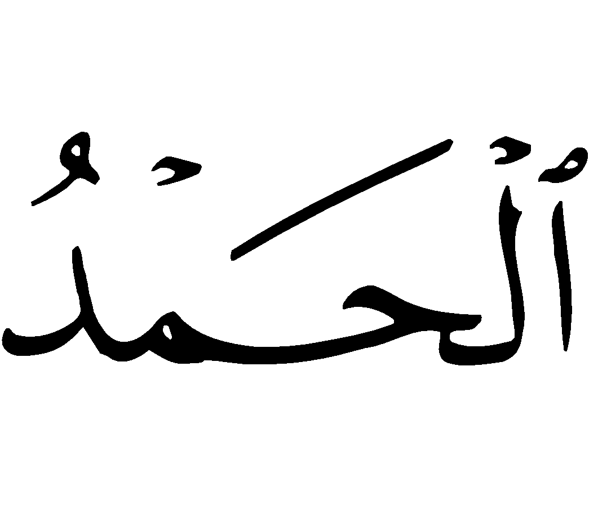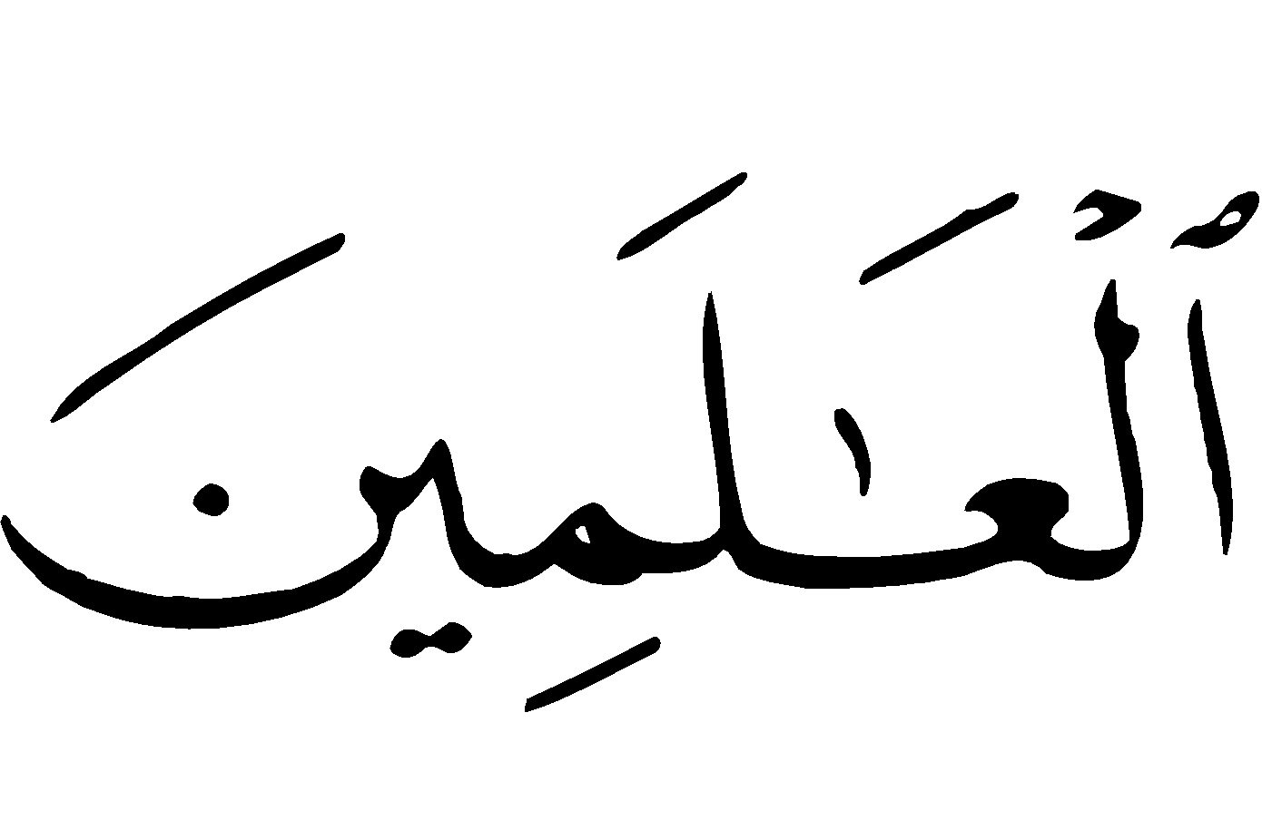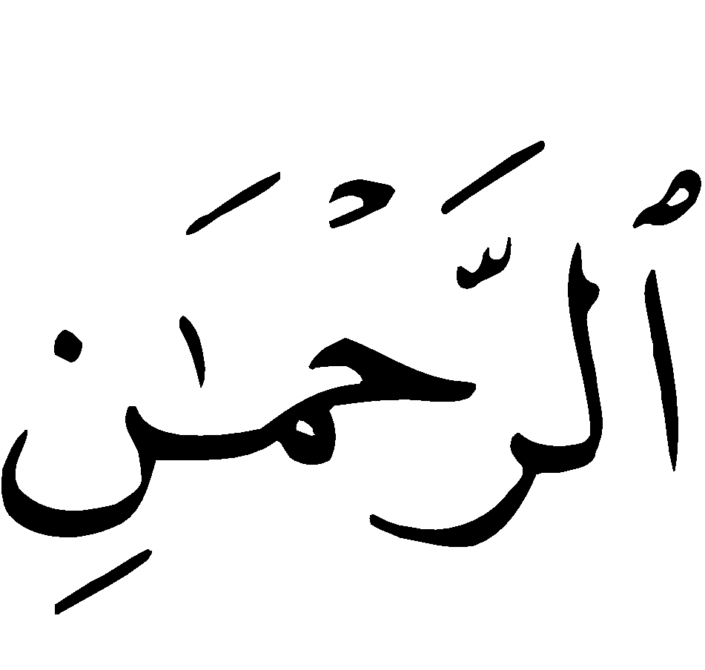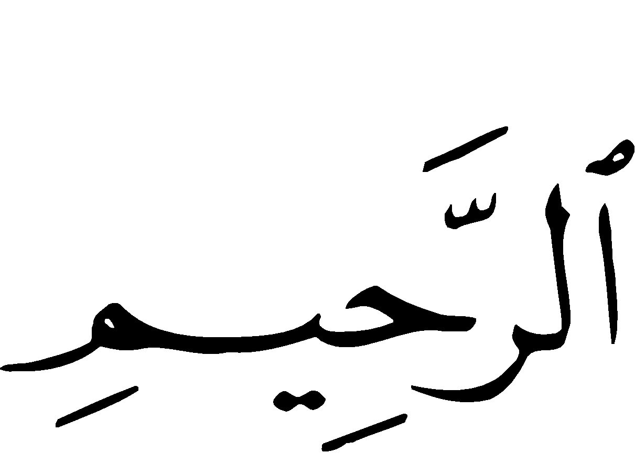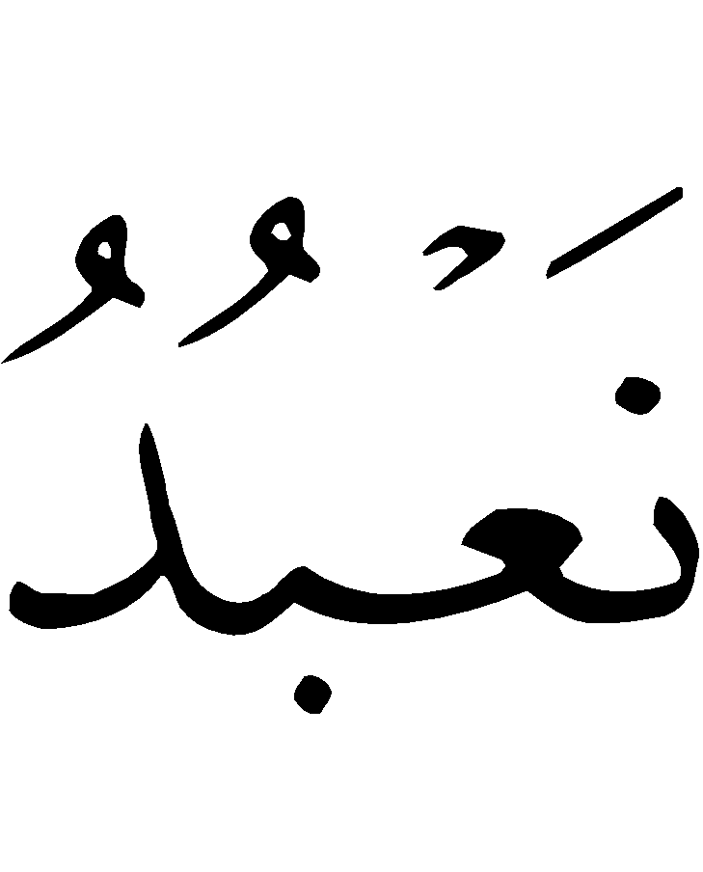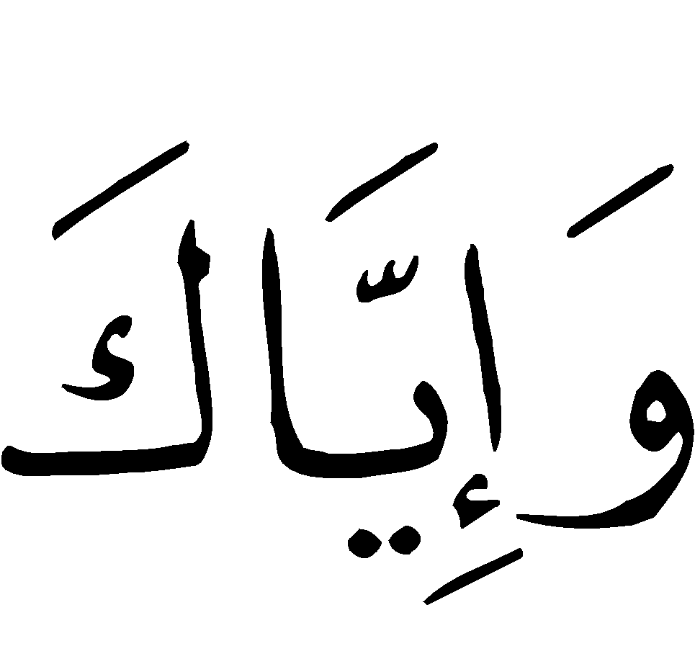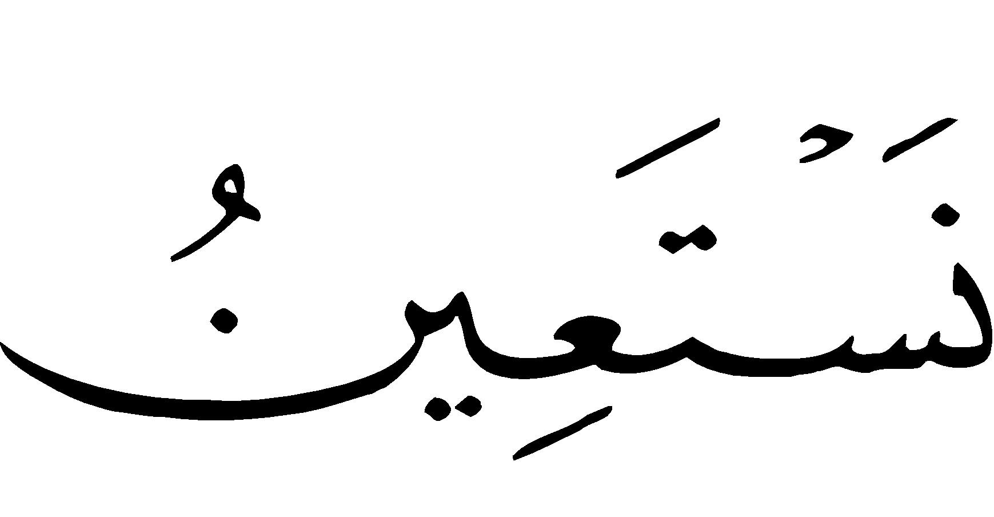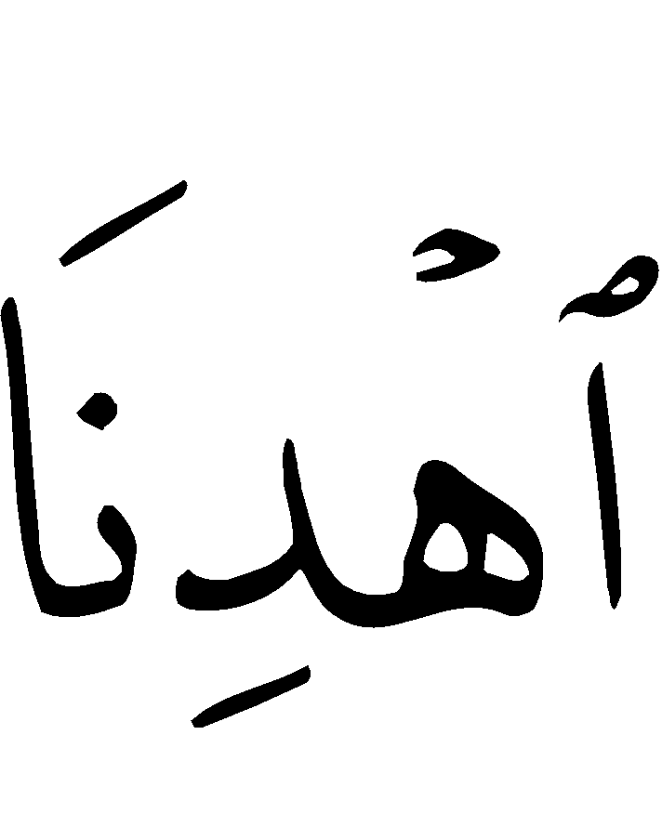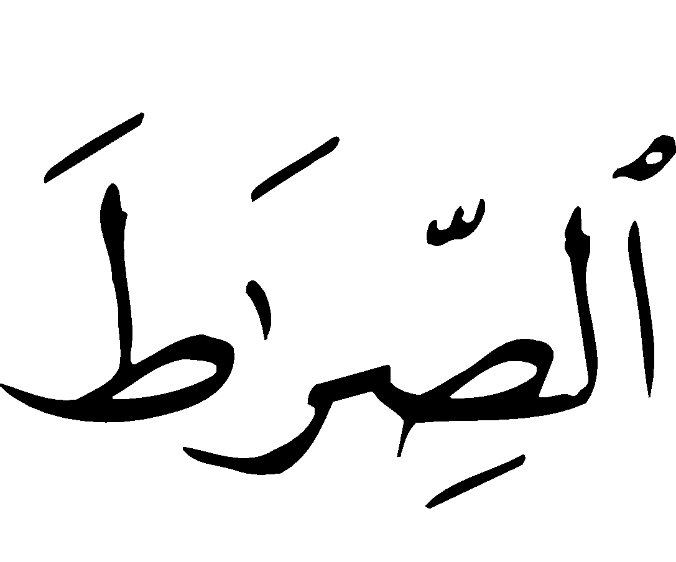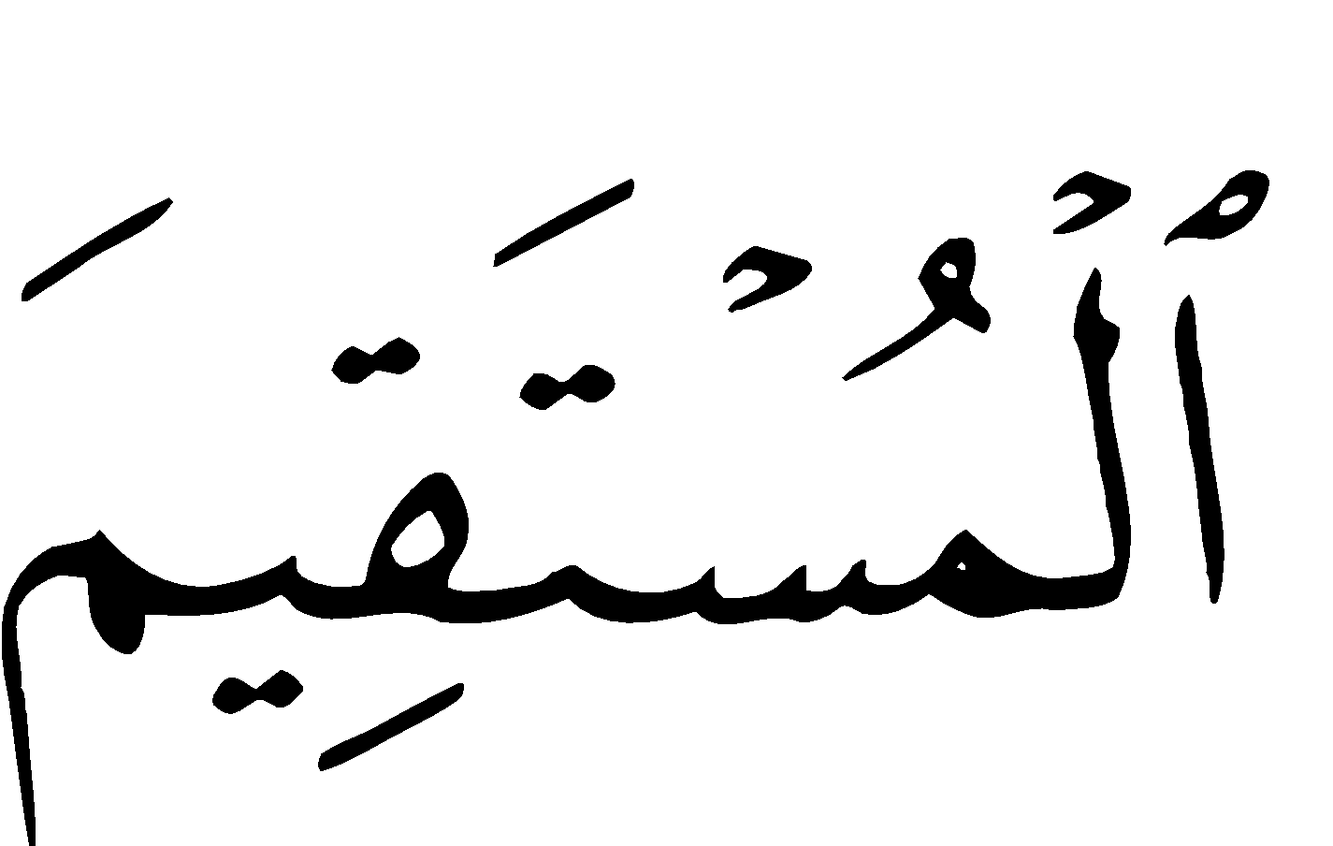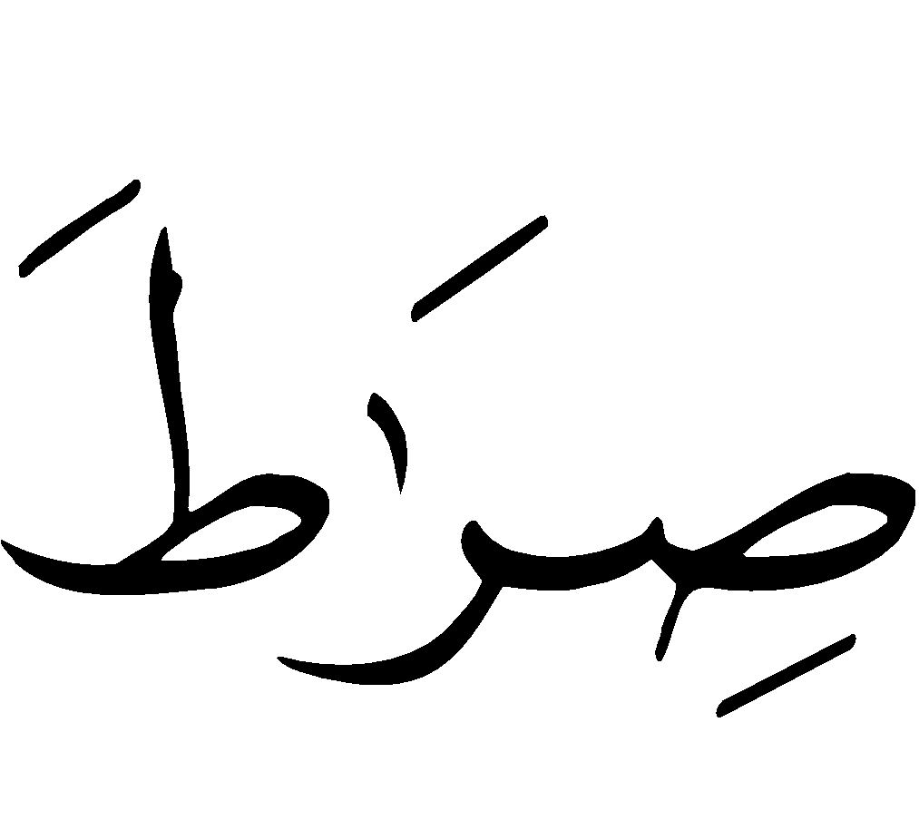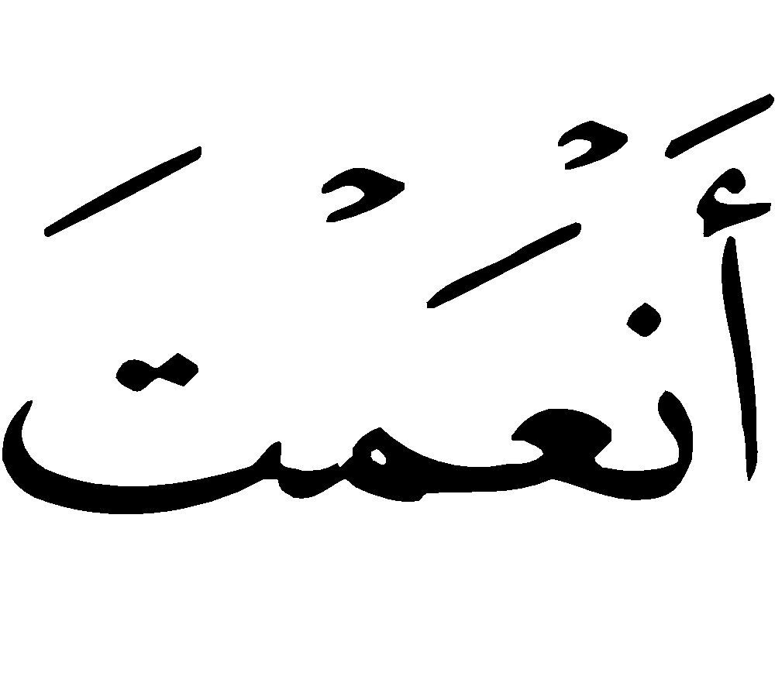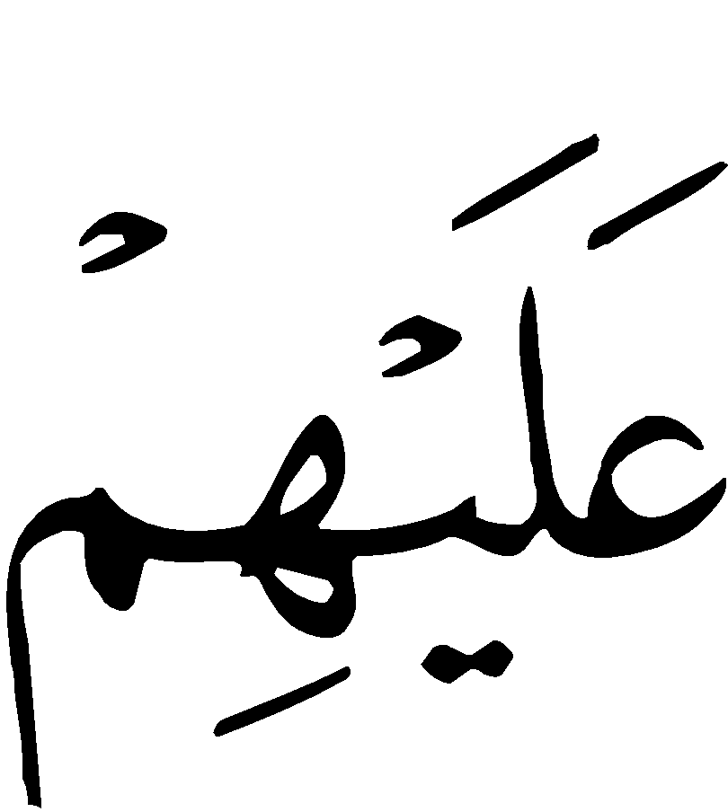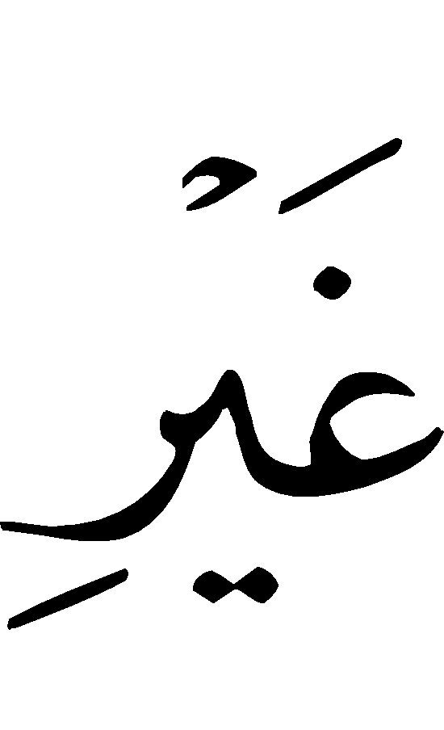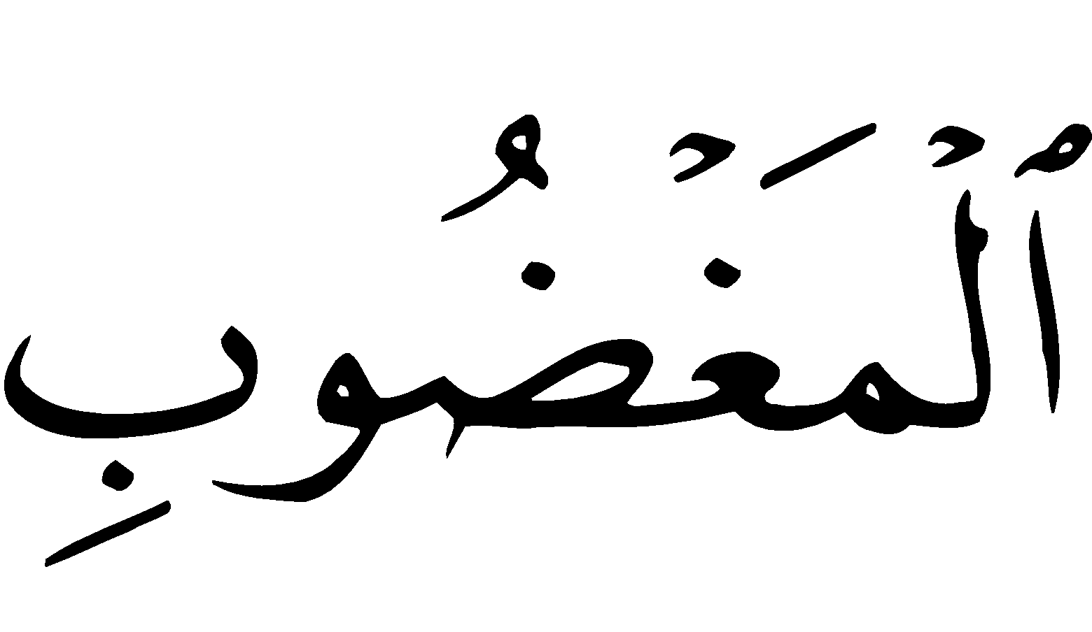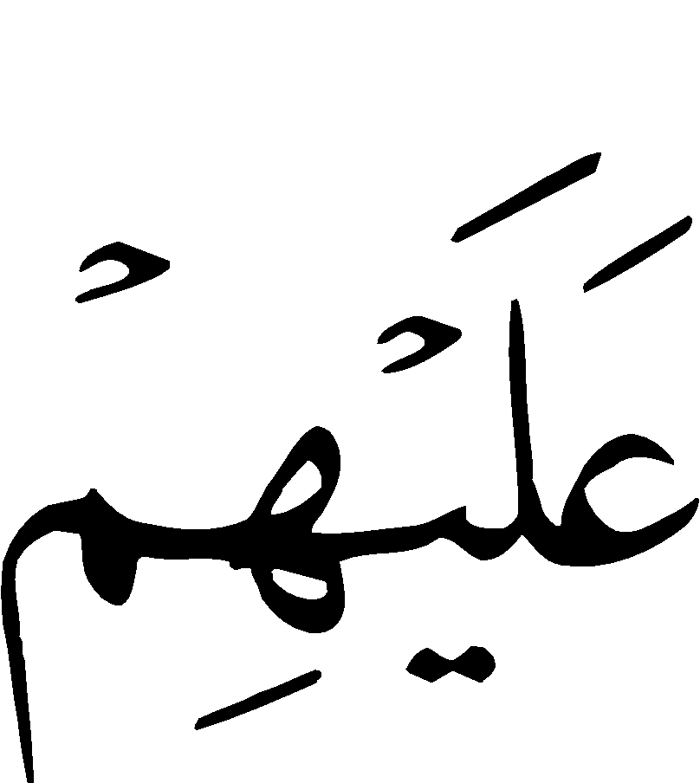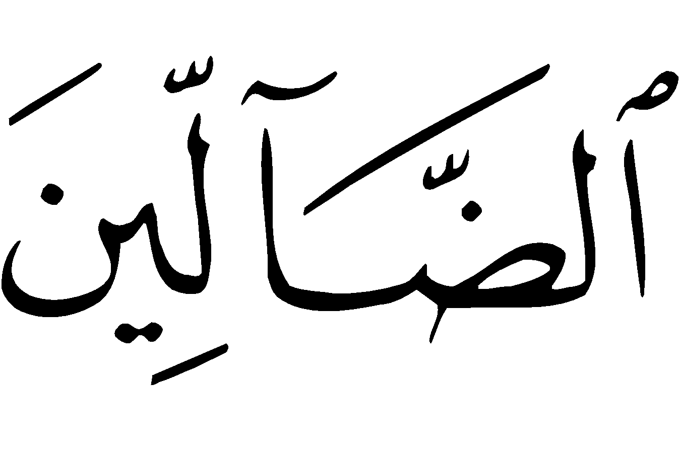
“Bismillaah ir-Rahmaan ir-Raheem. * Al-Hamdu lillaahi Rubb il-‘Aalameen. * Ar-Rahmaan ir-Raheem. * Maaliki yawm id-deen. * Eyyaaka na’budu wa eyyaaka nasta‘een. * Ihdinas-siraat al-mustaqeem. * Siraat al-ladheena an‘amta ‘alayhim. * Ghayr il-maghdoobi ‘alayhim wa lad-daalleen.”
“In the Name of Allah, the Most Beneficent, the Most Merciful. * All the praises and thanks be to Allah, the Lord of the 'Alamin (mankind, jinns and all that exists). * The Most Beneficent, the Most Merciful. * The Only Owner (and the Only Ruling Judge) of the Day of Recompense (i.e. the Day of Resurrection). * You Alone we worship, and You Alone we ask for help. * Guide us to the Straight Way. * The Way of those on whom You have bestowed Your Grace, not (the way) of those who earned Your Anger, nor of those who went astray.”

2) Surah al-Ikhlaas (The Purity 112:1-4)

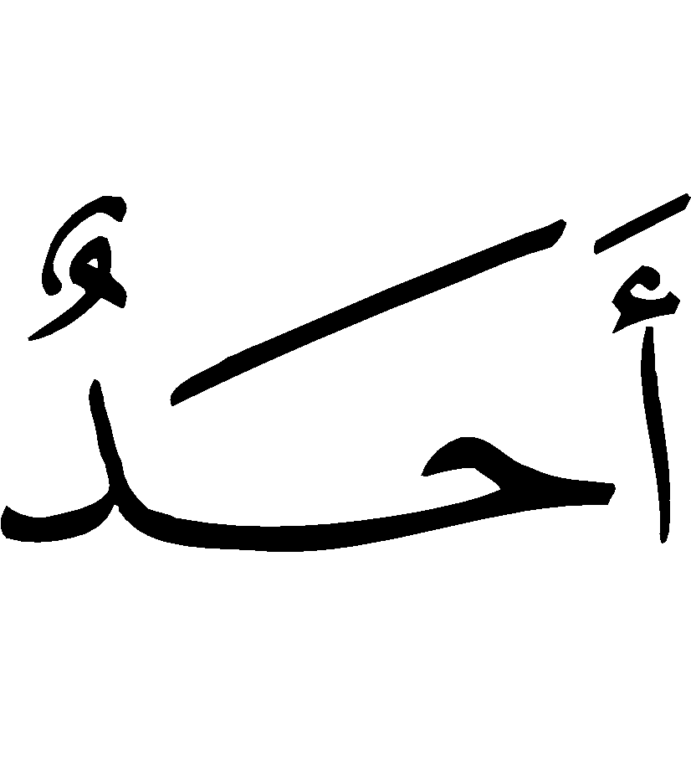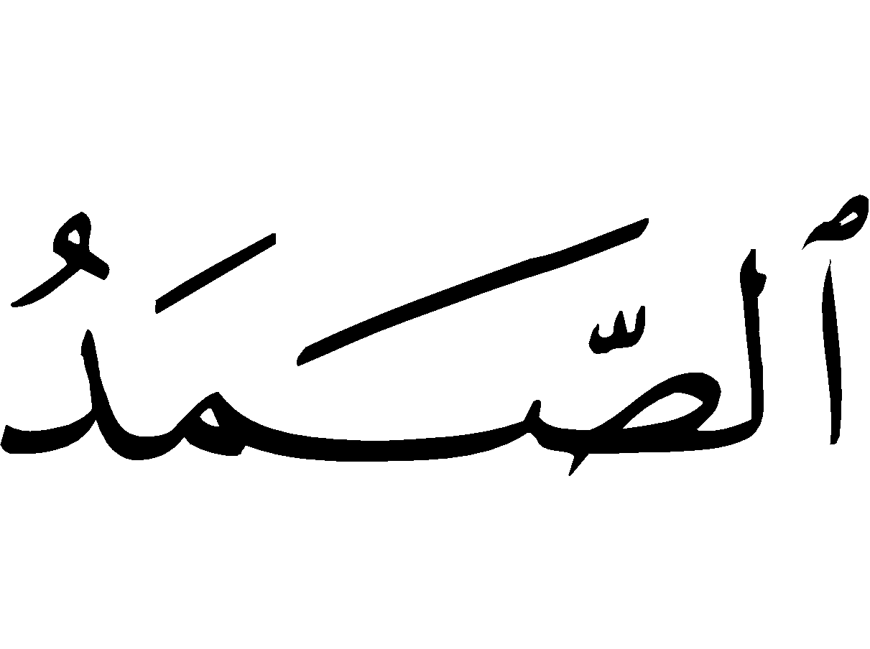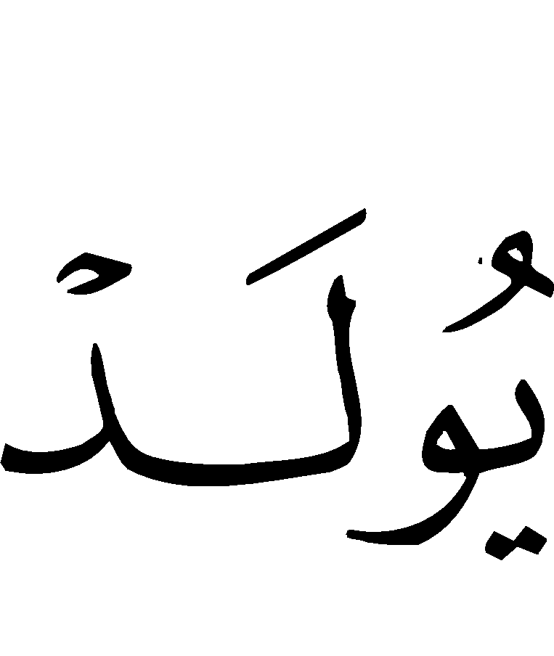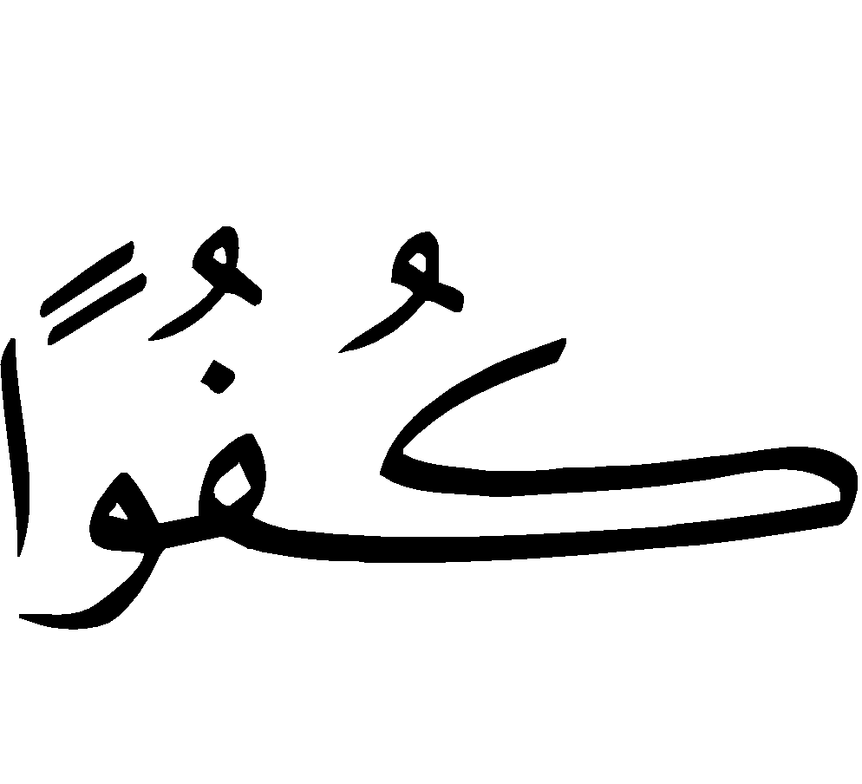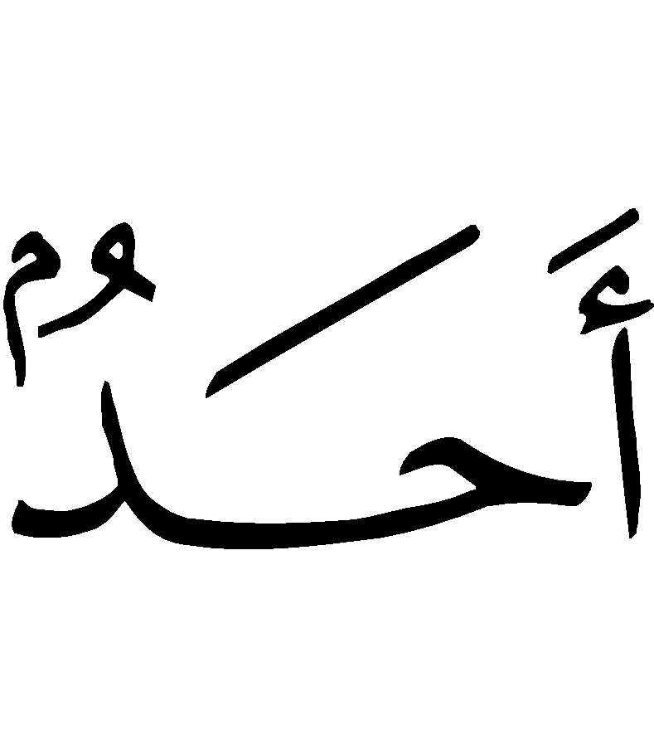
“Qul Huw-Allaahu Ahad. * Allaah us-Samad. * Lam yalid, walam yoolad. * Wa lam yakul-lahu kufuwan ahad.”
“Say [O Muhammad (Peace be upon him)]: He is Allah, [the] One. * Allah-us-Samad (The Self-Sufficient Master, Whom all creatures need while He is not in need of them). * He begets not, nor was He begotten. * And there is none co-equal or comparable unto Him.”

3) Surah al-Falaq (The Daybreak 113:1-5)

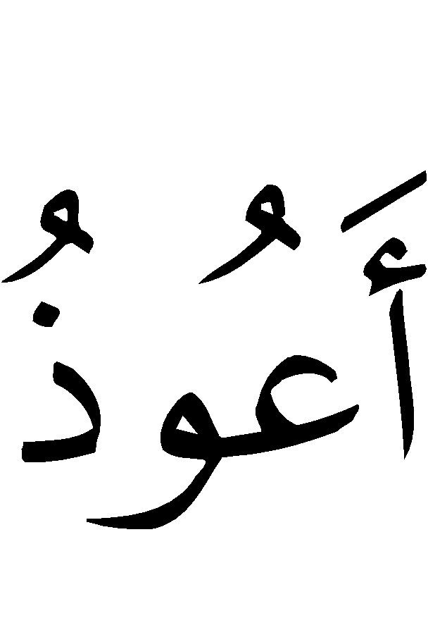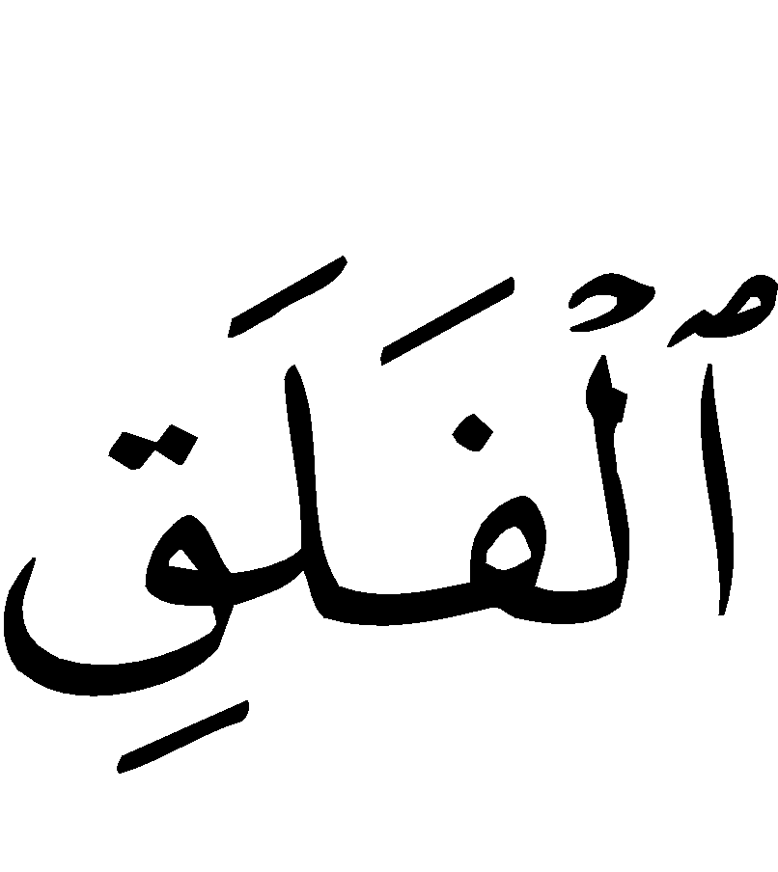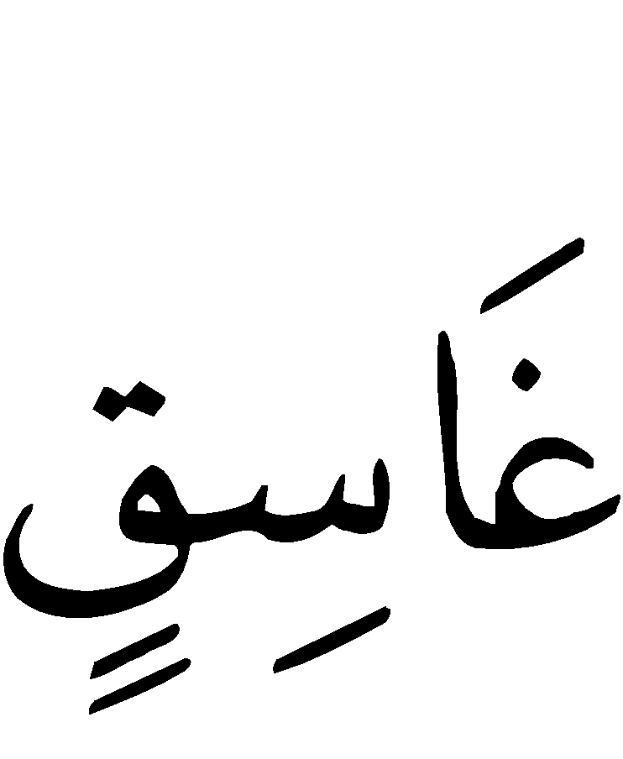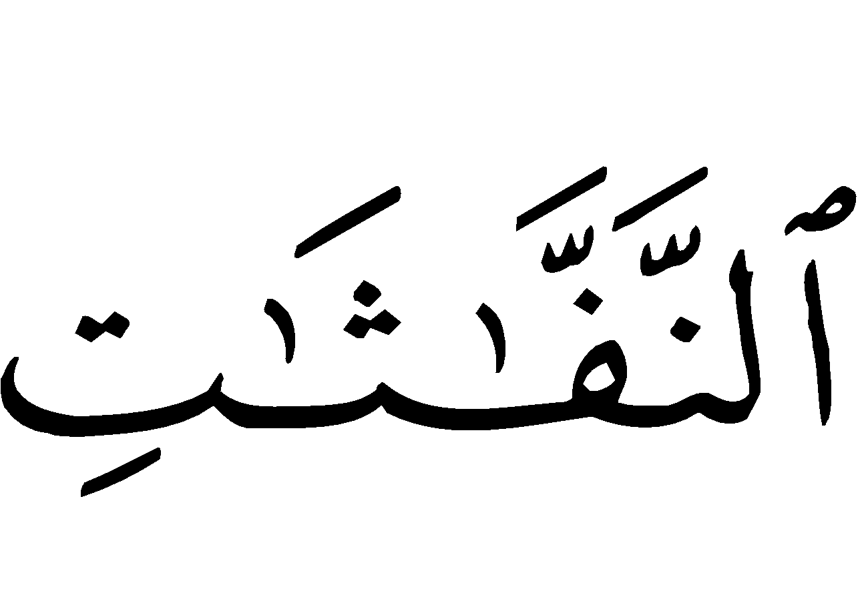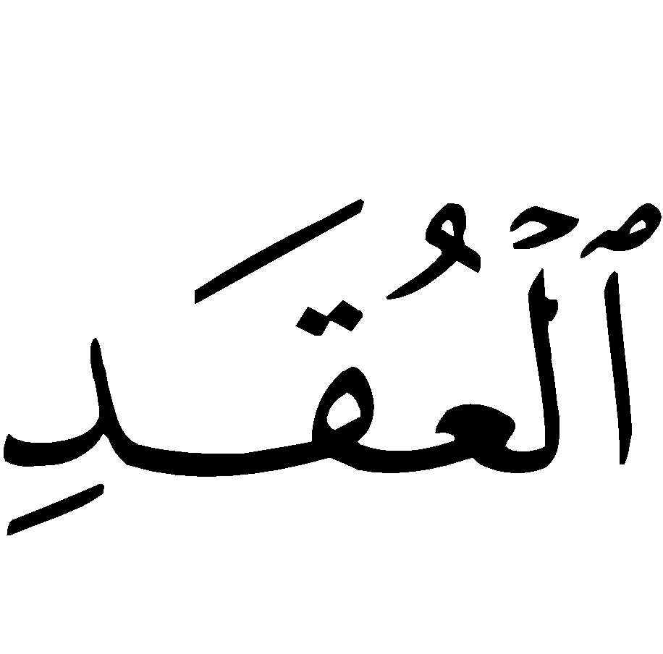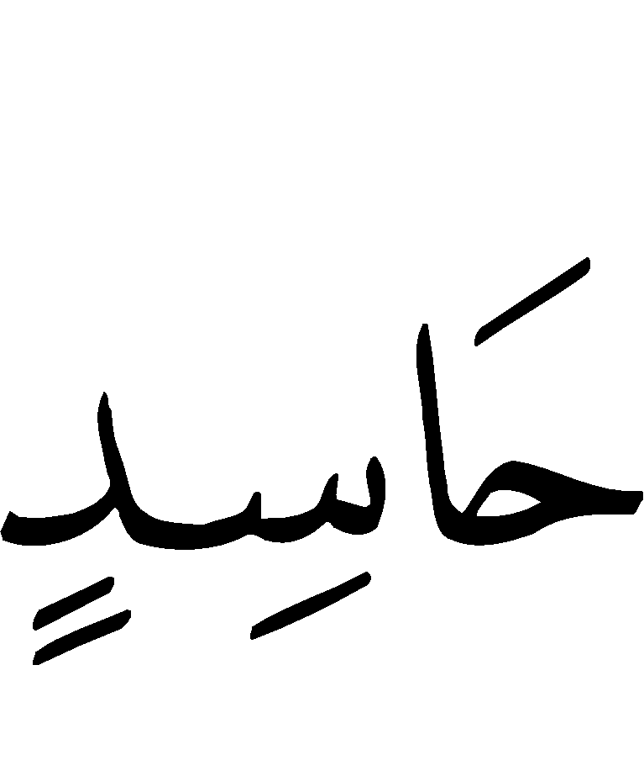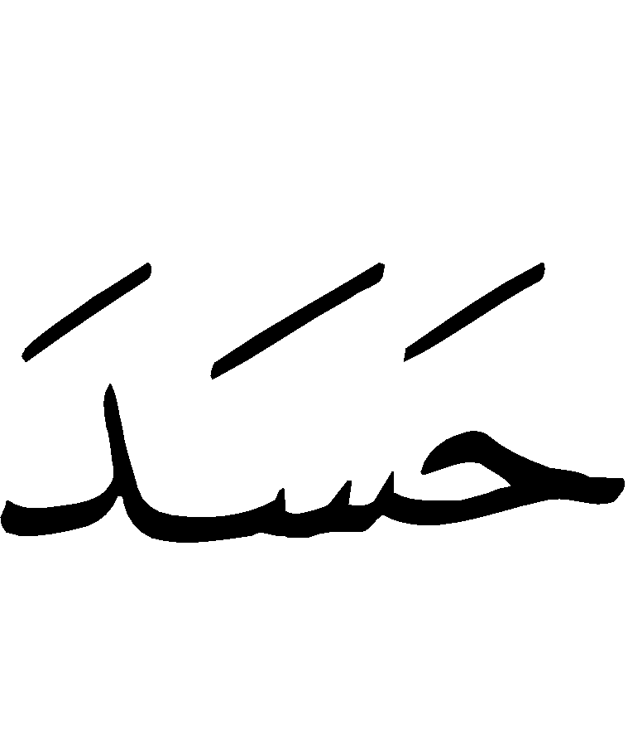
“Qul a‘oodhu bi Rabb-il-falaq. * Min sharri maa khalaq. * Wa min sharri ghaasiqin idhaa waqab. * Wa min sharrin-naffaathaati fil-‘uqad. * Wa min sharri haasidin idhaa hasad.”
“Say: I seek refuge with [Allah] the Lord of the daybreak. * From the evil of what He has created. * And from the evil of the darkening (night) as it comes with its darkness (or the moon as it sets or goes away). * And from the evil of the witches when they blow in the knots; and from the evil of the envier when he envies.”

4) Surah an-Naas (Mankind 114:1-6)

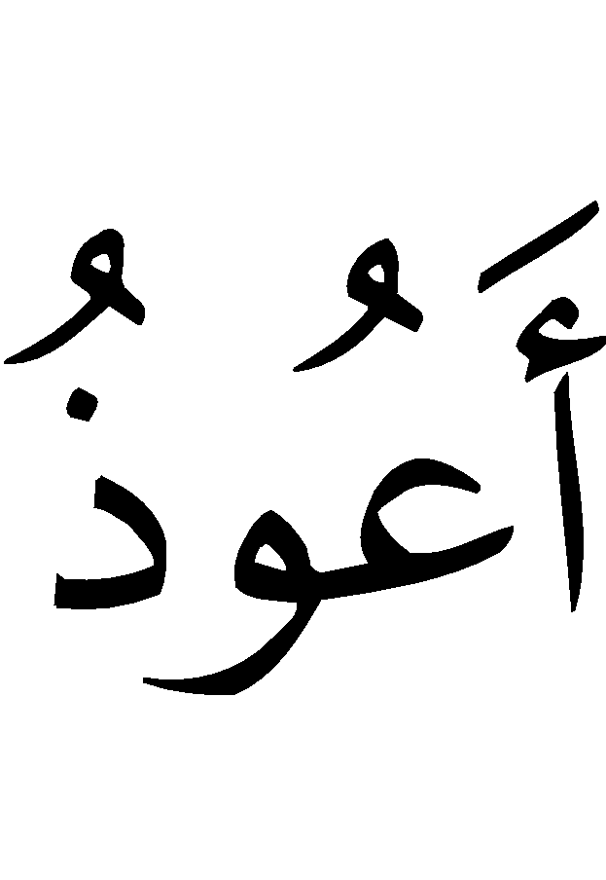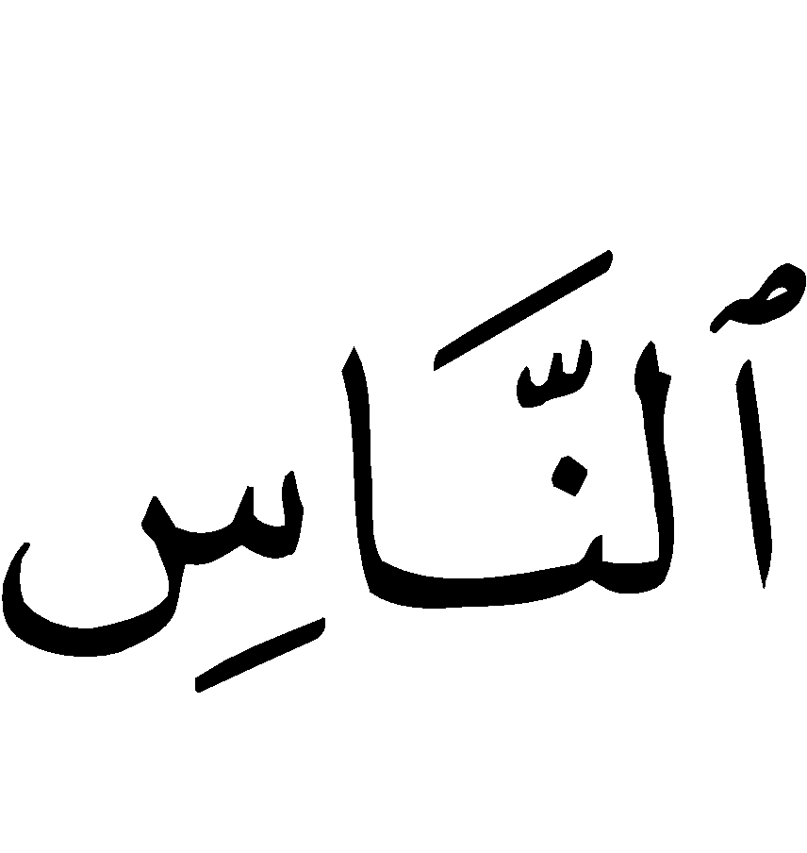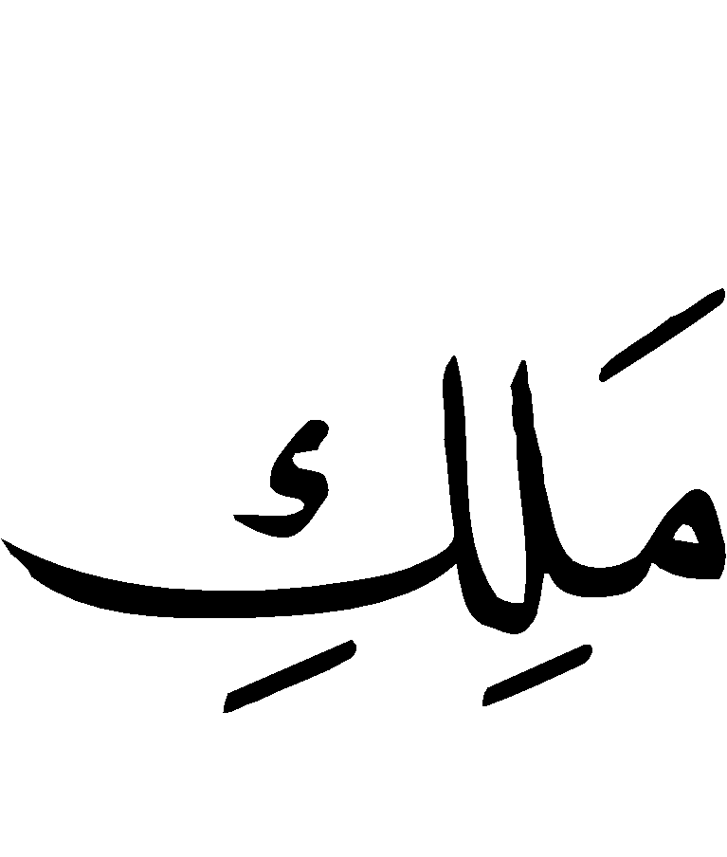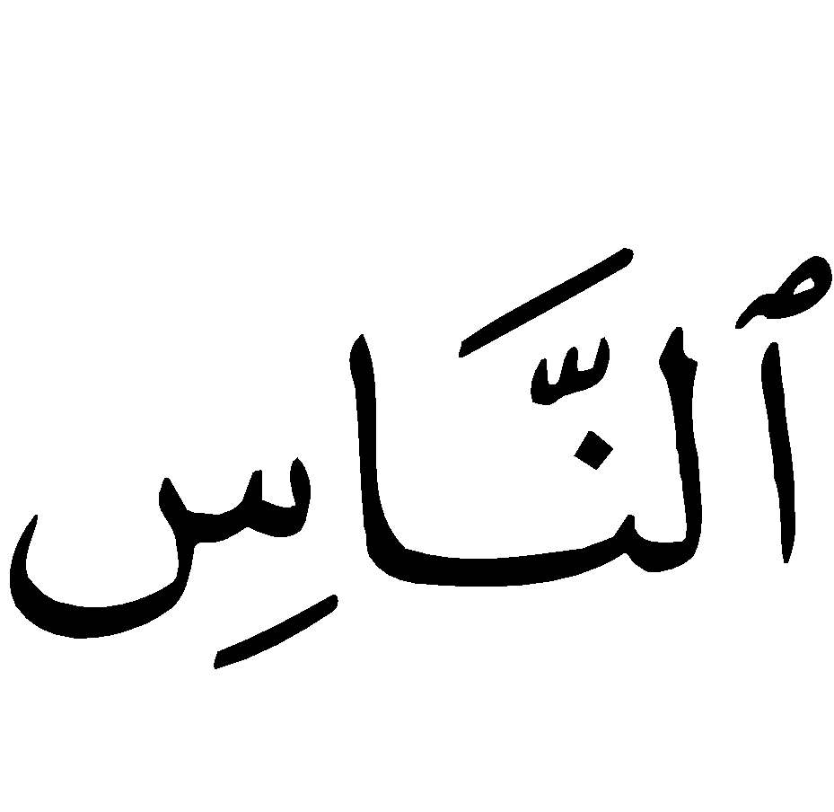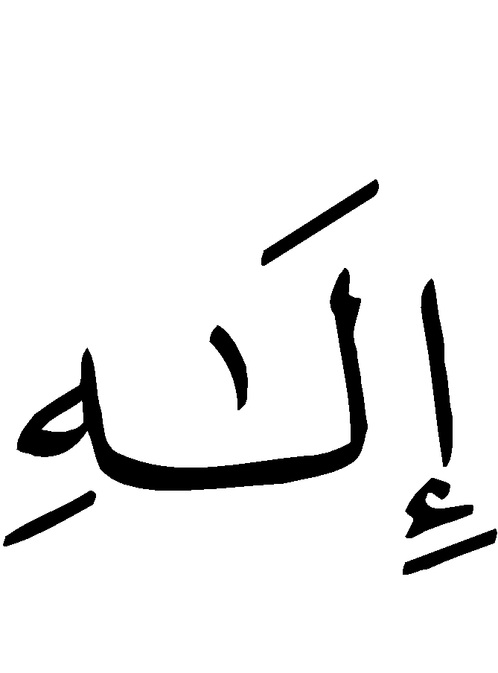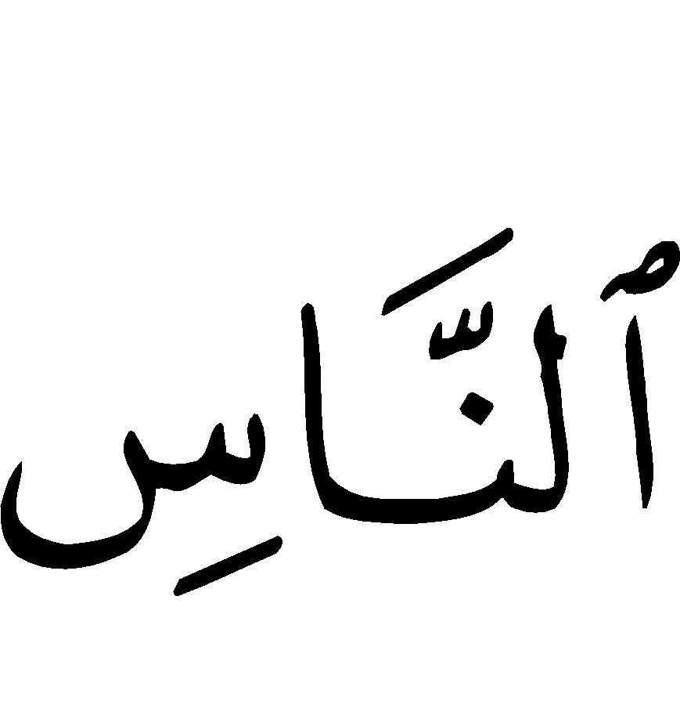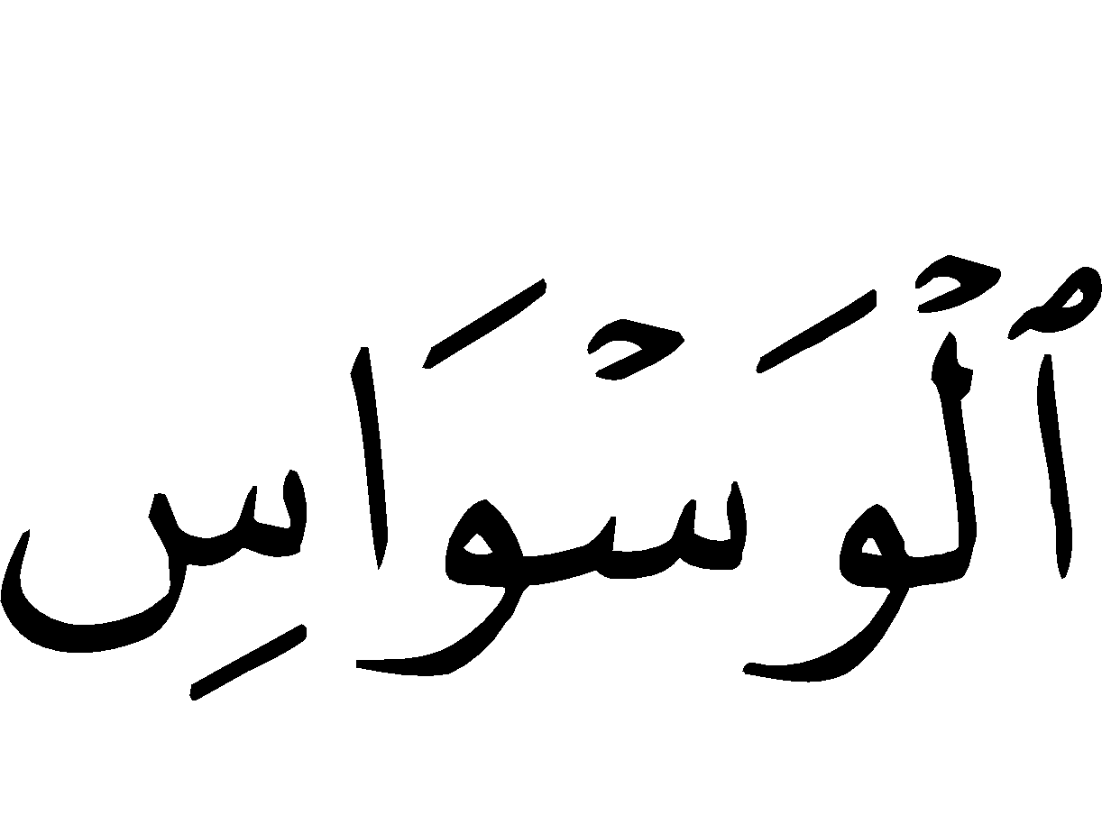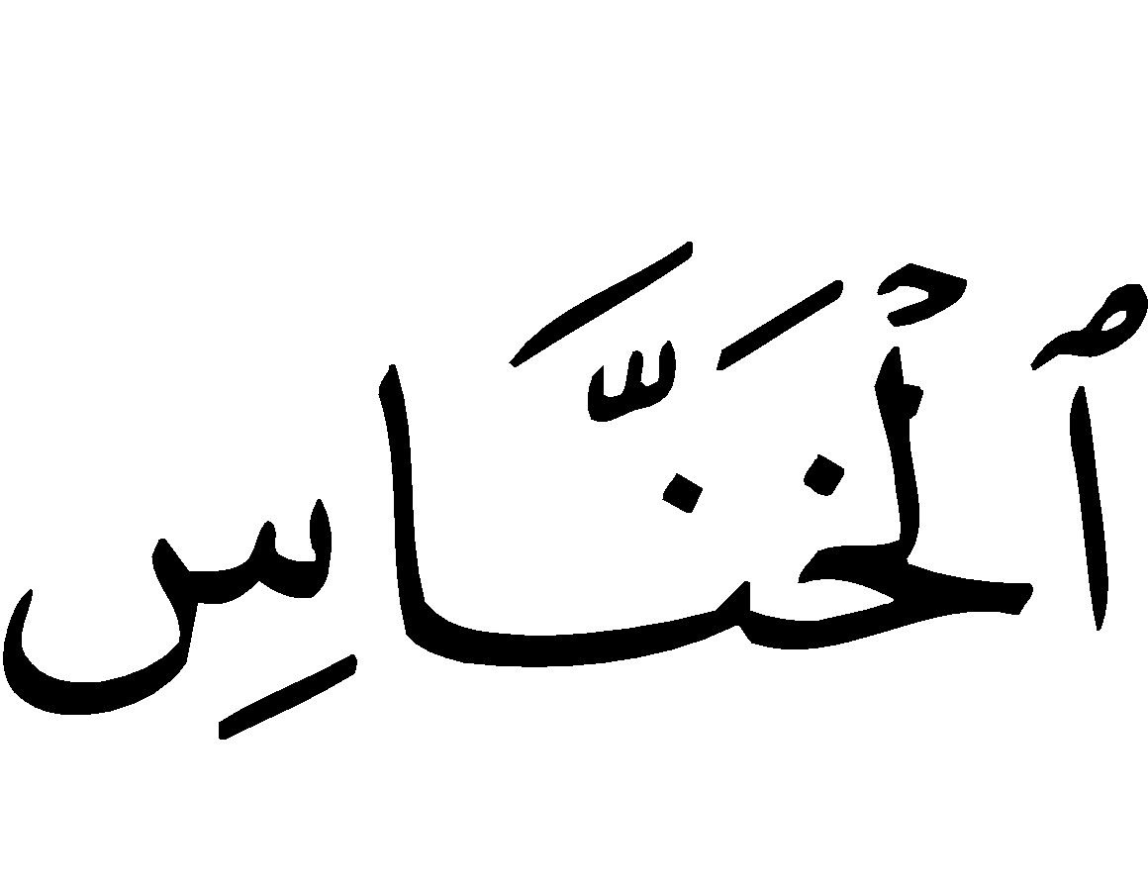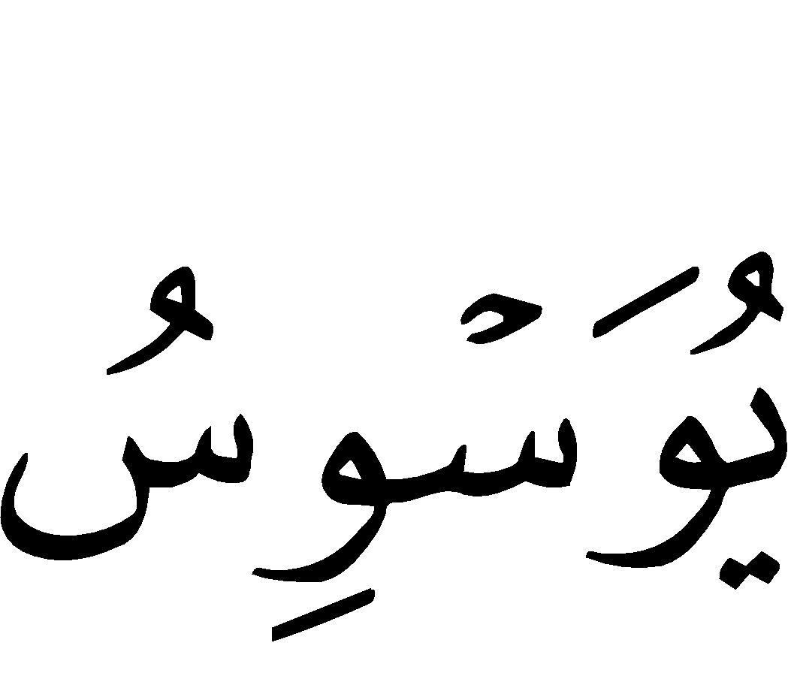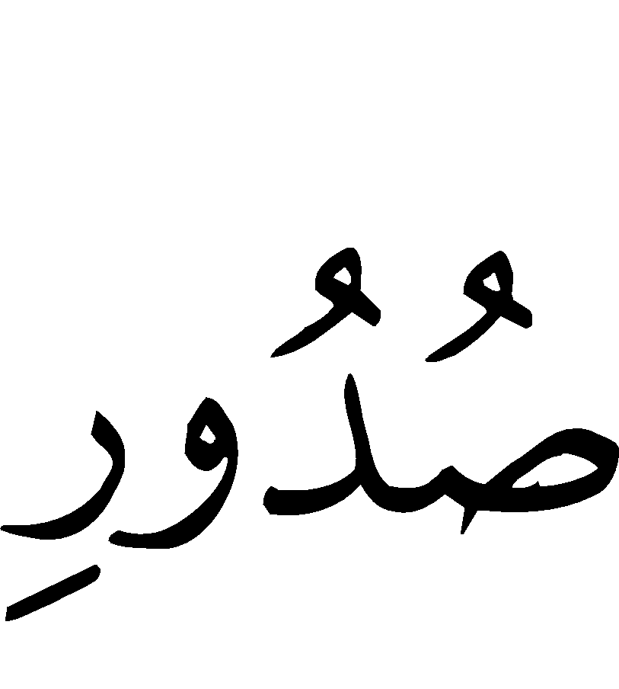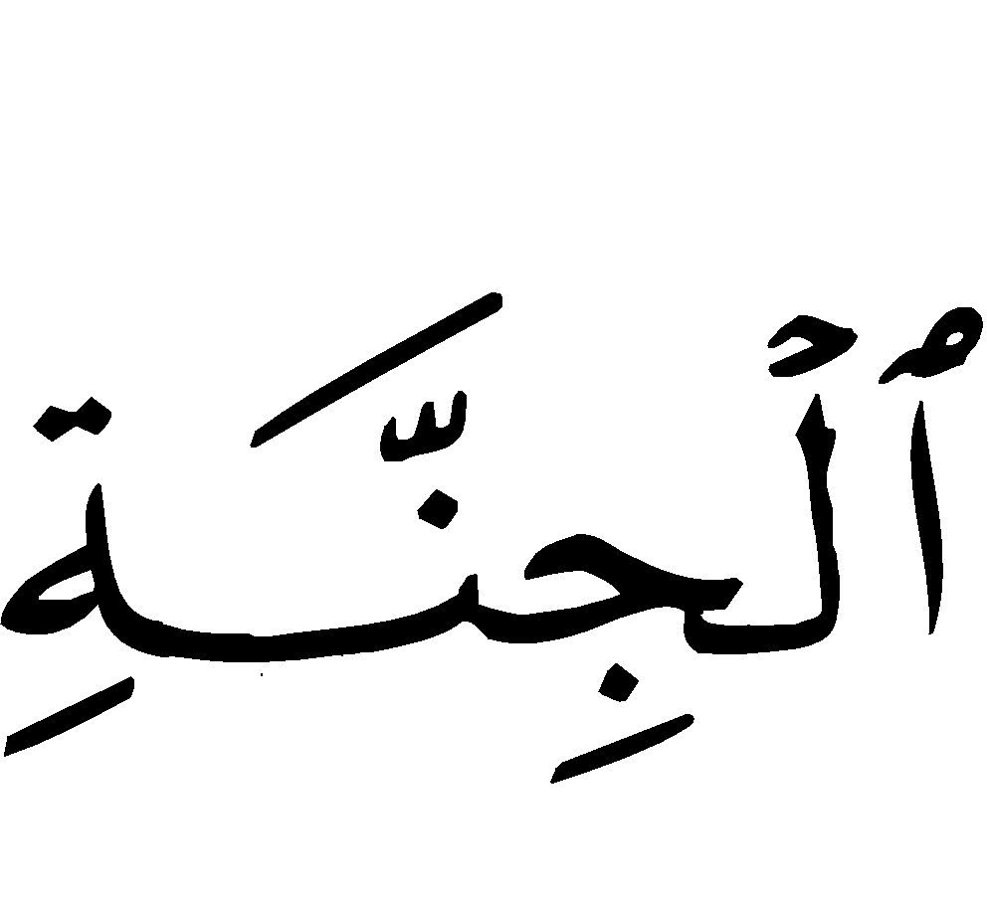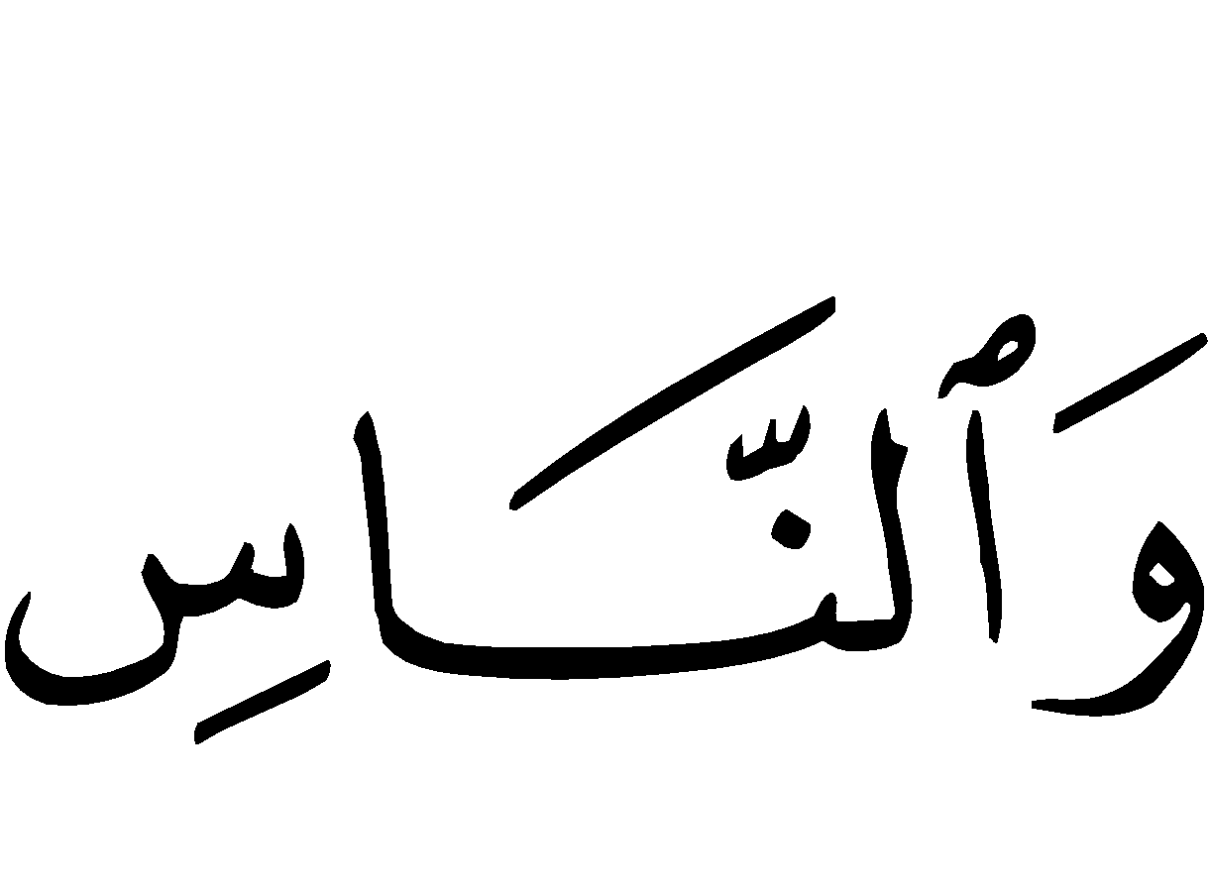
“Qul a‘oodhu bi Rabb in-naas. * Malik in-naas. * Ilaah in-Naas. * Min sharr il-waswaas il-khannaas. * Aladhi yuwaswisu fee sudoor in-naas. * Min al-jinnati wan-naas.”
“Say: I seek refuge with [Allah] the Lord of mankind. * The King of mankind. * The deity of mankind. * From the evil of the whisperer (devil who whispers evil in the hearts of men) who withdraws [from his whispering in ones heart after one remembers Allah]. * Who whispers in the breasts of mankind. Of jinns and men.”

5) Surah al-Kawthar (108:1-3)

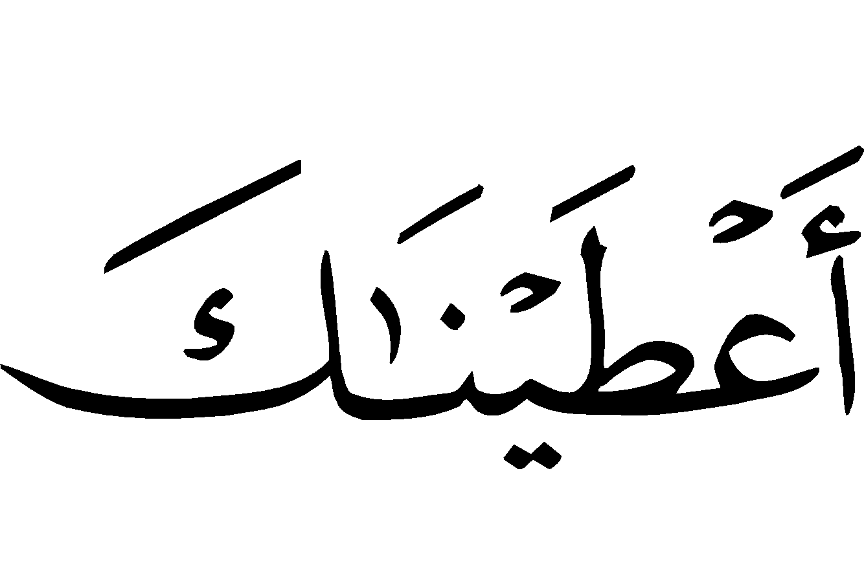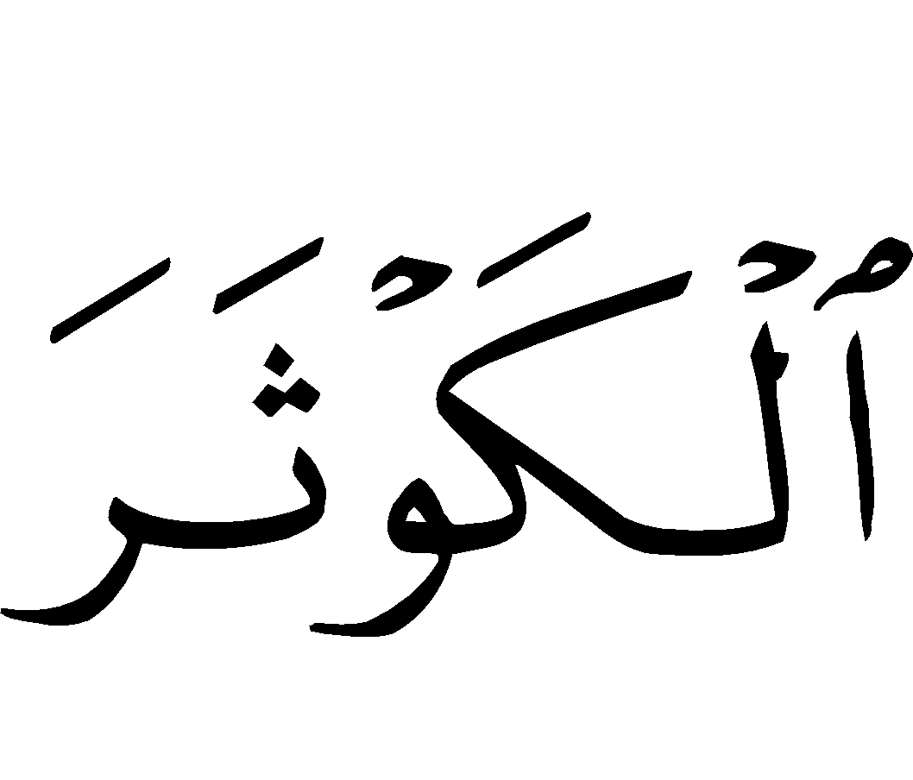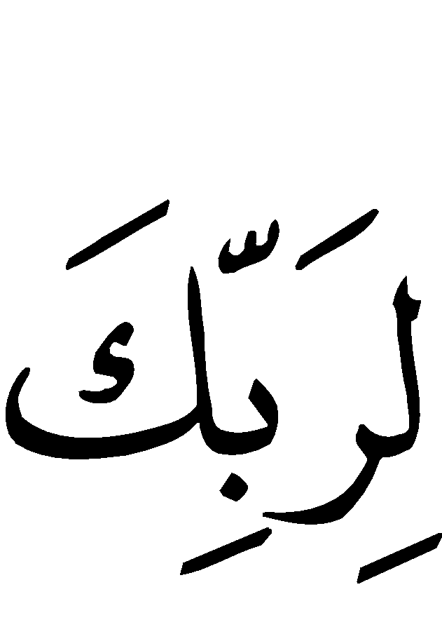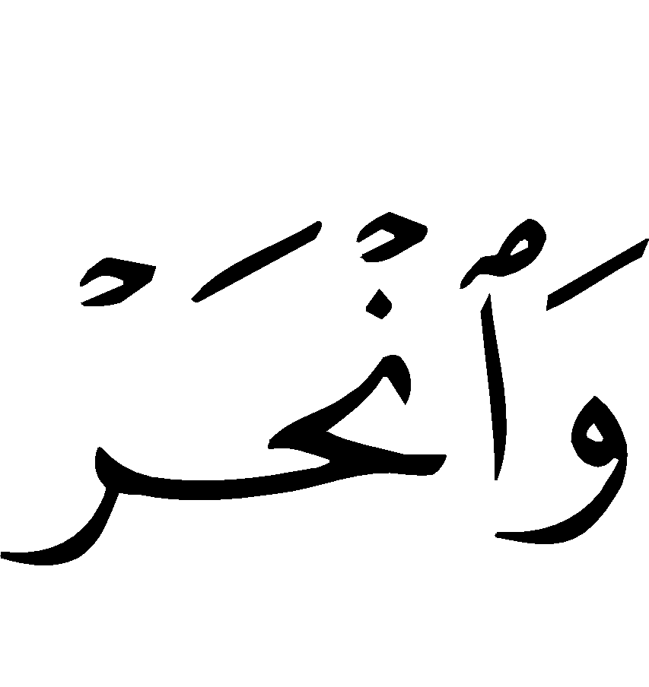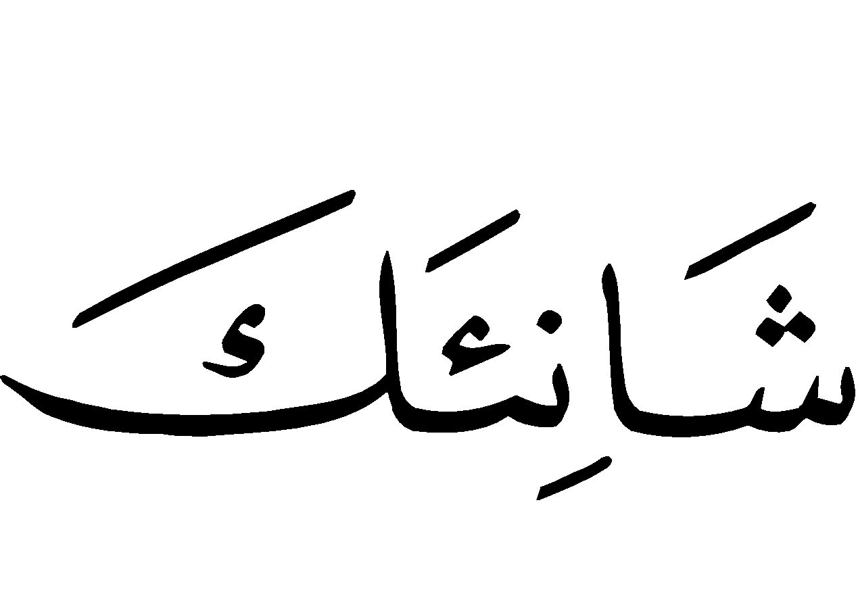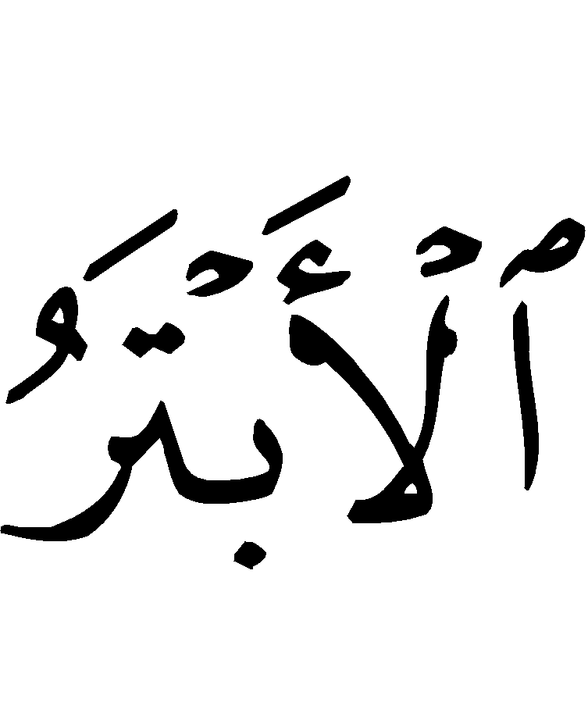
“Innaa a’taynaa kal-kawthar. * Fa salli li rubbika wanhar. * Inna shaani`aka huw al-abtar.”
“Verily We have granted you (O Muhammad ) al-Kawthar (a river in Paradise). Therefore turn in prayer to your Lord only and sacrifice. For he who makes you angry (O Muhammad ) he will be cut off (from every good thing in this world and in the Hereafter).”

6) Surah al-‘Asr (Time: 103:1-3)

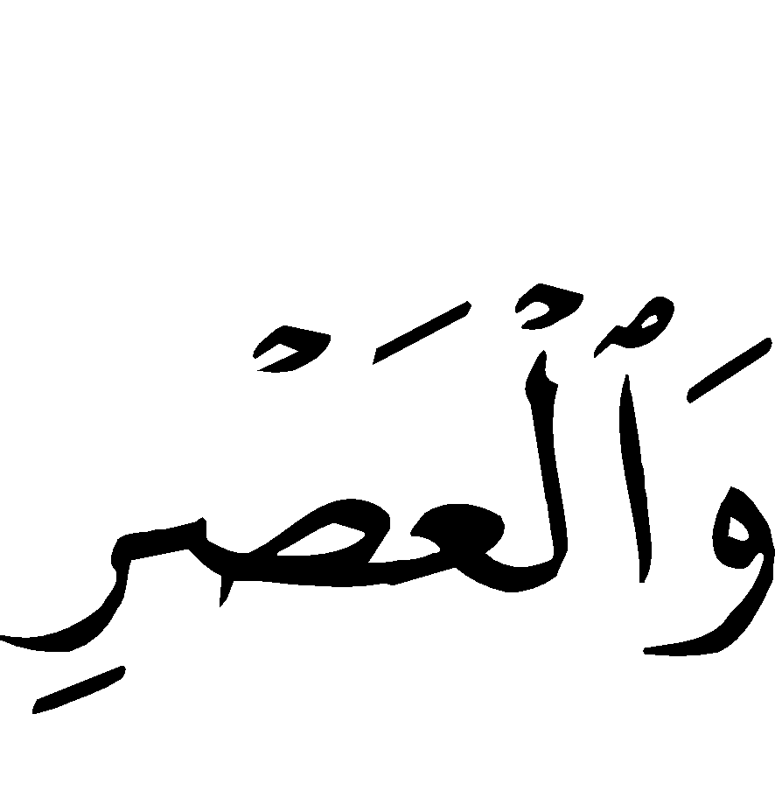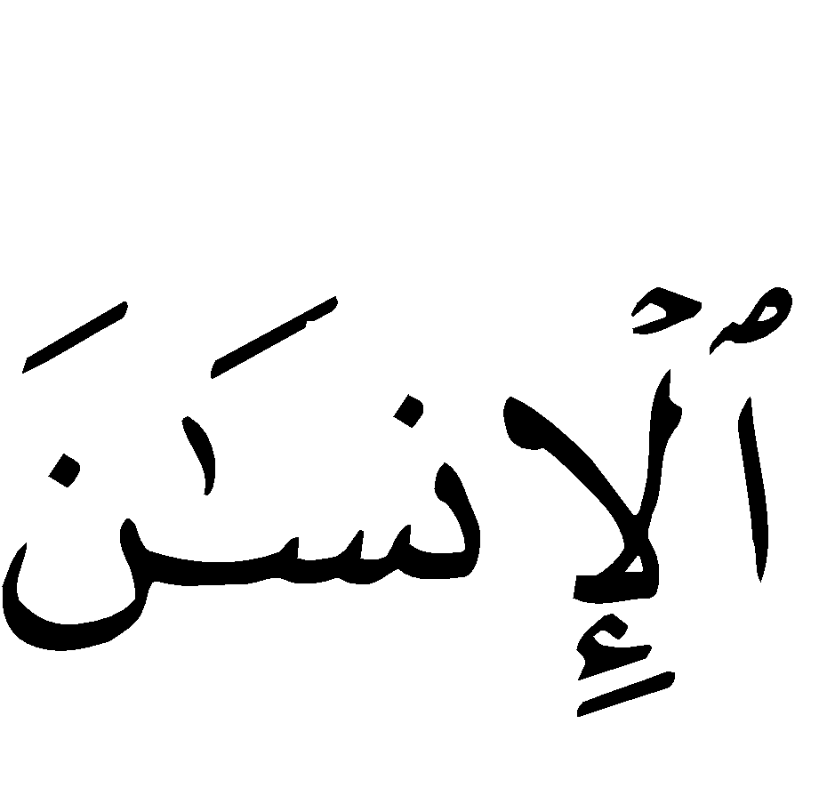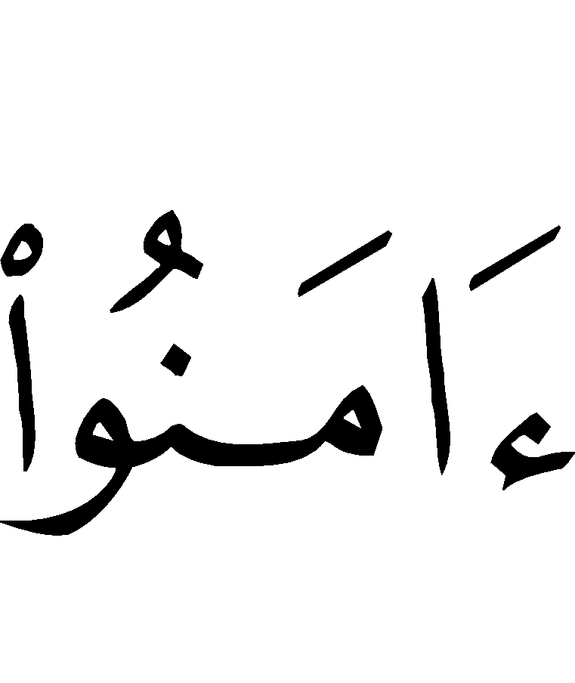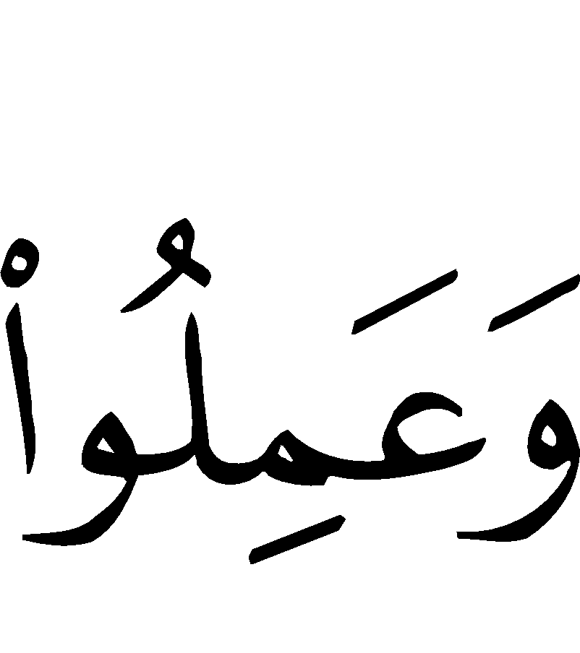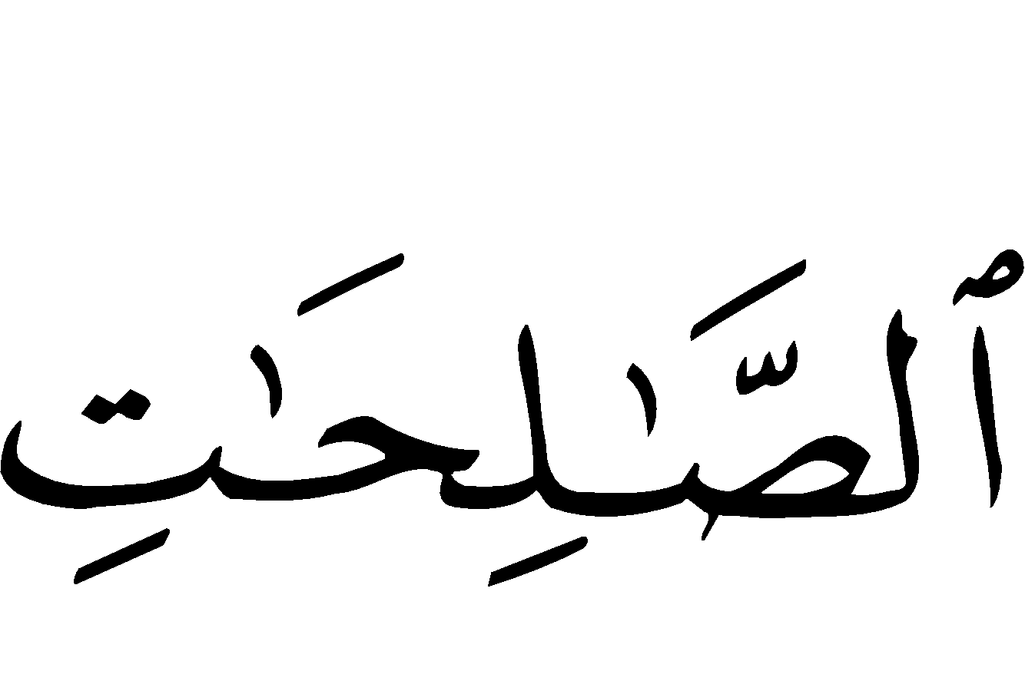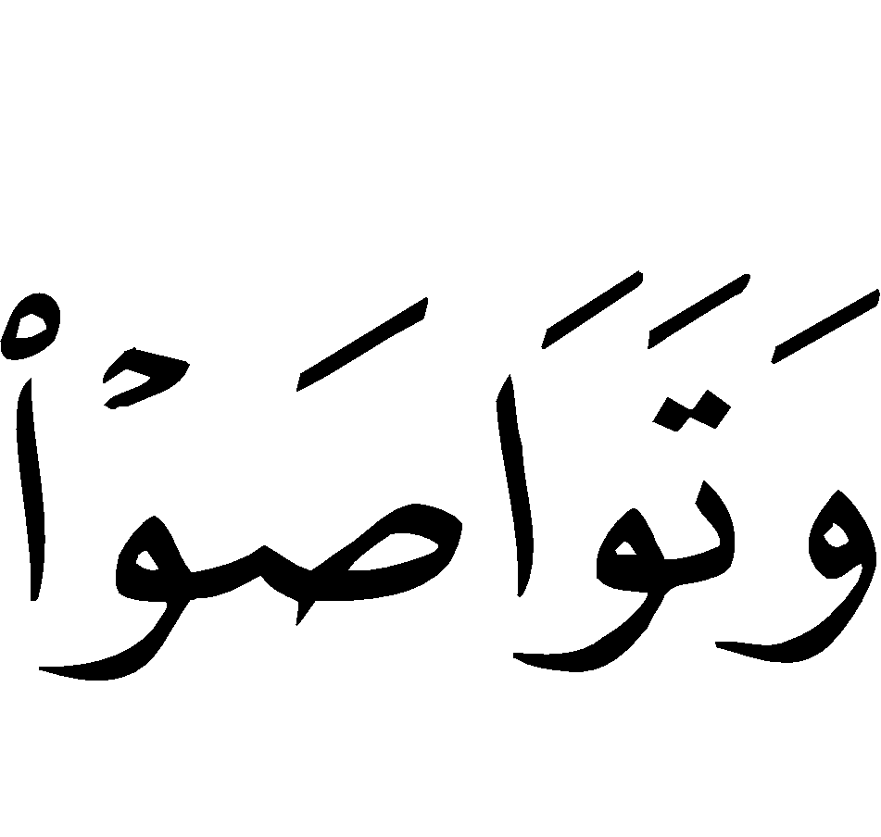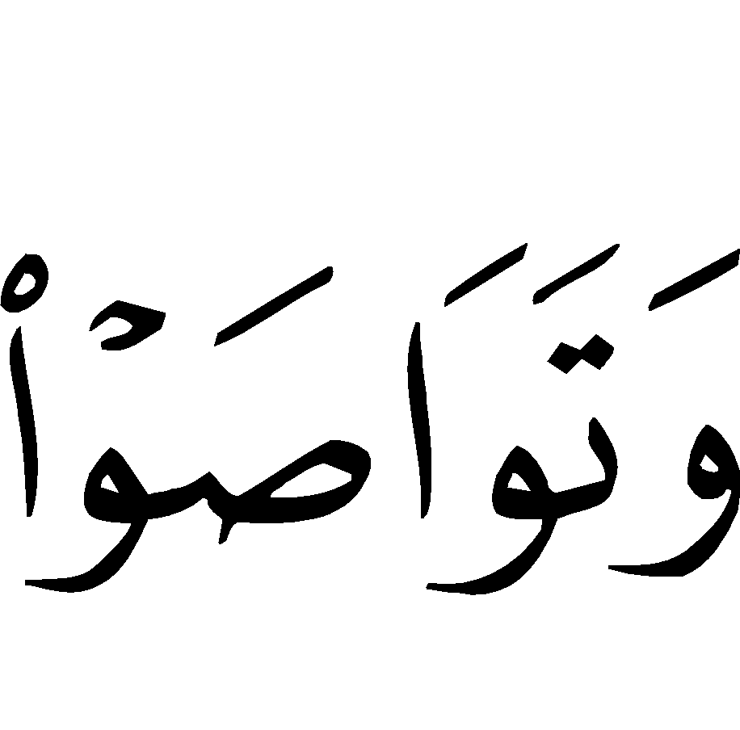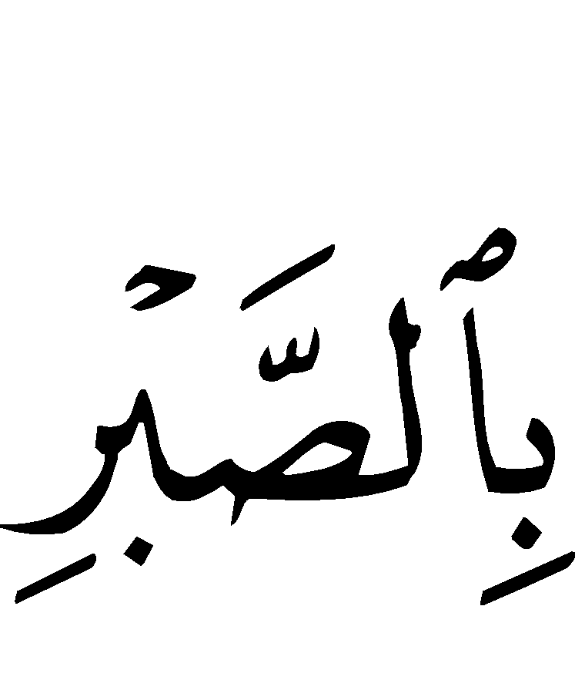
“Wal-‘Asr. * Innal-insaana la fee khusr. * Illalladheena aamanoo wa ‘amil us-saalihaati wa tawaasaw bil-haqqi wa tawaasaw bis-sabr.”
“By Al-‘Asr (the time). Verily! Man is in loss. Except those who believe (in Islamic Monotheism) and do righteous good deeds, and recommend one another to the truth and recommend one another to patience.”

7) Ayat-ul-Kursi (The Verse of the Pedestal) [Surah al-Baqarah (The Cow (2):255]
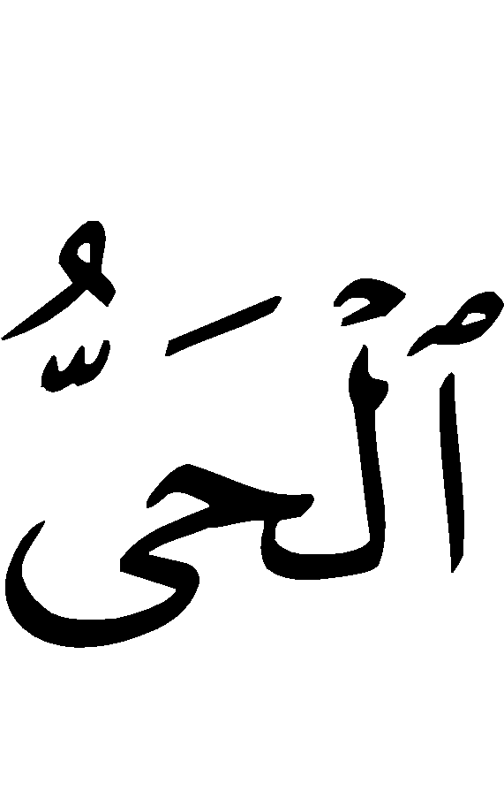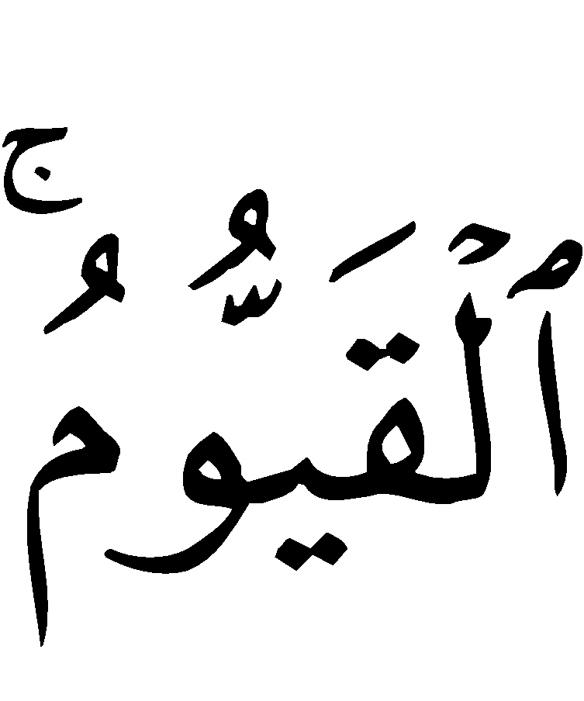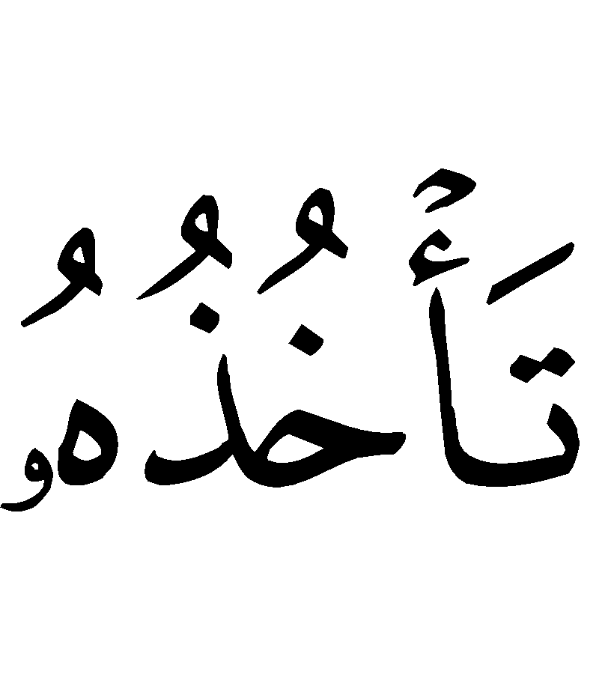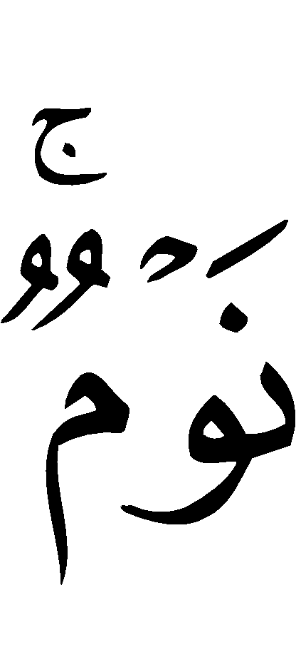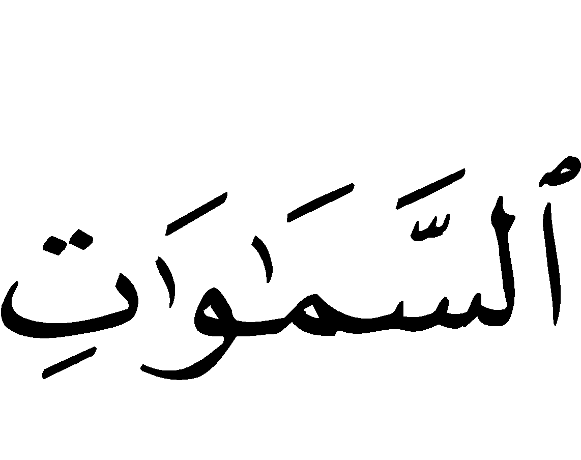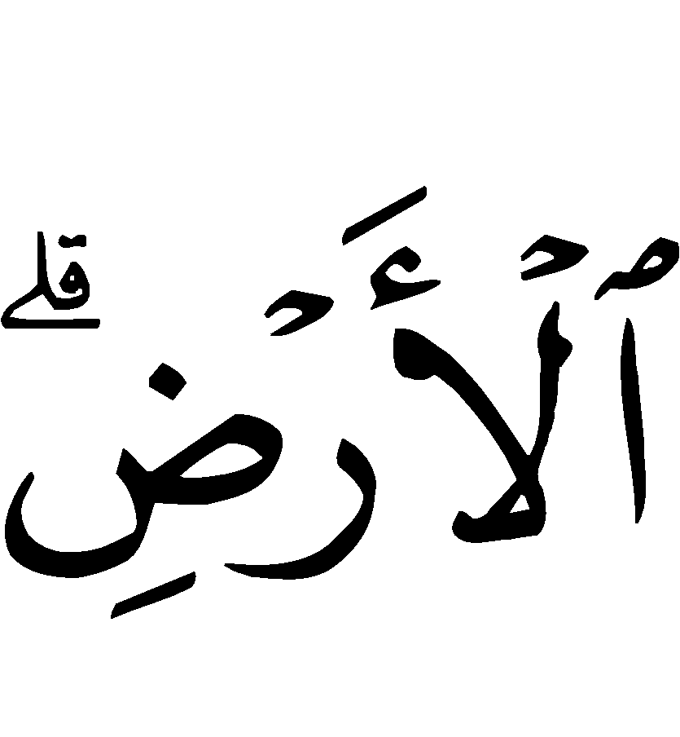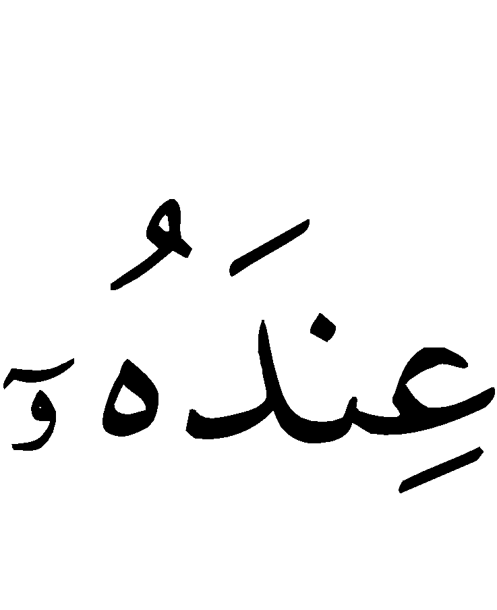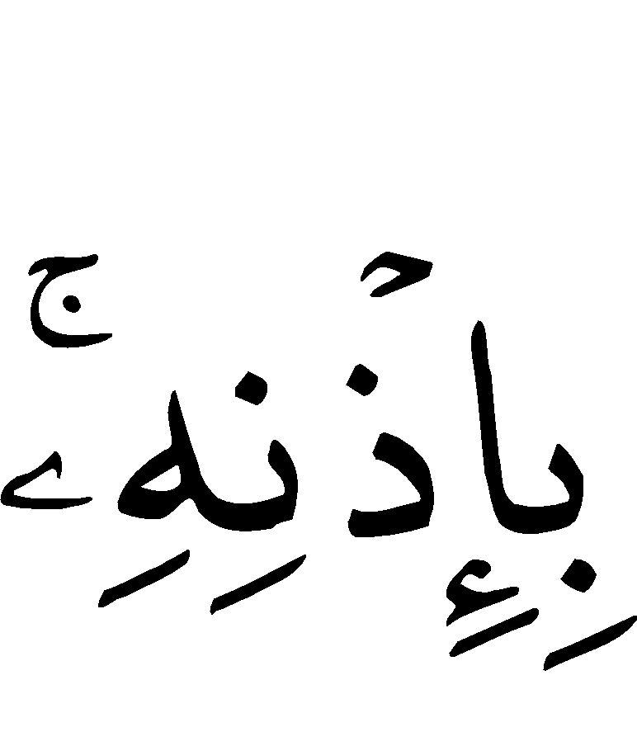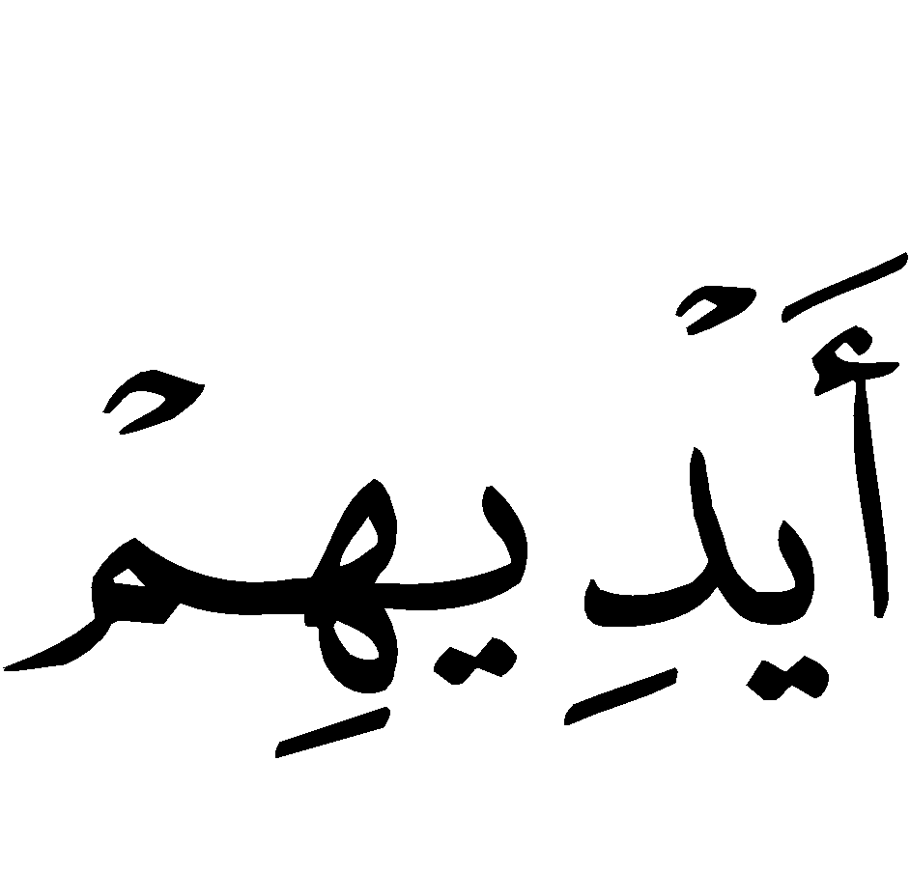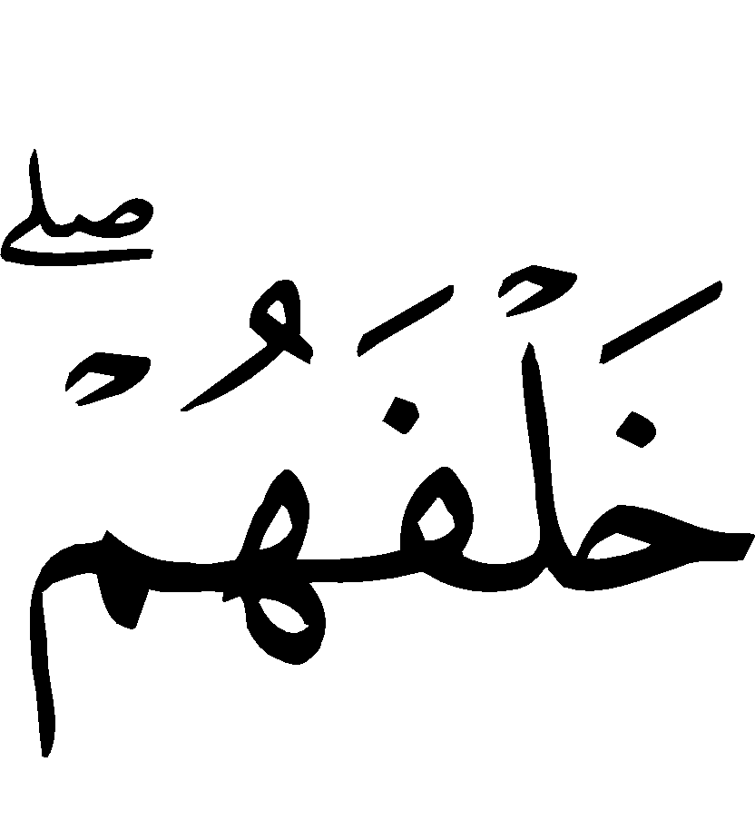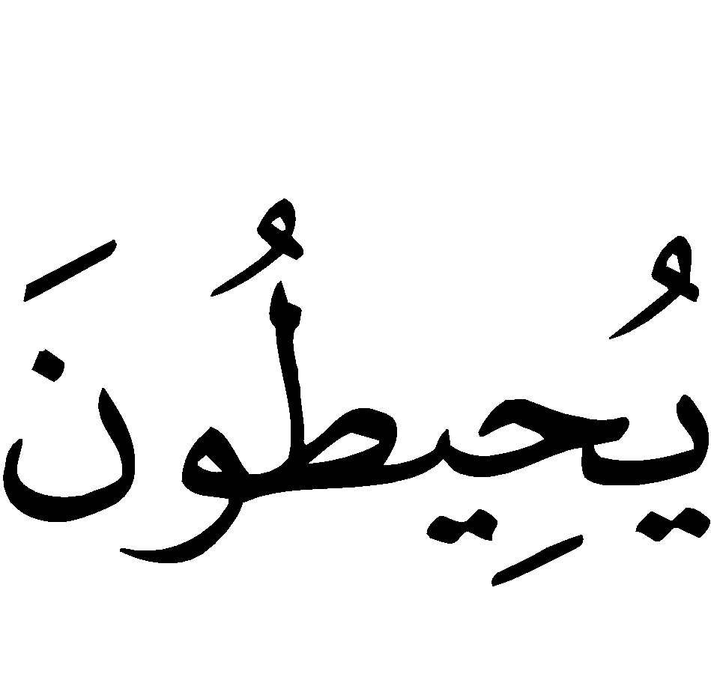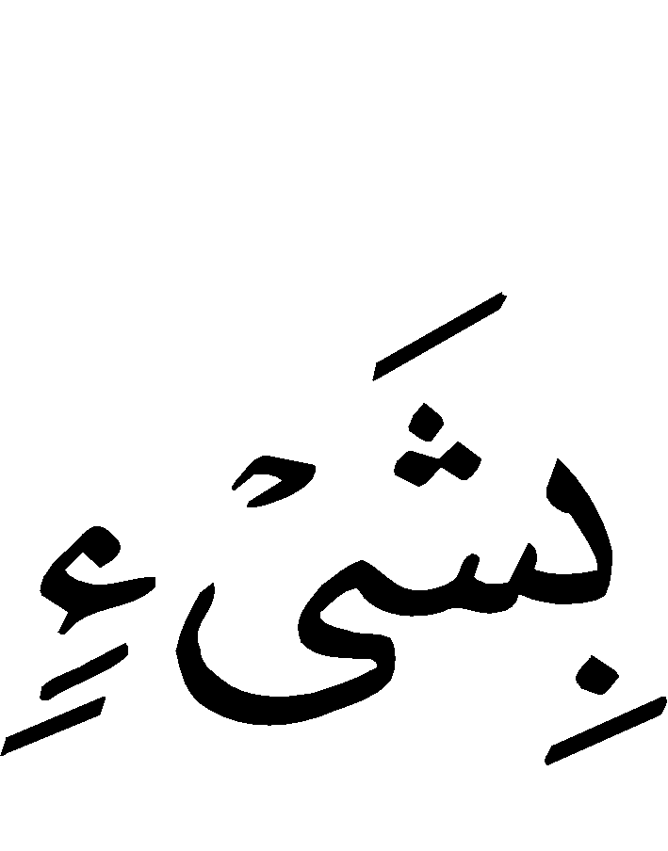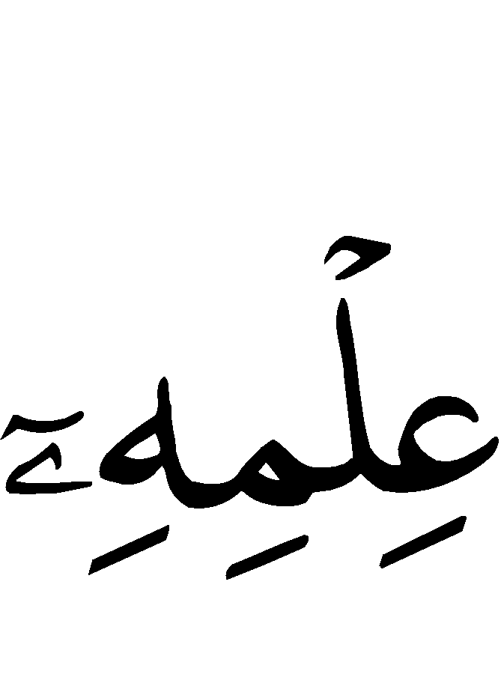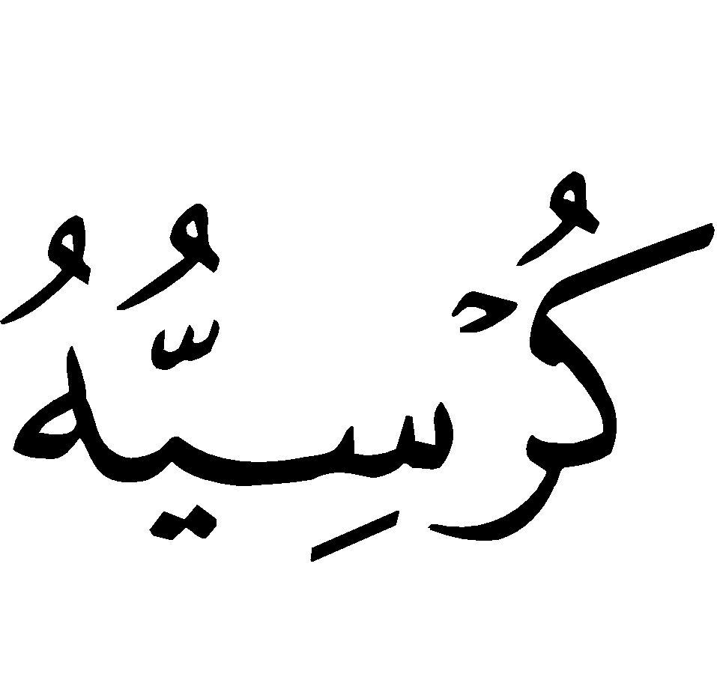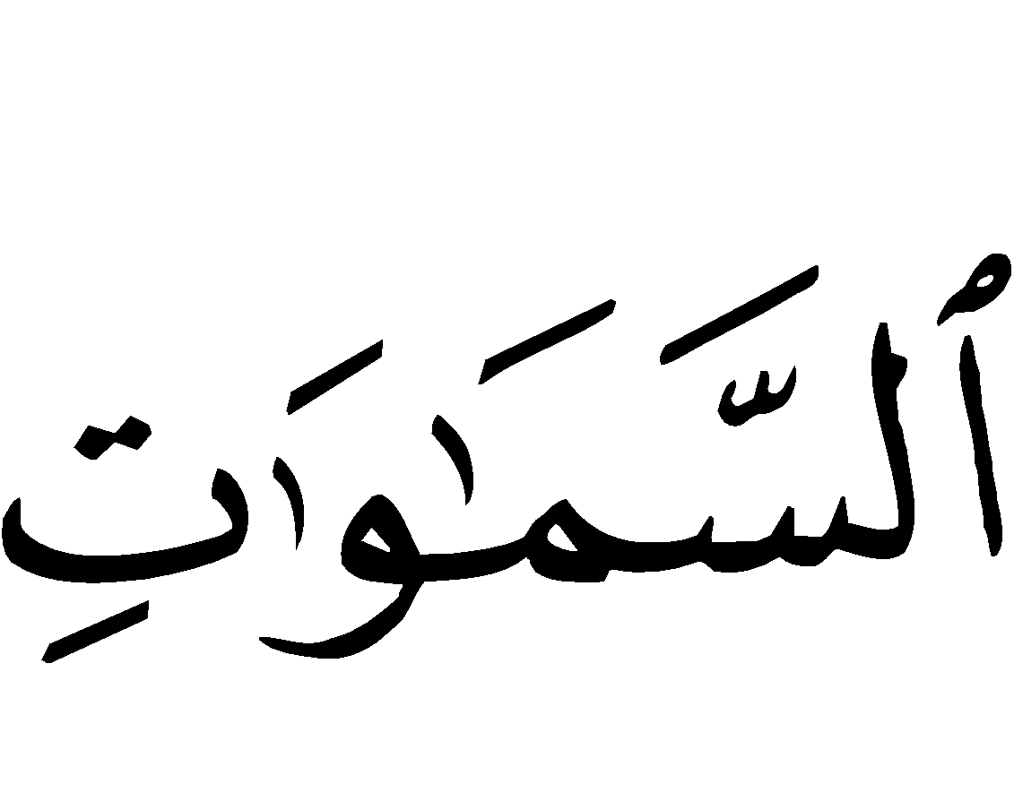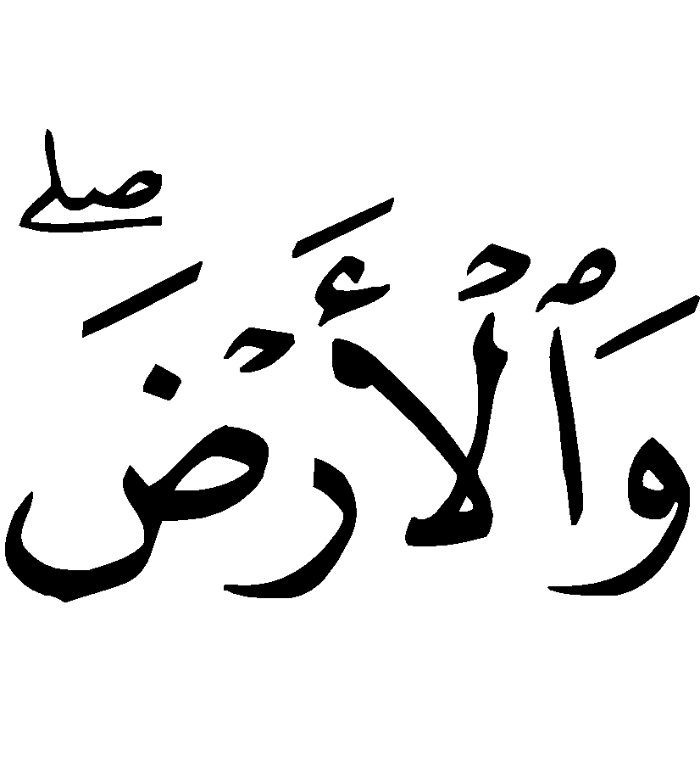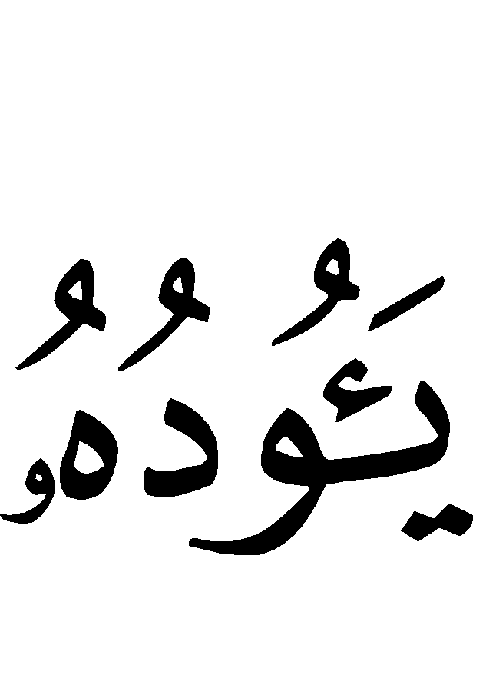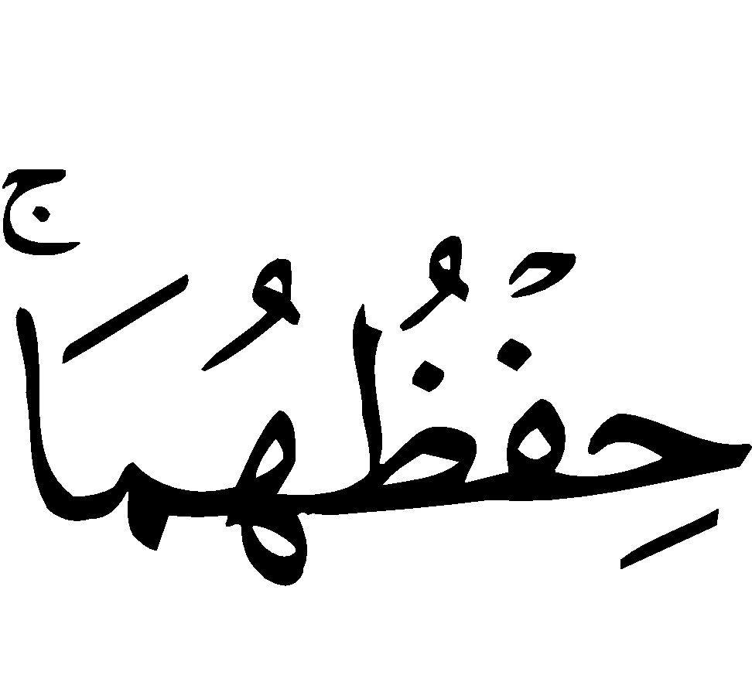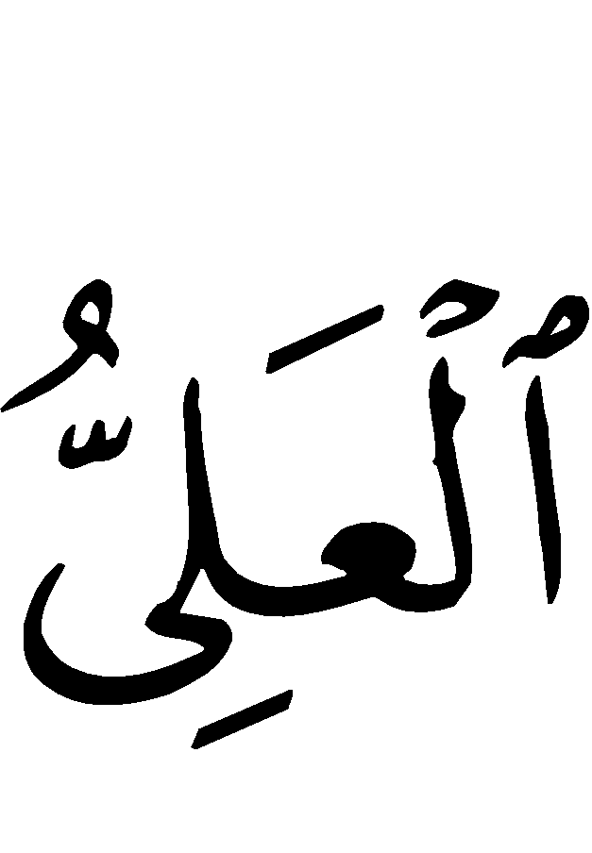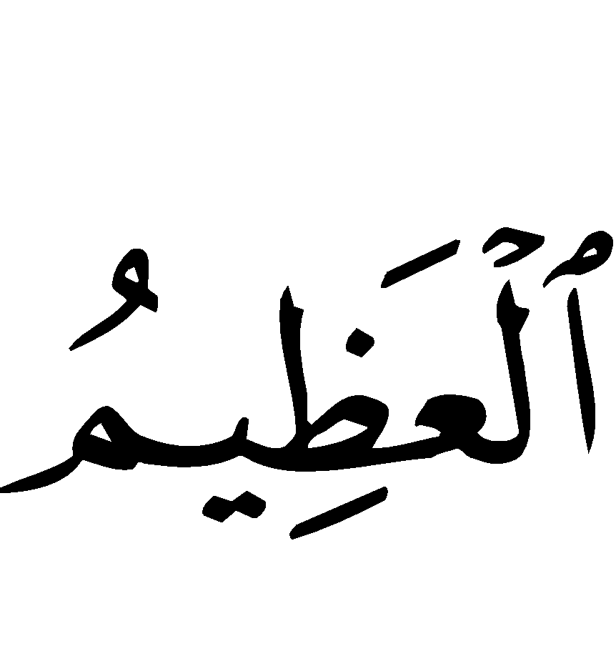
“Allaahu laa ilaaha illaa huw al-Hayy ul-Qayyoom. Laa ta´khudhuhoo sintataw wa laa nawm. Lahu maa fis-samaawaati wa maa fil-ard. Man dhal-ladhee yashfa‘u ‘indahu illaa bi idhnih. Ya’lamu maa bayna aydeehim wa maa khalfahum. Wa laa yuheetoona bi shay`im min ‘ilmihee illaa bimaa shaa´. Wasi‘a kursiyuhus-samaawaati wal-ard. Wa laa ya`ooduhu hif-dhuhumaa wa huwal-‘Aliyy ul-Adheem.”
“Allah! None has the right to be worshipped but He, the Ever Living, the One Who sustains and protects all that exists. Neither slumber, nor sleep overtake Him. To Him belongs whatever is in the heavens and whatever is on earth. Who is he that can intercede with Him except with His Permission? He knows what happens to them (His creatures) in this world, and what will happen to them in the Hereafter. And they will never encompass anything of His Knowledge except that which He wills. His Footstool extends over the heavens and the earth, and He feels no fatigue in guarding and preserving them. And He is the Most High, the Most Great.”

Appendix II
Supplications to be recited after the Obligatory Prayers

It is from the Sunnah of the Prophet () that you say the following supplications after every obligatory prayer, following his () guidance.

1.
‹‹ أَسْتَغْفِرُ اللهَ ، أَسْتَغْفِرُ اللهَ ، أَسْتَغْفِرُ اللهَ. ››
“Astaghfir-ullaah, Astaghfir-ullaah, Astaghfir-ullaah.”
“I seek Allah’s forgiveness, I seek Allah’s forgiveness. I seek Allah’s forgiveness.”

2.
‹‹ اللَّهُمَّ أَنْتَ السَّلاَمُ وَمِنْكَ السَّلاَمُ تَبَارَكْتَ يَا ذَا الْجَلالِ وَالإِكْرَامِ. ››
“Allaahumma ant as-Salaam wa mink as-Salaam tabaarakta yaa dhal-Jalaali wal-Ikraam.”
“O Allah, You are free from all defects and deficiencies, and from you is all peace, Blessed are You, O Possessor of Majesty and Honor.”

3.
‹‹ لاَ إِلـٰه إِلاَ الله ُوَحْدَهُ لاَ شَرِيْكَ لَهُ، لَهُ المُلْكُ وَلَهُ الحَمْدُ وَهُوَ عَلَىٰ كُلِّ شَيْءٍ قَدِيْرٌ. لاَ حَوْلَ وَلاَ قُوَّةَ إِلاَ بِاللهِ. لاَ إِلـٰهَ إِلاَ اللهُ، وَلاَ نَعْبُدُ إِلاَ إِيَاهُ. لَهُ النِّعْمَةُ وَلَهُ الْفَضْلُ، وَلَهُ الثَّنَاءُ الحَسَنُ ، لاَ إِلـٰهَ إِلاَ اللهُ، مُخْلِصِينَ لَهُ الدِّيْنَ وَلَوْ كَرِهَ الْكَافِرُونَ. ››
“Laa ilaaha ill-Allahu wahdahu laa shareeka lah, lahul-mulk wa lahul-hamd wa huwa ‘alaa kulli shay`in qadeer. Laa hawla wa laa quwwata illaa billaah, laa ilaaha ill-Allah, wa laa na’budu illaa iyaah. Lahun-ni’matu wa lah-ul-fadl, wa lah uth-thanaa ul-hasan, laa ilaaha ill-Allah, mukhliseena lah ud-deena wa law karih al-kaafiroon.”
“None has the right to be worshipped except Allah, alone, without partner, to him belongs all sovereignty and praise, and He is able to do all things. There is no might nor power except with Allah. None has the right to be worshipped except Allah, and we worship none but Him. For Him is all favor, grace, and glorious praise, none has the right to be worshipped except Allah, we are sincere in faith and devotion to Him, although the disbelievers hate it.”

4.
‹‹ اللـٰهُمَ لاَ مَانِعَ لمِاَ أَعْطَيْتَ وَلاَ مُعْطِيَ لِمَا مَنَعْتَ وَلاَ يَنْفَعُ ذَا الْجَدِّ مِنْكَ الْجَدُّ. ››
“Allaahumma laa maani‘a lima a’tayt, wa laa mu’tiya lima mana’t, wa laa yanfa‘u dhal-jaddi min kal-jadd.”
This supplication means that none can prevent what Allah gives, and none can give what Allah prevents, and that a rich person’s wealth can not benefit him, rather all creation are in need of Allah.

5. Then after that he should say 33 times:
‹‹ سُبْحَانَ اللهِ ، الحُمْدُ للهِ ، الله ُأَكْبَرُ. ››
“Subhaan-Allaah. Al-Hamdu lillaah. Allaahu Akbar.”
“How perfect Allah is. All praise is due to Allah. Allah is the Greatest.”

6. Then to complete 100, you should say once:
‹‹ لاَ إِلـٰه إِلاَ اللهُ وَحْدَهُ لاَ شَرِيْكَ لَه ُ، لَهُ المُلْكُ وَلَهُ الحَمْدُ وَهُوَ عَلَىٰ كُلِّ شَـيْءٍ قَدِيْرٌ. ››
“Laa ilaaha ill-Allahu wahdahu laa shareeka lah, lah ul-mulk wa lah ul-hamd wa huwa ‘alaa kulli shay`in qadeer.”
“None has the right to be worshipped except Allah, alone, without partner, to him belongs all sovereignty and praise, and He is able to do all things.”
7. Then He should recite the Verse of the Footstool (Aayat-ul-Kursi).
8. After this, he should recite Surah al-Ikhlaas, Surah al-Falaq and Surah an-Naas.

Hadeeth Qudsi: A hadeeth is a narration of the speech, actions, tacit approvals, and characteristics of the Prophet (). A Hadeeth Qudsi is a hadeeth in which the Prophet () narrates from Allah in the first person (I).
Jinn: A creation from the Unseen having free will like the humans, made from a smokeless flame of fire.
Shahaadatan: Literally, the two testimonies.
Tawheed: The concept of the Oneness and Uniqueness of Allah.
Point number one and two is the concept known as Tawheed ar-Ruboobiyyah, or the Oneness of Allah in His Attributes of Lordship. This is the belief that there is no Creator, Sovereign Master, Administrator, Provider, Sustainer, and Owner except for Allah.
This is concept is known as Tawheed al-Uloohiyyah, or the Oneness of Allah in His Worship. This is the belief that no worship should be directed to any except Allah.
This concept is known as Tawheed al-Asmaa´ was-Sifaat, that Allah has all the Best of Names and Attributes, and that there are none equal, comparable to, or like them.
Kufr: Disbelief.
It is not sufficient that a person merely know what the Shahaadah means and believe it with certainty. Rather he must accept it my pronouncing it openly and accepting to become a Muslim.
It is not sufficient that a person merely know what the Shahaadah means and believe in it with certainty, accept it by pronouncing it and accept to become a Muslim, but moreover, he must act according to it.
Muhsin: Literally, a person who does something well. Here it means one who does righteous deeds sincerely for Allah, according to the method the Prophet () taught us. Here we see that Allah mentions both submission to Allah along with doing righteous deeds, and only if a person does this has he grasped onto the sure handhold of the Shahaadah.
Even though a person may be doing all these things on the outside, he might be hiding disbelief in his heart, like the hypocrites.
It may be that one fulfills all the previous conditions, but he directs worship to other than Allah at times, like supplicating to the dead, etc. He has not made his worship purely for Allah.
The word Eemaan is usually translated as belief, but in reality has a wider meaning, for it entails internal belief, as well as outer speech and deeds. If a person was to ‘believe’ in Islam without ever acting upon it, it would not be said that he has ‘Eemaan’ and therefore his ‘belief’ would not be accepted.
Jannah: Heaven, paradise. The everlasting abode reserved only for the believers
Sunnah: The ‘Way’ of the Prophet (). It sometimes denotes the way he did something. Here it means the collection of the speech, deeds, and tacit approvals of the Prophet (), also known as hadeeth.
Shaytaan: Satan: A Jinn named Iblees who disobeyed Allah’s order to prostrate to Adam, and therefore was cursed for eternity. He asked Allah for respite, which He in turn granted, to strive to lead humanity to the Hellfire with him.
They will not be able to say: “Our Lord! Why did You not send us a Messenger? We should then have followed Your Ayat (Verses of the Qur'an) and should have been among the believers.” [Surah al-Qasas (28):47]
Bin pl. Banu: ‘the son of…’, pl. “the children of…”
Kunyah: Traditionally and until today, the Arab’s name a person, ‘Abu…(the father of so and so)’, or ‘Umm… (the mother of so and so)’.
Khaleel is one who is loved the highest form of love, which has no fault or shortcoming. The Prophet () is also the Khaleel of Allah. In a hadeeth narrated by Bukhari, “Indeed Allah has chosen me as a Khaleel, just as He chose Ibraheem as a Khaleel.”
The Siraat is a bridge set over the Hellfire over which all must pass, thinner than a strand of hair and sharper than a sword. Some will cross it as fast as lighting, some like a gust of wind, some like the speed of a fast horse, while others will cross it crawling, each according to his deeds.
Hawd: Literally: pool. The pool from which the true followers of Muhammad () will drink, after which they will never feel thirst again.
Intercession, or Shafaa‘ah: Allah will allow certain people to intercede for others, and from those will be the intercession of the Prophet ().
Qadaa´ and Qadar: These two Arabic words are usually translated as ‘fate’, ‘destiny’, or ‘pre-ordainment’. Many of these English words lead to incorrect belief this concept, so the original Arabic terms have been retained in order that one understand them in their true sense.
There was never a time when He did not know, rather, He always knew it.
‘Rawdat-un-Nadiyyah’ Sharh ‘Aqeedat-il-Waasitiyyah’, p.352-353.
Sahaabah: The Companions of the Prophet (). Any one who met the Prophet () as a Muslim and died as a Muslim.
Rak‘ah: a cycle consisting of one standing, bowing, and two prostrations. It will be explained further in detail later.
A state of impurity is a state one enters after having done specific acts. There are two types, major and minor, and both will be explained later.
A state of Janaabah is a spiritual state of impurity which one enters after having sexual intercourse, or after ejaculation of men or the release of orgasmic fluid for women.
The ablution, or wudoo´ in Arabic, is washing specific parts of the body to remove oneself from a state of minor impurity. It will be explained in detail later.
Note that he did not merely order him to wash his foot, but rather he ordered him to repeat the whole wudoo´ as well as his Prayer.
Jihad: Fighting against the disbelievers to raise Allah’s word and establish the laws of Islam.
Qiblah: the direction of the Ka’bah.
These are the Sunnah prayers which are emphasized; there are others related to each prayer which the author did not mention for the sake of brevity.
Makrooh: Something disliked in the religion. If a person does it, he will not be punished, but if he leaves it, he will be rewarded. It is preferred to pray ‘Asr before the sun starts to appear yellow, but it is still permissible until the sun reddens before the time of sunset. Other hadeeth show that the time of ‘Asr lasts until just before the sun sets. On another occasion, the Prophet () showed the companions the last time they could pray each prayer. For the time of ‘Asr, the Prophet (): “…delayed the ‘Asr Prayer until the time that upon finishing it, a person would say that the Sun had reddened (which occurs just before sunset.)” (Muslim)
‘Awrah: The parts of the body which is forbidden for other to look at.
See appendix I.
Imaam: Literally: leader. Here, it means one who leads others in Prayer.
This may be said in his own words, and need not be reported of the Prophet (). If he does not know Arabic, he may ask Allah in his native language.
The ‘Trials of Living…’ are that which a person encounters in life with regard to being enticed by the worldly life and the desires to which it gives rise. The ‘Trials of dying…’ are the trials of the grave, and the questioning by the two Angels. The ‘Trials of the False Messiah…’ are the supernatural occurrences that will happen at the Anti-Christ’s hands, called the Dajjaal in Arabic: things that will lead many people to go astray, to follow him and accept his claim to divinity.
This may be said in his own words, and need not be reported of the Prophet (). If he does not know Arabic, he may ask Allah in his native language.
About 15-20 minutes after the sun has risen.
Jihad: Here the word is used in its literal sense, which means ‘to strive against’.
One must make up the fasts before the arrival of the following Ramadaan.
‘Umrah: Lesser pilgrimage. It consists of Tawaaf and Sa‘i whilst in a state of Ihraam. These terms will be explain later.
Ihraam: A state in which certain things become forbidden for a pilgrim.
Meeqaat: Particular places which one cannot cross without entering a state of Ihraam if he wishes to perform ‘Umrah or Hajj.
Tawaaf: The act of circling the Ka’bah counter-clockwise.
The Ka’bah is the first place which was made for the worship of Allah on the face of the earth. It was built by Ibraheem and Ismaa‘eel, may the Safety and Mercy of Allah be upon them both, upon the command of Allah (). Allah said: “And Hajj to the House (Ka’bah) is a duty that mankind owes to Allah, those who can afford the expenses; and whoever disbelieves, then Allah stands not in need of any of the ‘Aalameen (mankind and jinns).” [Surah Aali ‘Imraan (3):97]
Duhaa: Forenoon. The time after the sun has risen a spear’s length until before it reaches its zenith.
Minaa´: A valley within the sacred precincts of Makkah.
Allah has legislated that a traveler shorten the Dhuhr, ‘Asr and ‘Ishaa´ prayers from four rak‘ahs to two rak‘ahs. A traveler may also combine the Dhuhr with the ‘Asr prayer, by praying them together, one after the other, as well as the Maghrib with the ‘Ishaa´ prayer.
‘Arafah: A plain just outside the sacred precincts of Makkah.
Muzdalifah: A hilly area between ‘Arafah and Minaa´.
There are three pillars in Minaa, the small, the medium and the large. The largest is called Jamrat-ul-‘Aqabah.
The Tawaaf al-Wadaa’, or the Farewell Tawaaf, is the Tawaaf which one performs when a pilgrim intends to return to his homeland. It is the last rite which is perfomed in Hajj, and should be the last thing one does at the House of Allah.
Muhaajir: a person who has made hijrah: migration from a land of disbelief to a land of Islam for the sake of Allah.
Mahram: Those relatives who are forbidden for a person to marry due to their closeness in blood, marriage, or due to wet-nursing, such as mothers, mothers in law, wet-nurses, sisters, aunts, etc.
Narrated by Dhahabi in ‘Al-Kabaa`ir’.
This is an Arabic expression of condemnation in which the literal meaning is not intended.
When someone says “As-Salaamu alaykum,” one should respond with, “wa ‘alaykum As-Salaam,” at the very least. It is better that one add, “wa Rahmatullaah,” and even further, “wa Barakaatuh.”
A person should refrain from saying, “God bless you,” or any other supplication other than what the Prophet () made.
Sleep is a lesser form of death, as Allah says in the Qur`an: “It is Allah Who takes away the souls at the time of their death, and those that do not die when their sleep. He keeps those (souls) for which He has ordained death and sends the rest for a term appointed. Verily, in this are signs for a people who think deeply.” [Surah az-Zumar (39):42]
Albani graded it as Saheeh.
To have taqwaa means to shield yourself from the punishment of Allah by avoiding sins and doing deeds of righteousness.
Jamaa‘ah: The general body of the Sahaabah and those who follow them.
A red camel was a highly prized species.
Ya´jooj and Ma´jooj: two tribes which will be let loose before the Last Day creating havoc on the earth.
A Mu´min is one who has fulfilled the level of both Islam and Eemaan, and is therefore stronger in faith than a mere Muslim, or one who has submitted to Allah.

